Blind Test XXII (NACJAF)
(Last updated March 2026)
Figure 1. The molecular diagram of Blind Test XXII.

CSP studies
REFCODE | NACJAF
Formula | C8 N4 S3
Common Name
IUPAC Systematic Name | 3,3a-dihydro-[1,4]-dithiino[2,3-c]isothiazole-3,5,6-tricarbonitrile
Other Names | Blind Test XXII
CSD Refcodes | NACJAF
Search Identifier | A
Scientist | Rebecca Hylton
Date | 2015
Publication | Reilly, A. M. et al, Acta Crystallogr B, 2016, Volume B72, pages 439-459
Energy model | 5 (List 2)
Study_ID | 31
Programs | Study_ID=11, DMACRYS (2.0.8)
Location on S Drive | \CHEMISTRY_CPOSS\BlindTest2015\NACJAF\PCM_SH
Potential Description | GDMA2.2(PCMdielectric3(PBE1PBE/6-31G(d,p))) + FIT with Scheraga sulfur parameters
Intramolecular Description | PCM3(PBE0/6-31G(d,p))
Energy model | 2 (List 1)
Study_ID | 10
Programs | Study_ID=20, CrystalOptimizer, DMACRYS (2.0.8)
Location on S Drive | \CHEMISTRY_CPOSS\BlindTest2015\NACJAF\CrystOpt
Potential Description | CrystalOptimizer with GDMA2.2(PBE1PBE/6-31G(d,p)) + FIT with Halgren sulfur parameters
Intramolecular Description | PBE1PBE/6-31G(d,p)
Energy model | 4
Study_ID | 30
Programs | Study_ID=10, DMACRYS (2.0.8)
Location on S Drive | \CHEMISTRY_CPOSS\BlindTest2015\NACJAF\PCM
Potential Description | GDMA2.2(PCMdielectric3(PBE1PBE/6-31G(d,p))) + FIT with Halgren sulfur parameters
Intramolecular Description | PCM3(PBE0/6-31G(d,p))
Energy model | 3
Study_ID | 11
Programs | Study_ID=20, CrystalOptimizer, DMACRYS (2.0.8)
Location on S Drive | \CHEMISTRY_CPOSS\BlindTest2015\NACJAF\CrystOpt_SH
Potential Description | CrystalOptimizer with GDMA2.2(PBE1PBE/6-31G(d,p)) + FIT with Scheraga sulfur parameters
Intramolecular Description | PBE1PBE/6-31G(d,p)
Energy model | 1
Study_ID | 20
Programs | Rigid CrystalPredictor, DMACRYS (2.0.8)
Location on S Drive | \CHEMISTRY_CPOSS\BlindTest2015\NACJAF\CrystPred
Potential Description | CrystalPredictor + DMACRYS with GDMA2.2(PBE1PBE/6-31G(d,p)) + FIT with Halgren sulfur parameters
Intramolecular Description | PBE1PBE/6-31G(d,p)
Energy model | 6
Study_ID | 1
Programs | Study_ID=20, DMACRYS (2.0.8)
Location on S Drive | \CHEMISTRY_CPOSS\BlindTest2015\NACJAF\Delaware
Potential Description | DMACRYS + custom Delaware exp-6/damp1-1/comb
Intramolecular Description | MP2/6-31G(d,p)
Energy model | 7
Study_ID | 2
Programs | Study_ID=20, DMACRYS (2.0.8)
Location on S Drive | \CHEMISTRY_CPOSS\BlindTest2015\NACJAF\Delaware2
Potential Description | DMACRYS + custom Delaware LL+LR+crys
Intramolecular Description | MP2/6-31G(d,p)

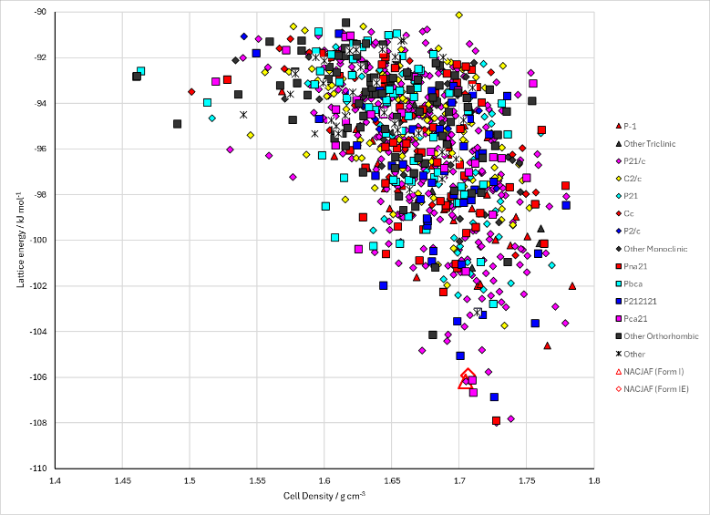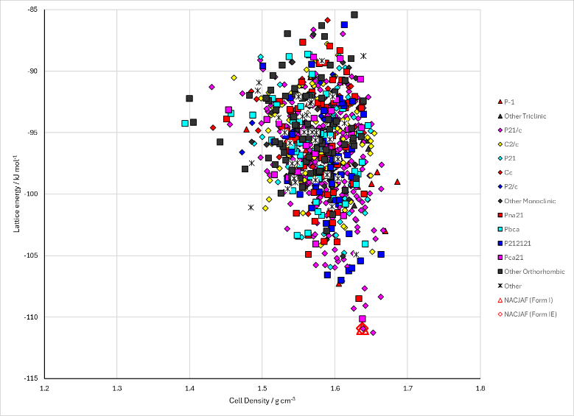
Figure 2. Crystal energy landscape of Blind Test XXII from previous work. Left: CrystOpt, Energy Model A2 (list 1). Right: PCM with Scheraga potential, Energy model A5 (list 2).

CSD structures (CSD version 6.01)

Table 1. Crystallographic information for CSD entries for Blind Test XXII. Different polymorphs are coloured differently.
REFCODE | space group | Z’ | a / Å | b / Å | c / Å | α / ° | β / ° | γ / ° | density / g cm⁻³ | Form
NACJAF | P21/n | 1.0 | 11.9470 | 6.69600 | 12.598 | 90.0 | 108.60000 | 90.0 | 1.7267 | None

Table 2. Experimental information for CSD entries for Blind Test XXII.
REFCODE | space group | R factor | T / K | Year | Comments
NACJAF | P21/n | 4.73 | 150 K | 2016 | None

Make this table include whether polymorphs are solution-grown, sublimation grown, templated or otherwise. Add references.

Other notes

