Clozapine
(Last updated 27 November 2025)
Figure 1. The molecular diagram of Clozapine.

CSP studies
REFCODE | NDNHCL
Formula | C18 H19 N4 Cl1
Common Name | Clozapine
IUPAC Systematic Name | 8-Chloro-11-(4-methyl-1-piperazinyl)-5H-dibenzo(b,e)(1,4)diazepine
CSD Refcodes | NDNHCL10
Search Identifier | B
Scientist | Louise Price
Date | 2025
Publication | No publication planned.
Energy model | 2
Study_ID | 10
Programs | Study_ID=20, CrystalOptimizer (2.4.7), DMACRYS (2.3.1.1)
Location on S Drive | \CHEMISTRY_CPOSS\Olanzapine\Clozapine\CrystOpt
Potential Description | CrystalOptimizer PBE1PBE/6-31G(d,p) intramolecular + GDMA2.2(PBE1PBE/6-31G(d,p)) DMA + FIT
Energy model | 1
Study_ID | 20
Programs | Flexible CrystalPredictor (2.?), DMACRYS 2.3.1.1
Location on S Drive | \CHEMISTRY_CPOSS\Olanzapine\Clozapine\CrystPred
Potential Description | CrystalPredictor + DMACRYS with GDMA2.2(PBE1PBE/6-31G(d,p)) + FIT
Search Identifier | A
Scientist | Louise Price
Date | 2013
Publication | No publication planned.
Energy model | 1
Study_ID | 1
Programs | MOLPAK, DMACRYS (2.0.4)
Location on S Drive | \CHEMISTRY_CPOSS\Olanzapine\Clozapine\exp01_molpak
Potential Description | GDMA2(MP2/6-31G(d,p)) + FIT

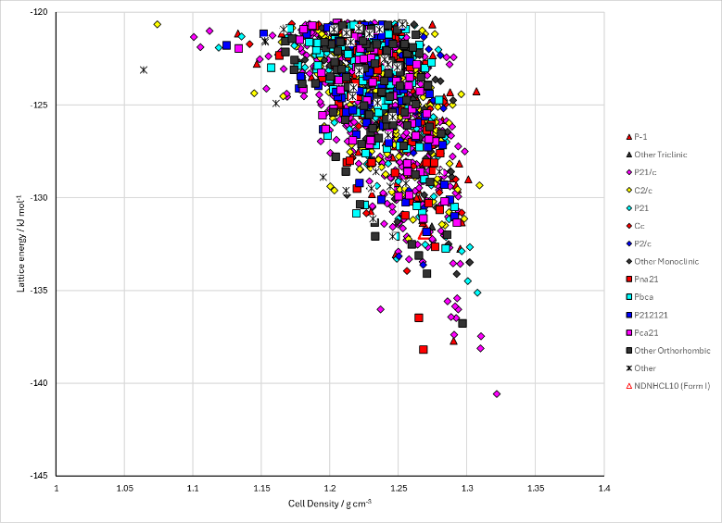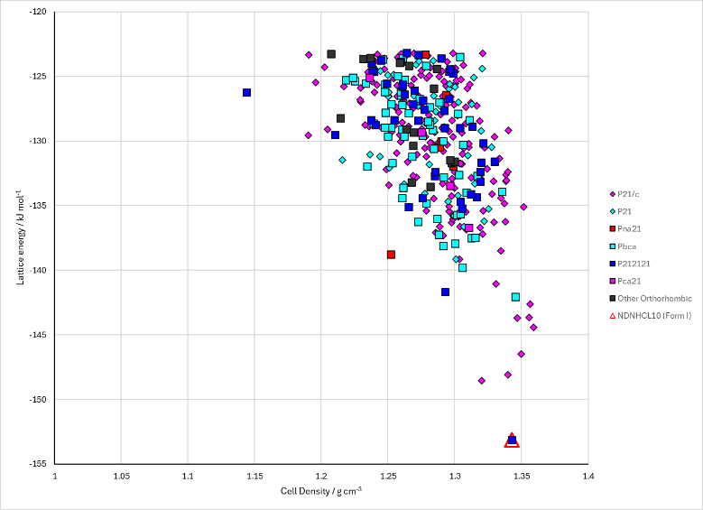
Figure 2. Crystal energy landscape of Clozapine from previous work. Left: the CrystalOptimizer refinement of the CrystalPredictor search. Right: the rigid molecule MOLPAK search using the experimental conformation.

CSD structures (CSD version 6.01)

Table 1. Crystallographic information for CSD entries for Clozapine. Different polymorphs are coloured differently.
REFCODE | space group | Z’ | a / Å | b / Å | c / Å | α / ° | β / ° | γ / ° | density / g cm⁻³ | Form
NDNHCL01 | P212121 | 1 | 18.143 | 9.555 | 9.488 | 90 | 90 | 90 | 1.3197 | I
NDNHCL10 | P212121 | 1 | 18.04 | 9.57 | 9.5 | 90 | 90 | 90 | 1.3235 | I

Table 2. Experimental information for CSD entries for Clozapine.
REFCODE | space group | R factor | T / K | Year | Comments
NDNHCL01 | P212121 | - | - | 1982 | 10.1107/S0567740882007109
NDNHCL10 | P212121 | 3.6 | RT | 1976 | 10.1039/p29760001415

Make this table include whether polymorphs are solution-grown, sublimation grown, templated or otherwise. Add references.

Other notes

