Lamotrigine
(Last updated January 2026)
Figure 1. The molecular diagram of Lamotrigine.

CSP studies
REFCODE | EFEMUX
Formula | C9 H7 N5 Cl2
Common Name | Lamotrigine
IUPAC Systematic Name | 6-(2,3-dichlorophenyl)-1,2,4-triazine-3,5-diamine
Other Names
CSD Refcodes | EFEMUX01
Search Identifier | A
Scientist | Louise Price
Date | 2018
Publication | No publication planned.
Energy model | 2
Study_ID | 10
Programs | Study_ID=20, CrystalOptimizer (2.4.7.1), DMACRYS (2.3.0)
Location on S Drive | \CHEMISTRY_CPOSS\MagnaPharm\Lamotrigine\CrystOpt
Potential Description | CrystalOptimizer PBE1PBE/6-31G(d,p) intramolecular + GDMA2.2(PBE1PBE/6-31G(d,p)) DMA + FIT
Intramolecular Description | PBE1PBE/6-31G(d,p)
Energy model | 1
Study_ID | 20
Programs | Flexible CrystalPredictor (2.2), DMACRYS (2.3.0)
Location on S Drive | \CHEMISTRY_CPOSS\MagnaPharm\Lamotrigine\CP_Dmacrys
Potential Description | CrystalPredictor + DMACRYS with GDMA2.2(PBE1PBE/6-31G(d,p)) + FIT
Intramolecular Description | PBE0/6-31G(d,p)

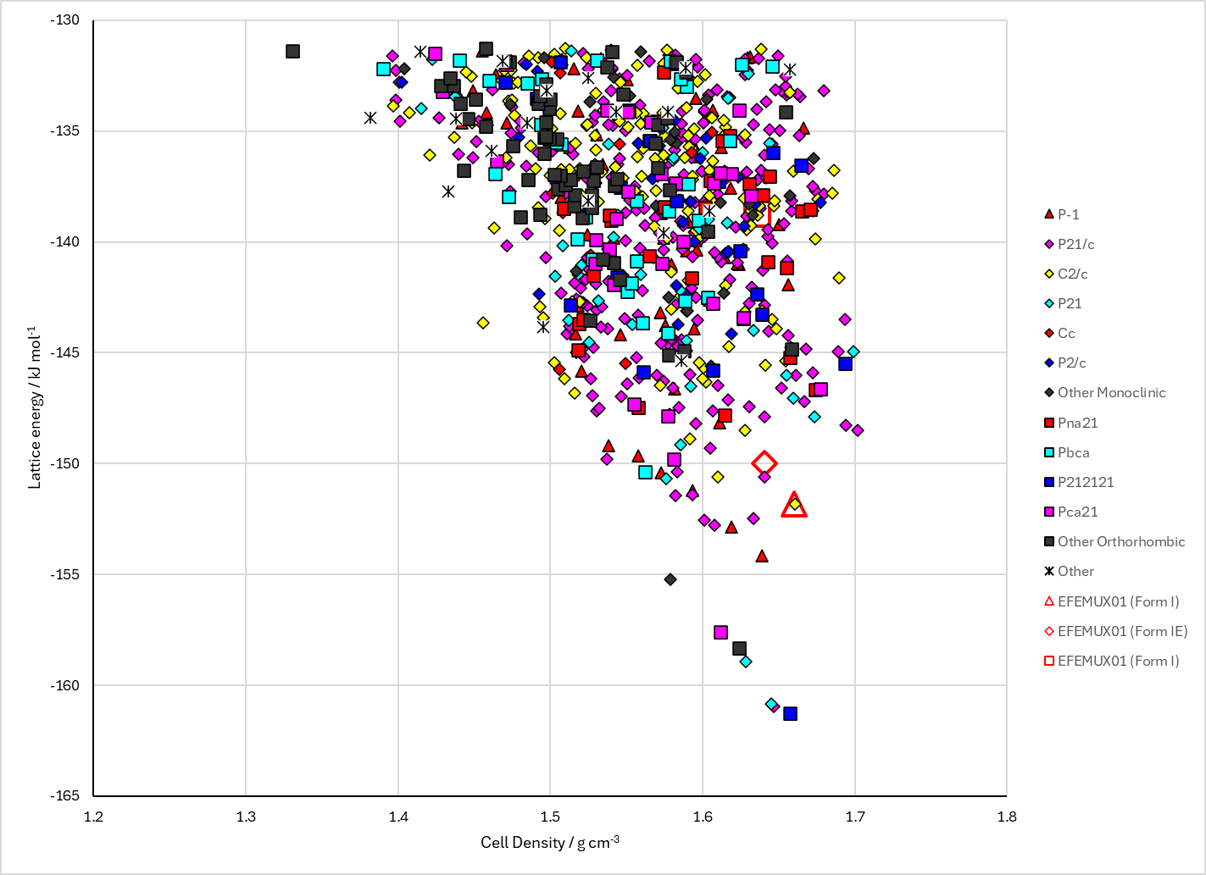
Figure 2. Crystal energy landscape of Lamotrigine from previous work.

CSD structures (CSD version 6.01)

Table 1. Crystallographic information for CSD entries for Lamotrigine. Different polymorphs are coloured differently.
REFCODE | space group | Z’ | a / Å | b / Å | c / Å | α / ° | β / ° | γ / ° | density / g cm⁻³ | Form
EFEMUX01 | C2/c | 1.0 | 19.136 | 8.6409 | 13.5549 | 90.0 | 109.172 | 90.0 | 1.6069 | None
EFEMUX02 | C2/c | 1.0 | 20.081(4) | 8.864(1) | 14.091(3) | 90.00 | 109.48(3) | 90.00 | 1.439 | None

Table 2. Experimental information for CSD entries for Lamotrigine.
REFCODE | space group | R factor | T / K | Year | Comments
EFEMUX01 | C2/c | 2.81 | at 294 K | 2009 | 10.1107/S0108270109030960
EFEMUX02 | C2/1 | 17.54 | at 293 K | 2025 | Electron diffraction; 10.1107/S1600576725006892

Make this table include whether polymorphs are solution-grown, sublimation grown, templated or otherwise. Add references.

Other notes

