5-Formyluracil
(Last updated June 2026)
Figure 1. The molecular diagram of 5-Formyluracil.

CSP studies
REFCODE | GIMREA
Formula | C5 H4 N2 O3
Common Name | 5-formyluracil
IUPAC Systematic Name | 2,4-dioxo-1,2,3,4-tetrahydropyrimidine-5-carbaldehyde
Other Names
CSD Refcodes | GIMREA
Search Identifier | A
Scientist | Not sure
Date | 2009
Publication | No publication planned.
Energy model | 1
Study_ID | 0
Programs | MOLPAK, DMAREL (4.1.1)
Location on S Drive | \CHEMISTRY_CPOSS\0-SolventDatabasesForCrystOpt\5-formyluracil
Potential Description | DMA + FIT
Intramolecular Description | MP2/6-31G(d,p)

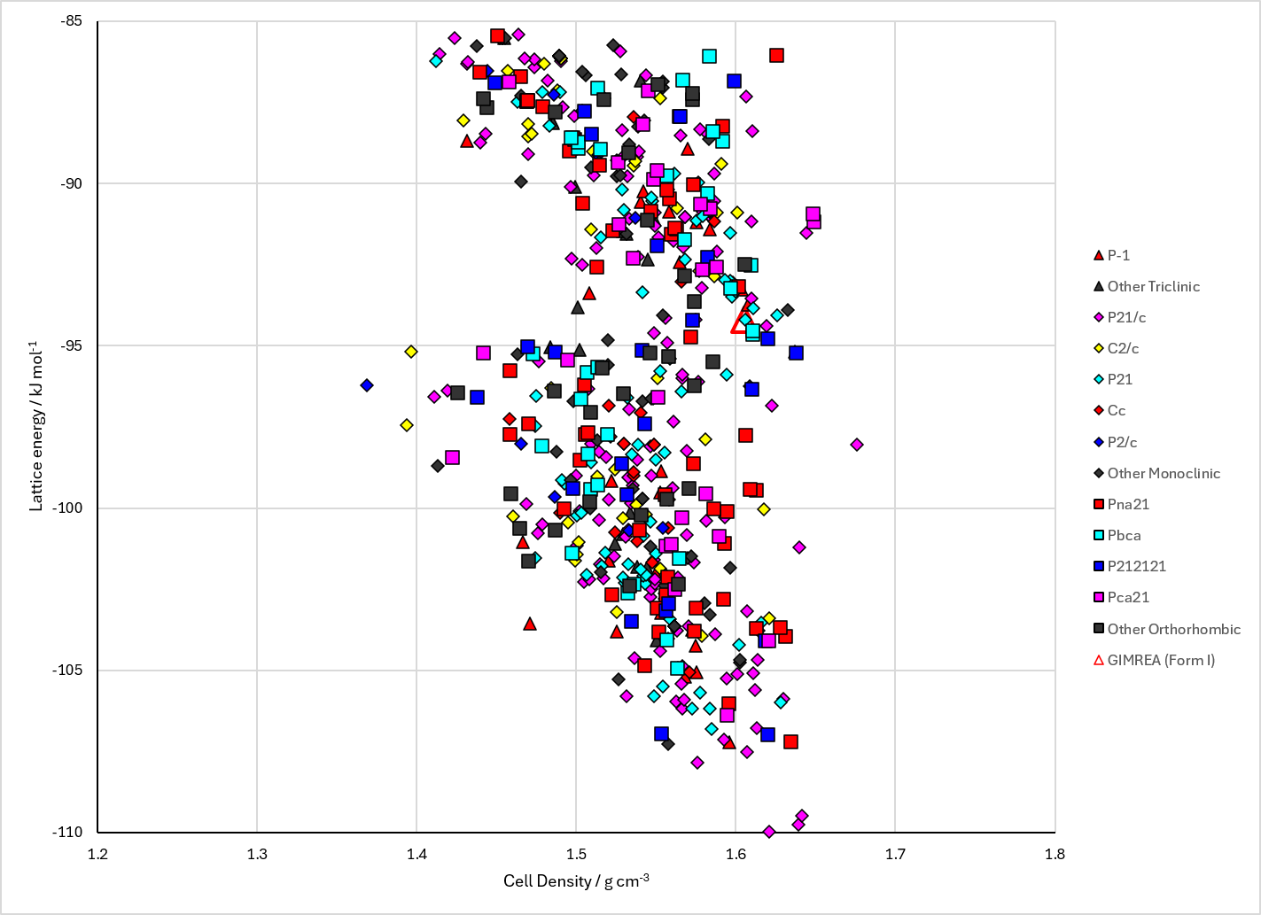
Figure 2. Crystal energy landscape of 5-Formyluracil from previous work.

CSD structures (CSD version 6.01 with Feb 2026 update)

Table 1. Crystallographic information for CSD entries for 5-Formyluracil. Different polymorphs are coloured differently.
REFCODE | space group | Z’ | a / Å | b / Å | c / Å | α / ° | β / ° | γ / ° | density / g cm⁻³ | Form
GIMREA | Cmc21 | 0.5 | 6.28400 | 6.705 | 12.8302 | 90.0 | 90.0 | 90.0 | 1.7213 | None

Table 2. Experimental information for CSD entries for 5-Formyluracil.
REFCODE | space group | R factor | T / K | Year | Comments
GIMREA | Cmc21 | 4.25 | at 298 K | 2007 | 10.1107/S0108270107045659

Make this table include whether polymorphs are solution-grown, sublimation grown, templated or otherwise. Add references.

Other notes

