Orotic Acid
(Last updated June 2026)
Figure 1. The molecular diagram of Orotic Acid.

CSP studies
REFCODE | OROTIC
Formula | C5 H4 N2 O4
Common Name | orotic acid
IUPAC Systematic Name | orotic acid
Other Names
CSD Refcodes
Search Identifier | A
Scientist | Sally Price
Date | pre-2010
Publication | No publication planned.
Energy model | 1
Study_ID | 0
Programs | MOLPAK, DMAREL (4.1.1)
Location on S Drive | \CHEMISTRY_CPOSS\0-EarlySearches\home\louise_price.eminerals\orotic_acid
Potential Description | MP2 6-31G(d,p) DMA(1.1)+ fit.pots
Intramolecular Description | MP2 6-31G(d,p)

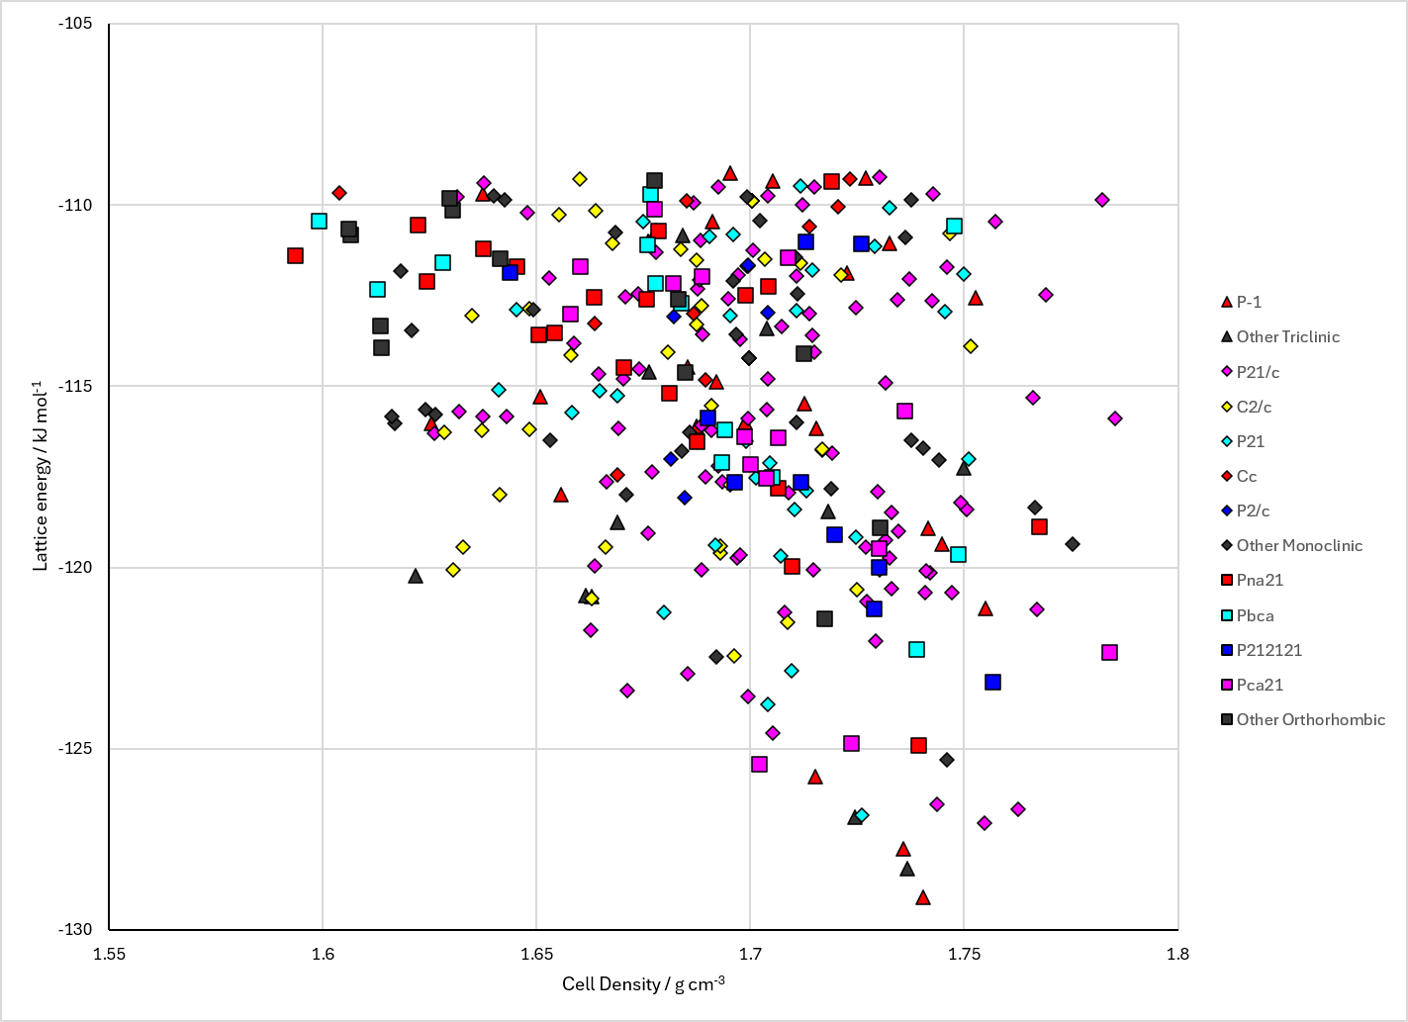
Figure 2. Crystal energy landscape of Orotic Acid from previous work.

CSD structures (CSD version 6.01 with Feb 2026 update)

Table 1. Crystallographic information for CSD entries for Orotic Acid. Different polymorphs are coloured differently.
REFCODE | space group | Z’ | a / Å | b / Å | c / Å | α / ° | β / ° | γ / ° | density / g cm⁻³ | Form

Table 2. Experimental information for CSD entries for Orotic Acid.
REFCODE | space group | R factor | T / K | Year | Comments

Make this table include whether polymorphs are solution-grown, sublimation grown, templated or otherwise. Add references.

Other notes

