Oxamic Acid
(Last updated June 2026)
Figure 1. The molecular diagram of Oxamic Acid.

CSP studies
REFCODE | AFIGOO
Formula | C2 H3 N1 O3
Common Name | Oxamic acid
IUPAC Systematic Name | Oxalamic acid
Other Names | Oxalic acid monoamide, Aminooxoacetic acid
CSD Refcodes | AFIGOO
Search Identifier | A
Scientist | Not sure
Date | pre-2010
Publication | No publication planned.
Energy model | 1
Study_ID | 0
Programs | MOLPAK, DMAREL (4.1.1)
Location on S Drive | \CHEMISTRY_CPOSS\0-EarlySearches\home\louise_price.eminerals\oxamic_acid
Potential Description | DMA + FIT
Intramolecular Description | MP2/6-31G(d,p)

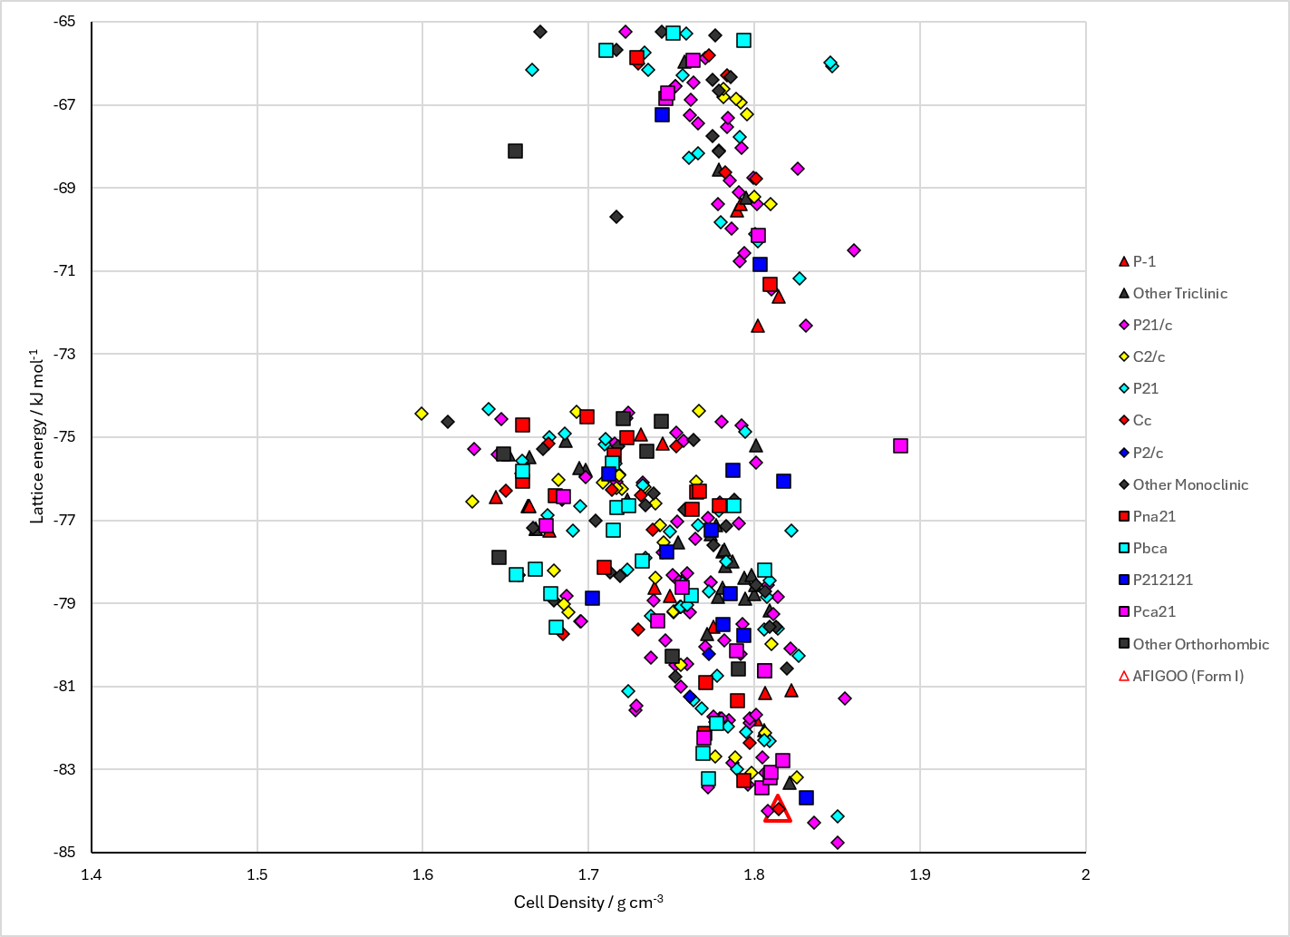
Figure 2. Crystal energy landscape of Oxamic Acid from previous work.

CSD structures (CSD version 6.01 with Feb 2026 update)

Table 1. Crystallographic information for CSD entries for Oxamic Acid. Different polymorphs are coloured differently.
REFCODE | space group | Z’ | a / Å | b / Å | c / Å | α / ° | β / ° | γ / ° | density / g cm⁻³ | Form
AFIGOO | Cc | 1.0 | 9.4989 | 5.43796 | 6.86370 | 90.0 | 107.15200 | 90.0 | 1.7459 | None
AFIGOO01 | Cc | 1.0 | 9.4994 | 5.43800 | 6.8636 | 90.0 | 107.149 | 90.0 | 1.7458 | None

Table 2. Experimental information for CSD entries for Oxamic Acid.
REFCODE | space group | R factor | T / K | Year | Comments
AFIGOO | Cc | 3.27 | 298 K | 2019 | 10.1016/j.molstruc.2018.09.089
AFIGOO01 | Cc | 8.887 | 298 K | 2023 | None

Make this table include whether polymorphs are solution-grown, sublimation grown, templated or otherwise. Add references.

Other notes

