Chlorothiazide
(Last updated April 2026)
Figure 1. The molecular diagram of Chlorothiazide.

CSP studies
REFCODE | QQQAUG
Formula | C7 H6 N3 O4 Cl1 S2
Common Name | chlorothiazide
IUPAC Systematic Name | 6-Chloro-2H-1,2,4-benzothiadiazine-7-sulfonamide 1,1-dioxide
Other Names
CSD Refcodes | QQQAUG04, QQQAUG17, QQQAUG22, QQQAUG23
Search Identifier | A
Scientist | Sally Price
Date | pre-2010
Publication | Johnston A, Bardin J, Johnston BF, Fernandes P, Kennedy AR, Price SL, Florence AJ 2011. Cryst Growth Des 11, 405-413.
Energy model | 1
Study_ID | 0
Programs | MOLPAK, DMAREL (4.1.1)
Location on S Drive | \CHEMISTRY_CPOSS\0-EarlySearches\home\louise_price.eminerals\chlorothiazide
Potential Description | MP2 6-31G(d,p) DMA + SONClfit.pots
Intramolecular Description | MP2 energy for SCF 6-31G(d,p) optimised

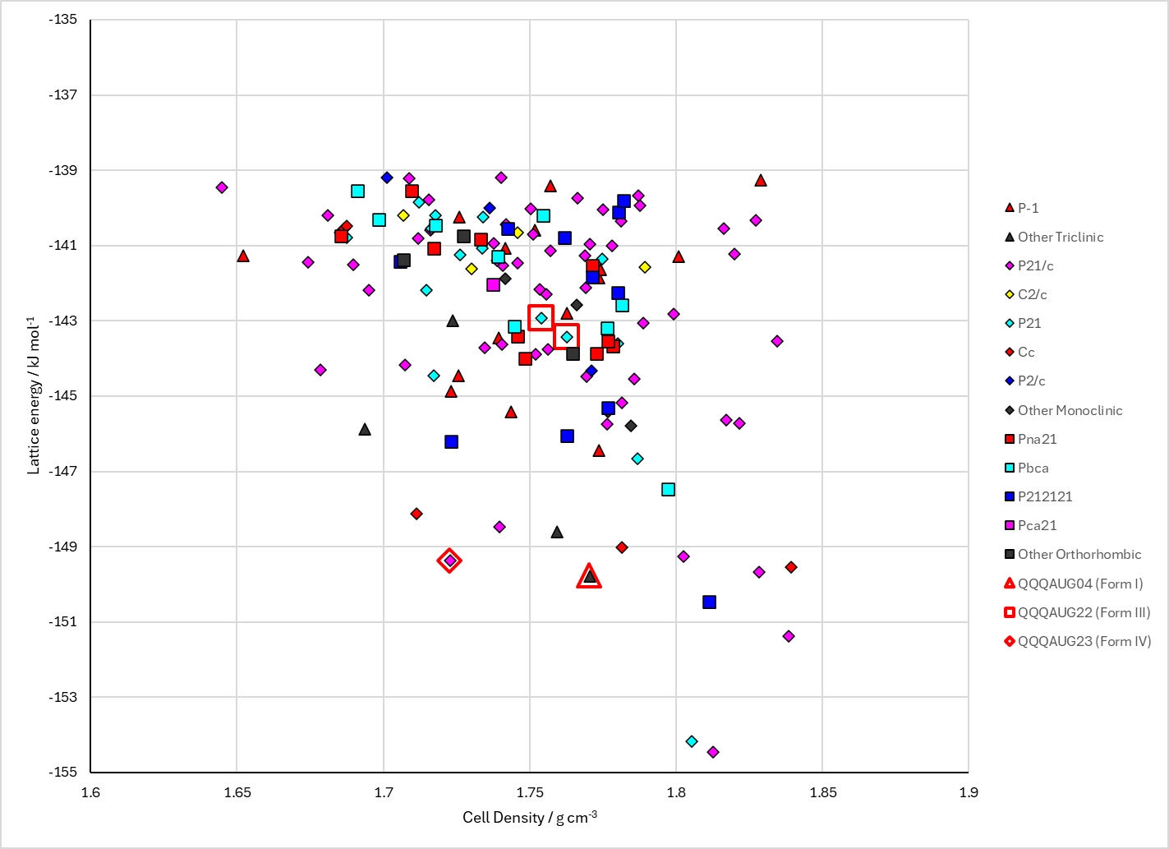
Figure 2. Crystal energy landscape of Chlorothiazide from previous work.

CSD structures (CSD version 6.01 with Feb 2026 update)
Table 1. Crystallographic information for CSD entries for Chlorothiazide. Different polymorphs are coloured differently.
REFCODE | space group | Z’ | a / Å | b / Å | c / Å | α / ° | β / ° | γ / ° | density / g cm⁻³ | Form
QQQAUG01 | P1 | 1.0 | 6.372 | 8.9159 | 4.8554 | 96.1321 | 99.476 | 74.4119 | 1.8778 | Form II
QQQAUG02 | P1 | 1.0 | 4.8499 | 6.36940 | 8.9106 | 74.401 | 83.865 | 80.524 | 1.8819 | Form I
QQQAUG03 | P1 | 1.0 | 4.86140 | 6.3802 | 8.9251 | 74.422 | 83.885 | 80.554 | 1.8708 | Form I
QQQAUG04 | P1 | 1.0 | 4.84810 | 6.359 | 8.9 | 74.49 | 83.9 | 80.53 | 1.8870 | Form I
QQQAUG05 | P1 | 1.0 | 4.8619 | 6.377 | 8.926 | 74.4 | 83.93 | 80.56 | 1.8715 | Form I
QQQAUG06 | P1 | 1.0 | 4.8707 | 6.3951 | 8.9448 | 74.368 | 83.786 | 80.459 | 1.8600 | Form I
QQQAUG07 | P1 | 1.0 | 4.8737 | 6.4046 | 8.9548 | 74.324 | 83.751 | 80.449 | 1.8545 | Form I
QQQAUG08 | P1 | 1.0 | 4.87860 | 6.4126 | 8.9665 | 74.266 | 83.693 | 80.445 | 1.8486 | Form I
QQQAUG09 | P1 | 1.0 | 4.8746 | 6.40110 | 8.98 | 74.05 | 83.54 | 80.468 | 1.8528 | Form I
QQQAUG10 | P1 | 1.0 | 4.835 | 6.31000 | 8.895 | 74.62 | 84.12 | 80.67 | 1.9056 | Form I
QQQAUG11 | P1 | 1.0 | 4.76 | 6.1455 | 8.737 | 76.06 | 84.56 | 81.25 | 2.0066 | Form I
QQQAUG12 | P1 | 1.0 | 4.728 | 6.05010 | 8.68400 | 76.54 | 84.73 | 81.67 | 2.0581 | Form I
QQQAUG13 | P1 | 1.0 | 4.69300 | 5.9013 | 8.599 | 77.48 | 84.97 | 82.35 | 2.1351 | Form I
QQQAUG14 | P1 | 1.0 | 4.676 | 5.81150 | 8.54300 | 77.95 | 85.11 | 82.77 | 2.1842 | Form I
QQQAUG15 | P1 | 1.0 | 4.51 | 5.9287 | 8.503 | 76.528 | 85.624 | 83.203 | 2.2395 | Form II
QQQAUG16 | P1 | 1.0 | 4.4832 | 5.8932 | 8.465 | 76.234 | 85.836 | 83.284 | 2.2786 | Form II
QQQAUG17 | P1 | 1.0 | 4.46090 | 5.8592 | 8.427 | 75.991 | 86.055 | 83.349 | 2.3154 | Form II
QQQAUG22 | P21 | 1.0 | 4.8296 | 6.27030 | 16.9551 | 90.0 | 92.214 | 90.0 | 1.9142 | Form III
QQQAUG23 | P21/c | 1.0 | 7.3334 | 14.741 | 10.871 | 90.0 | 114.959 | 90.0 | 1.8436 | Form IV

Table 2. Experimental information for CSD entries for Chlorothiazide.
REFCODE | space group | R factor | T / K | Year | Comments
QQQAUG01 | P1 | 5.100 | at 130 K | 1997 | synchrotron, powder, 10.1039/a606998c
QQQAUG02 | P1 | 4.25 | at 130 K | 2008 | neutron, powder, 10.1107/S010876810705687X
QQQAUG03 | P1 | 3.48 | at 123 K | 2008 | 10.1107/S010876810705687X
QQQAUG04 | P1 | 2.27 | at 90 K | 2008 | synchrotron, powder, 10.1107/S0021889808030872
QQQAUG05 | P1 | 2.300 | at 120 K | 2008 | synchrotron, powder, 10.1107/S0021889808030872
QQQAUG06 | P1 | 2.4 | at 150 K | 2008 | synchrotron, powder, 10.1107/S0021889808030872
QQQAUG07 | P1 | 2.45 | at 180 K | 2008 | synchrotron, powder, 10.1107/S0021889808030872
QQQAUG08 | P1 | 2.52 | at 210 K | 2008 | synchrotron, powder, 10.1107/S0021889808030872
QQQAUG09 | P1 | 6.57 | at 293 K | 2010 | 10.1039/c001355b
QQQAUG10 | P1 | 7.01 | at 293 K | 2010 | 0.5 GPa, 10.1039/c001355b
QQQAUG11 | P1 | 5.39 | at 293 K | 2010 | 1.3 GPa, 10.1039/c001355b
QQQAUG12 | P1 | 5.64 | at 293 K | 2010 | 2.1 GPa, 10.1039/c001355b
QQQAUG13 | P1 | 6.270 | at 293 K | 2010 | 3.5 GPa, 10.1039/c001355b
QQQAUG14 | P1 | 6.25 | at 293 K | 2010 | 4.0 GPa, 10.1039/c001355b
QQQAUG15 | P1 | 2.88 | at 293 K | 2010 | 4.4 GPa, 10.1039/c001355b
QQQAUG16 | P1 | 2.56 | at 293 K | 2010 | 5.1 GPa, 10.1039/c001355b
QQQAUG17 | P1 | 2.4 | at 293 K | 2010 | 5.9 GPa, 10.1039/c001355b
QQQAUG22 | P21 | 2.81 | 100 K | 2024 | 10.1107/S2056989024006078
QQQAUG23 | P21/c | 5.531 | 293 K | 2025 | powder, 10.1039/D4PM00286E

Make this table include whether polymorphs are solution-grown, sublimation grown, templated or otherwise. Add references.

Other notes

