Equilin
(Last updated April 2026)
Figure 1. The molecular diagram of Equilin.

CSP studies
REFCODE | GODTIC
Formula | C18 H20 O2
Common Name | equilin
IUPAC Systematic Name | 3-Hydroxy-13-methyl-6,9,11,12,13,14,15,16-octahydro-cyclopenta[a]phenanthren-17-one
Other Names | Estra-1,3,5(10),7-tetraen-17-one, 3-hydroxy-; Dihydroequilenin; 7-Dehydroestrone; 3-Hydroxyestra-1,3,5(10),7-tetraen-17-oneIsoindole-1,3-dione
CSD Refcodes | GODTIC
Search Identifier | A
Scientist | Not sure
Date | pre-2010
Publication | No publication planned.
Energy model | 2
Study_ID | 10
Programs | Study_ID=0, dmaflex, DMAREL (4.1.1)
Location on S Drive | \CHEMISTRY_CPOSS\0-EarlySearches\home\louise_price.eminerals\equilin_dmaflex
Potential Description | MP2 6-31G(d,p) DMA + fit.pots
Intramolecular Description | MP2 6-31G(d,p)
Energy model | 1
Study_ID | 0
Programs | MOLPAK, DMAREL (4.1.1)
Location on S Drive | \CHEMISTRY_CPOSS\0-EarlySearches\home\louise_price.eminerals\equilin
Potential Description | MP2 6-31G(d,p) DMA + fit.pots
Intramolecular Description | MP2 6-31G(d,p)
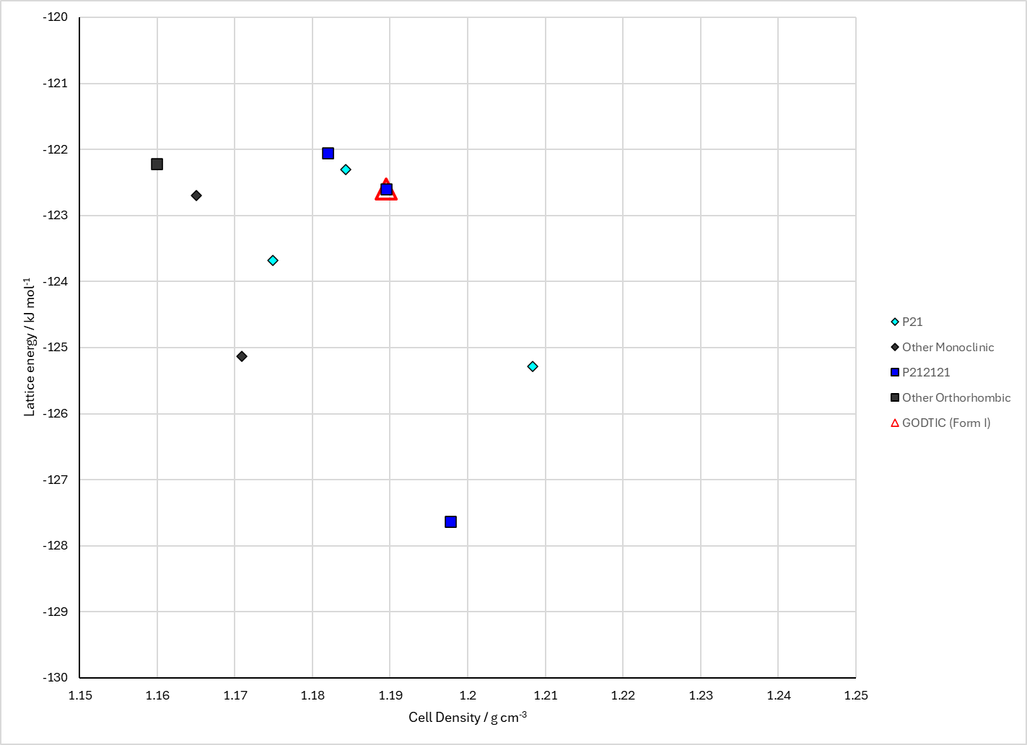
Figure 2. Crystal energy landscape of Equilin from previous work.

CSD structures (CSD version 6.01 with Feb 2026 update)

Table 1. Crystallographic information for CSD entries for Equilin. Different polymorphs are coloured differently.
REFCODE | space group | Z’ | a / Å | b / Å | c / Å | α / ° | β / ° | γ / ° | density / g cm⁻³ | Form
GODTIC | P212121 | 1.0 | 6.5429 | 9.03450 | 23.8940 | 90.0 | 90.0 | 90.0 | 1.2619 | None

Table 2. Experimental information for CSD entries for Equilin.
REFCODE | space group | R factor | T / K | Year | Comments
GODTIC | P212121 | 5.0 | None | 1999 | 10.1107/S0108270198013250

Make this table include whether polymorphs are solution-grown, sublimation grown, templated or otherwise. Add references.

Other notes

