Equilinin
(Last updated April 2026)
Figure 1. The molecular diagram of Equilinin.

CSP studies
REFCODE | QQQAMM
Formula | C18 H18 O2
Common Name | equilinin
IUPAC Systematic Name | 3-Hydroxyestra-1,3,5(10),6,8-pentaen-17-one
Other Names
CSD Refcodes | QQQAMM01
Search Identifier | A
Scientist | Not sure
Date | pre-2010
Publication | No publication planned.
Energy model | 2
Study_ID | 10
Programs | Study_ID=0, dmaflex, DMAREL (4.1.1)
Location on S Drive | \CHEMISTRY_CPOSS\0-EarlySearches\home\louise_price.eminerals\equilinin_dmaflex
Potential Description | MP2 6-31G(d,p DMA(v2.1)+ fit.pots
Intramolecular Description | MP2/6-31G(d,p)
Energy model | 1
Study_ID | 0
Programs | MOLPAK, DMAREL (4.1.1)
Location on S Drive | \CHEMISTRY_CPOSS\0-EarlySearches\home\louise_price.eminerals\equilinin
Potential Description | MP2 6-31G(d,p DMA(v2.1)+ fit.pots
Intramolecular Description | MP2 6-31G(d,p)
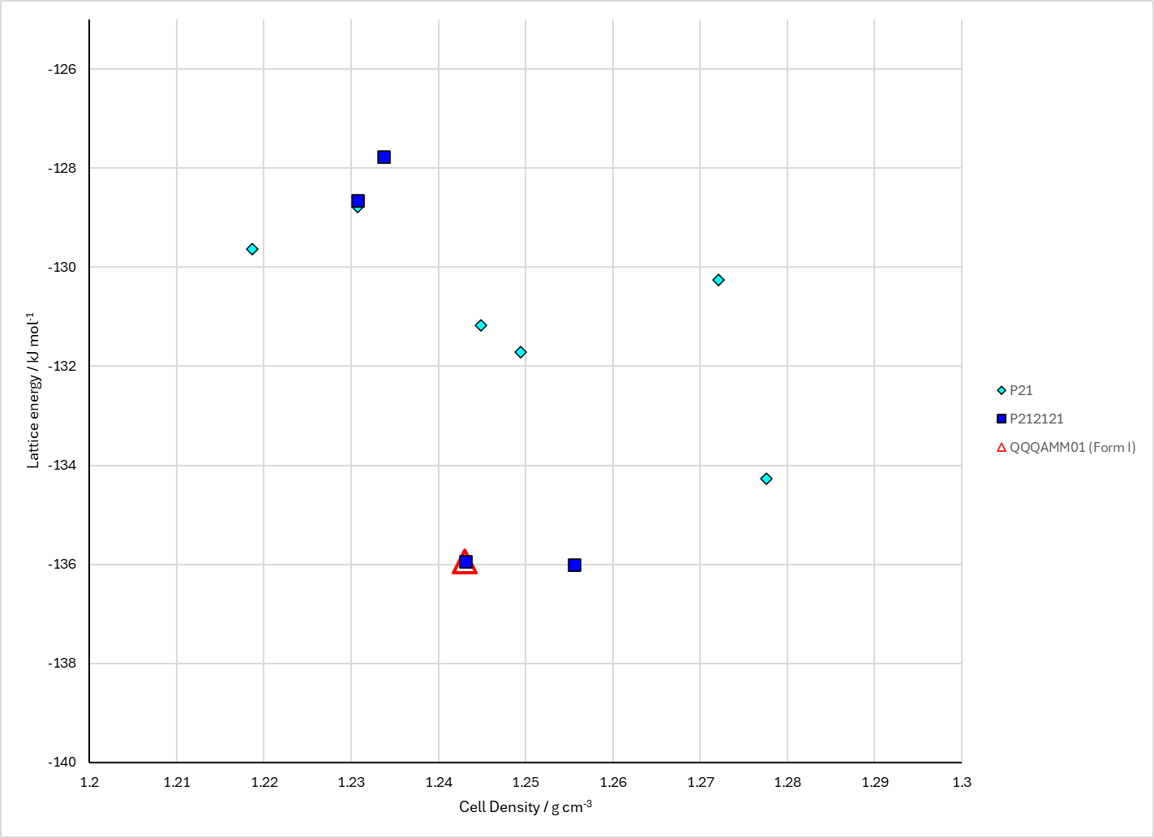
Figure 2. Crystal energy landscape of Equilinin from previous work.

CSD structures (CSD version 6.01 with Feb 2026 update)

Table 1. Crystallographic information for CSD entries for Equilinin. Different polymorphs are coloured differently.
REFCODE | space group | Z’ | a / Å | b / Å | c / Å | α / ° | β / ° | γ / ° | density / g cm⁻³ | Form
QQQAMM01 | P212121 | 1.0 | 7.27709 | 7.32686 | 25.5179 | 90.0 | 90.0 | 90.0 | 1.3002 | None

Table 2. Experimental information for CSD entries for Equilinin.
REFCODE | space group | R factor | T / K | Year | Comments
QQQAMM01 | P212121 | 2.92 | 100 K | 2017 | 10.1107/S2056989017010532

Make this table include whether polymorphs are solution-grown, sublimation grown, templated or otherwise. Add references.

Other notes

