Hydrochlorothiazide
(Last updated April 2026)
Figure 1. The molecular diagram of Hydrochlorothiazide.

CSP studies
REFCODE | HCSBTZ
Formula | C7 H8 N3 O4 Cl1 S2
Common Name | hydrochlorothiazide
IUPAC Systematic Name | 6-Chloro-7-sulfamyl-3,4-dihydro-1,2,4-benzothiadiazine 1,1-dioxide
Other Names | 6-Chloro-3,4-dihydro-2H-1,2,4-benzothiadiazine-7-sulfonamide 1,1-dioxide
CSD Refcodes | HCSBTZ08, HCSBTZ02
Search Identifier | A
Scientist | Sally Price
Date | pre-2010
Publication | No publication planned.
Energy model | 1
Study_ID | 0
Programs | MOLPAK, DMAREL (4.1.1)
Location on S Drive | \CHEMISTRY_CPOSS\0-EarlySearches\home\louise_price.eminerals\hydrochlorothiazide
Potential Description | MP2 6-31G(d,p) DMA + SONClfit.pots
Intramolecular Description | MP2 energy for SCF 6-31G(d,p) optimised
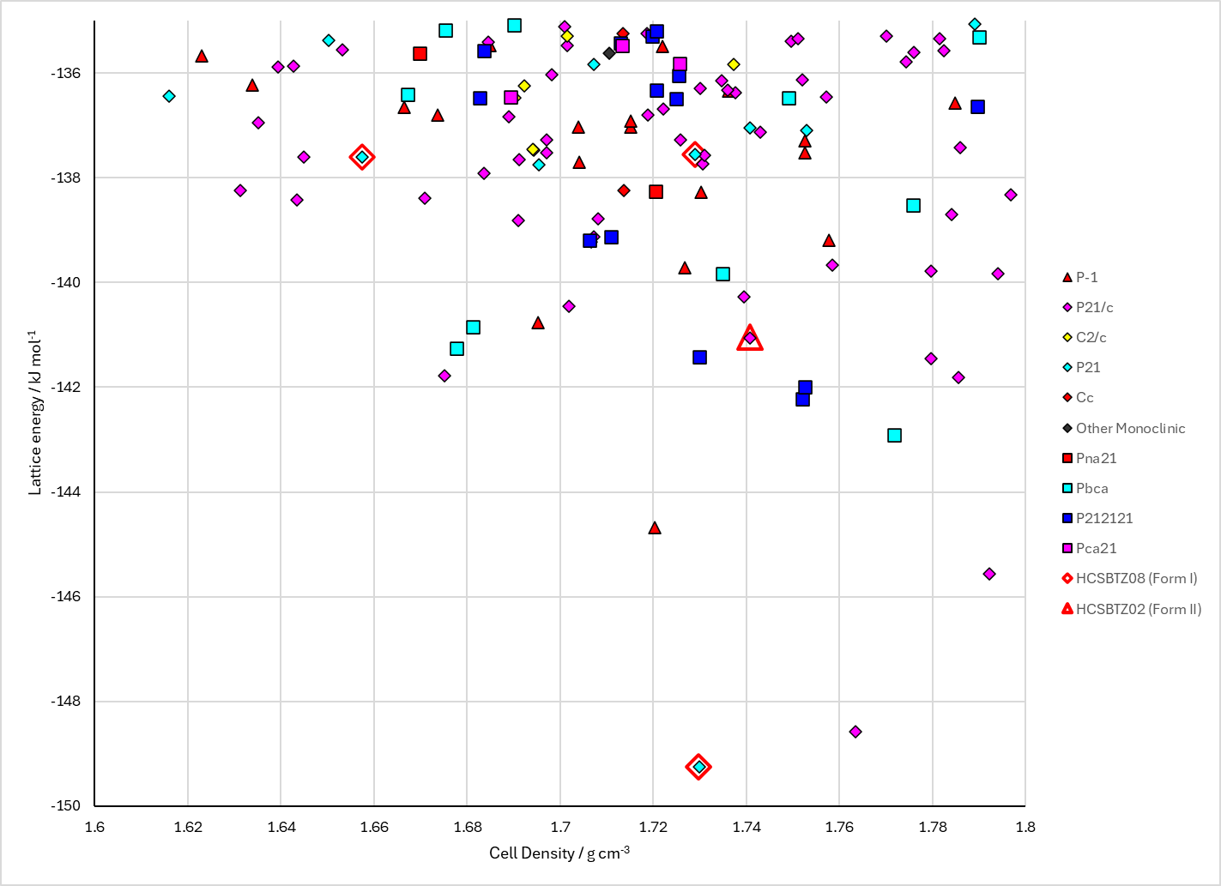
Figure 2. Crystal energy landscape of Hydrochlorothiazide from previous work.

CSD structures (CSD version 6.01 with Feb 2026 update)

Table 1. Crystallographic information for CSD entries for Hydrochlorothiazide. Different polymorphs are coloured differently.
REFCODE | space group | Z’ | a / Å | b / Å | c / Å | α / ° | β / ° | γ / ° | density / g cm⁻³ | Form
HCSBTZ | P21 | 1.0 | 7.41900 | 8.521 | 10.003 | 90.0 | 111.72 | 90.0 | 1.6831 | Form I
HCSBTZ01 | P21/c | 1.0 | 9.4884 | 8.33340 | 15.1309 | 90.0 | 113.20870 | 90.0 | 1.7985 | P21/c Form II
HCSBTZ02 | P21/c | 1.0 | 9.4855 | 8.3325 | 15.1201 | 90.0 | 113.24000 | 90.0 | 1.8009 | Form II
HCSBTZ03 | P21 | 1.0 | 7.34010 | 8.5077 | 9.9643 | 90.0 | 111.33200 | 90.0 | 1.7059 | Form I
HCSBTZ04 | P21/c | 1.0 | 9.4689 | 8.242 | 15.0636 | 90.0 | 113.062 | 90.0 | 1.8283 | Form II
HCSBTZ05 | P21 | 1.0 | 7.3822 | 8.459 | 9.958 | 90.0 | 111.70000 | 90.0 | 1.7114 | Form I
HCSBTZ06 | P21 | 1.0 | 7.39490 | 8.5096 | 10.0046 | 90.0 | 111.622 | 90.0 | 1.6895 | Form IA
HCSBTZ07 | P21 | 1.0 | 7.3322 | 8.5031 | 9.9529 | 90.0 | 111.282 | 90.0 | 1.7101 | Form I
HCSBTZ08 | P21 | 1.0 | 7.33230 | 8.5031 | 9.952 | 90.0 | 111.281 | 90.0 | 1.7102 | Form I
HCSBTZ09 | P21 | 1.0 | 7.3288 | 8.50320 | 9.94670 | 90.0 | 111.29 | 90.0 | 1.7120 | Form I
HCSBTZ10 | P21 | 1.0 | 7.3856 | 8.5021 | 9.99580 | 90.0 | 111.607 | 90.0 | 0.0 | Form I

Table 2. Experimental information for CSD entries for Hydrochlorothiazide.
REFCODE | space group | R factor | T / K | Year | Comments
HCSBTZ | P21 | 6.600 | None | 1972 | 10.1107/S0567740872006090
HCSBTZ01 | P21/c | 1.3 | at 298 K | 2005 | powder, 10.1107/S1600536805023640
HCSBTZ02 | P21/c | 1.660 | at 295 K | 2008 | neutron, powder, 10.1107/S010876810705687X
HCSBTZ03 | P21 | 3.52 | at 123 K | 2008 | 10.1107/S010876810705687X
HCSBTZ04 | P21/c | 2.98 | at 123 K | 2008 | 10.1107/S010876810705687X
HCSBTZ05 | P21 | 3.070 | 200 K | 2016 | 10.3109/10837450.2015.1041040
HCSBTZ06 | P21 | 3.85 | 296 K | 2016 | 10.3109/10837450.2015.1041040
HCSBTZ07 | P21 | 3.91 | 100 K | 2019 | neutron, 10.1002/anie.201905085
HCSBTZ08 | P21 | 2.139 | 100.0 K | 2019 | 10.1002/anie.201905085
HCSBTZ09 | P21 | 3.2 | 100 K | 2021 | 10.1107/S2052520621009914
HCSBTZ10 | P21 | 4.36 | 270 K | 2016 | 10.3109/10837450.2015.1041040

Make this table include whether polymorphs are solution-grown, sublimation grown, templated or otherwise. Add references.

Other notes

