[amino-[(Z)-2-carboxyvinyl]sulfanyl-methylene]ammonium chloride monohydrate (Blind Test XXIV)
(Last updated February 2026)
Figure 1. The molecular diagram of [amino-[(Z)-2-carboxyvinyl]sulfanyl-methylene]ammonium chloride monohydrate.

CSP studies
REFCODE | XAFQON
Formula | C4 H7 N2 O2 S1+ . Cl- . H2 O
Common Name
IUPAC Systematic Name | [amino-[(Z)-2-carboxyvinyl]sulfanyl-methylene]ammonium chloride monohydrate
Other Names | Blind Test XXIV
CSD Refcodes | XAFQON
Search Identifier | A
Scientist | Rui Guo
Date | 2015
Publication | Reilly, AM et al, Acta Cryst. B, (2016) 72, 439-459
Energy model | 7 (published List 2)
Study_ID | 33
Programs | Study_ID=12, DMACRYS (2.0.8)
Location on S Drive | \CHEMISTRY_CPOSS\BlindTest2015\XAFQON\PCM11_Will
Potential Description | GDMA2.2(PCMdielectric11(PBE1PBE/6-31G(d,p))) + Will + Day chloride ion + Halgren sulfur potential
Intramolecular Description | PBE1PBE/6-31G(d,p)
Energy model | 2 (published List 1)
Study_ID | 10
Programs | Study_ID=11, CrystalOptimizer, DMACRYS (2.0.8)
Location on S Drive | \CHEMISTRY_CPOSS\BlindTest2015\XAFQON\CrystOpt_FIT_chloride
Potential Description | CrystalOptimizer with GDMA2.2(PBE1PBE/6-31G(d,p)) + FIT + Day chloride ion potential
Intramolecular Description | PBE1PBE/6-31G(d,p)
Energy model | 6
Study_ID | 30
Programs | Study_ID=10, DMACRYS (2.0.8)
Location on S Drive | \CHEMISTRY_CPOSS\BlindTest2015\XAFQON\PCM11_FIT_chloride
Potential Description | GDMA2.2(PCMdielectric11(PBE1PBE/6-31G(d,p))) + FIT + Day chloride potential
Intramolecular Description | PBE1PBE/6-31G(d,p)
Energy model | 5
Study_ID | 32
Programs | Study_ID=11, DMACRYS (2.0.8)
Location on S Drive | \CHEMISTRY_CPOSS\BlindTest2015\XAFQON\PCM11_FIT
Potential Description | GDMA2.2(PCMdielectric11(PBE1PBE/6-31G(d,p))) + FIT
Intramolecular Description | PBE1PBE/6-31G(d,p)
Energy model | 4
Study_ID | 31
Programs | Study_ID=11, DMACRYS (2.0.8)
Location on S Drive | \CHEMISTRY_CPOSS\BlindTest2015\XAFQON\PCM3_FIT
Potential Description | GDMA2.2(PCMdielectric3(PBE1PBE/6-31G(d,p))) + FIT
Intramolecular Description | PBE1PBE/6-31G(d,p)
Energy model | 3
Study_ID | 12
Programs | Study_ID=11, CrystalOptimizer, DMACRYS (2.0.8)
Location on S Drive | \CHEMISTRY_CPOSS\BlindTest2015\XAFQON\CrystOpt_Will
Potential Description | CrystalOptimizer with GDMA2.2(PBE1PBE/6-31G(d,p)) + Will + Day chloride ion + Halgren sulfur potential
Intramolecular Description | PBE1PBE/6-31G(d,p)
Energy model | 1
Study_ID | 11
Programs | Flexible CrystalPredictor (1.8), CrystalOptimizer, DMACRYS (2.0.8)
Location on S Drive | \CHEMISTRY_CPOSS\BlindTest2015\XAFQON\CrystOpt_FIT
Potential Description | CrystalOptimizer with GDMA2.2(PBE1PBE/6-31G(d,p)) + FIT
Intramolecular Description | PBE1PBE/6-31G(d,p)

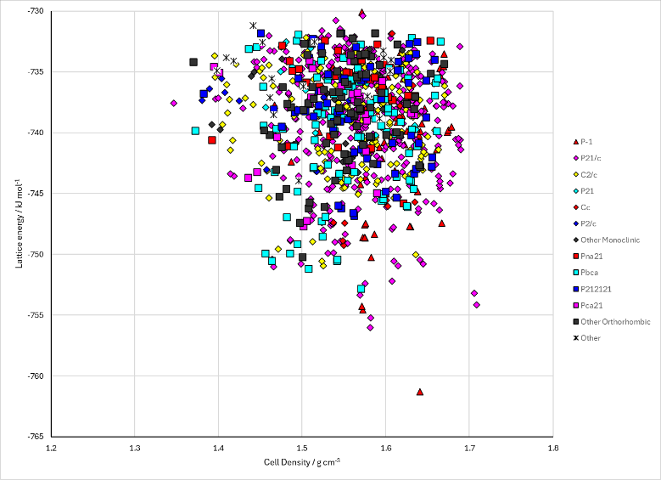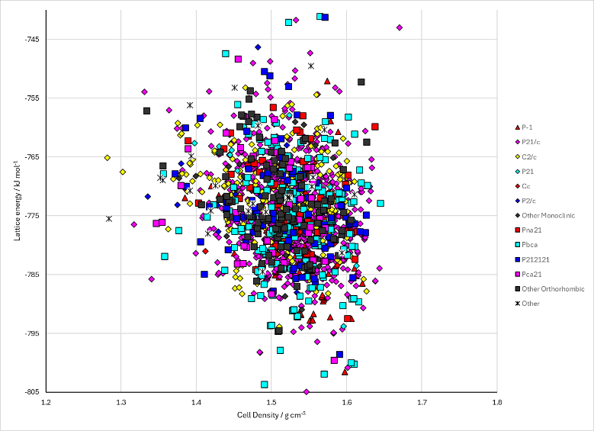
Figure 2. Crystal energy landscape of [amino-[(Z)-2-carboxyvinyl]sulfanyl-methylene]ammonium chloride monohydrate from previous work. Left: CrystOpt with FIT potential and Day chloride ion (Energy Model 2). Right: Single point PCM model with Williams potential (Energy Model 7).

CSD structures (CSD version 6.01)

Table 1. Crystallographic information for CSD entries for [amino-[(Z)-2-carboxyvinyl]sulfanyl-methylene]ammonium chloride monohydrate. Different polymorphs are coloured differently.
REFCODE | space group | Z’ | a / Å | b / Å | c / Å | α / ° | β / ° | γ / ° | density / g cm⁻³ | Form
XAFQON | P21/c | 1.0 | 3.9906 | 21.2366 | 10.1014 | 90.0 | 97.8331 | 90.0 | 1.5714 | None

Table 2. Experimental information for CSD entries for [amino-[(Z)-2-carboxyvinyl]sulfanyl-methylene]ammonium chloride monohydrate.
REFCODE | space group | R factor | T / K | Year | Comments
XAFQON | P21/c | 2.45 | 240 K | 2016 | Private Communication

Make this table include whether polymorphs are solution-grown, sublimation grown, templated or otherwise. Add references.

Other notes
The SI of the paper on the sixth Blind Test makes mention of Regions A, B and C. However, the structure names for the submitted structures don’t agree with these names. Structures without a prefix correspond the Region A. Those with the prefix “i” correspond to Region B (with an intramolecular bond), but virtually all transformed conformation to Region A. Structures with the prefix “C” correspond to Region C, but Region C is like Region B and the main torsion angle transformed to be like Region A but the alternative COOH configuration was unchanged.

