2-Halobenzamides
(Last updated December 2025)
Figure 1. The molecular diagrams of the 2-halobenzamides.

CSP studies
REFCODE | BIGSUF
Formula | C7 H6 N1 O1 F1
Common Name | 2-Fluorobenzamide
IUPAC Systematic Name | 2-Fluorobenzamide
Other Names | 2-Fluorobenzamide
CSD Refcodes | BIGSUF01
Search Identifier | A
Scientist | Anastasia Ntantou
Date | pre-2010
Publication | Masters thesis
Energy model | 1
Study_ID | 0
Programs | MOLPAK, DMAREL (4.1.1)
Location on S Drive | CHEMISTRY_CPOSS\0-EarlySearches\home\louise_price.eminerals\2-fluorobenzamide\opt
Potential Description | DMA + FIT
Intramolecular Description | MP2/6-31G(d,p)
Search Identifier | B
Scientist | Anastasia Ntantou
Date | pre-2010
Publication | Masters thesis
Energy model | 1
Study_ID | 1
Programs | MOLPAK, DMAREL (4.1.1)
Location on S Drive | CHEMISTRY_CPOSS\0-EarlySearches\home\louise_price.eminerals\2-fluorobenzamide\con_opt
Potential Description | DMA + FIT
Intramolecular Description | MP2/6-31G(d,p)
REFCODE | CLBZAM
Formula | C7 H6 N1 O1 Cl1
Common Name | 2-Chlorobenzamide
IUPAC Systematic Name | 2-Chlorobenzamide
Other Names | 2-Chlorobenzamide
CSD Refcodes | CLBZAM12, CLBZAM11, CLBZAM13
Search Identifier | A
Scientist | Louise Price
Date | 2011
Publication | Cockcroft JK; Buanz ABM; Ntantou A; Price LS; Tocher DA; Vickers M; Lancaster RW, Crystal Growth & Design 2016, 16(11), 6144-6147
Energy model | 1
Study_ID | 10
Programs | Flexible CrystalPredictor (1.x), CrystalOptimizer (x), DMACRYS (2.0.4)
Location on S Drive | \CHEMISTRY_CPOSS\2-chlorobenzamide_CPCO
Potential Description | CrystalOptimizer, GDMA2.2 (MP2/6-31G(d,p)) multipoles, MP2/6-31G(d,p) intra, FIT
Intramolecular Description | MP2/6-31G(d,p)
Search Identifier | B
Scientist | Anastasia Ntantou
Date | pre-2010
Publication | Masters thesis only
Energy model | 1
Study_ID | 0
Programs | MOLPAK, DMAREL (4.1.1)
Location on S Drive | \CHEMISTRY_CPOSS\0-EarlySearches\home\louise_price.eminerals\2-chlorobenzamide
Potential Description | DMA + FIT + CL (DAY & PRICE 2003)
Intramolecular Description | MP2/6-31G(d,p)
Search Identifier | C
Scientist | Bob Lancaster
Date | pre-2010
Publication | No publication planned
Energy model | 1
Study_ID | 2
Programs | MOLPAK, DMACRYS (1.1.1)
Location on S Drive | \CHEMISTRY_CPOSS\0-EarlySearches\home\louise_price.eminerals\2-chlorobenzamide_BOB
Potential Description | DMA + FIT
Intramolecular Description | MP2/6-31G(d,p)
REFCODE | BRBZAO
Formula | C7 H6 N1 O1 Br1
Common Name | o-bromobenzamide
IUPAC Systematic Name | 2-bromobenzamide
Other Names | 2-bromobenzamide
CSD Refcodes | BRBZAO01
Search Identifier | A
Scientist | Anastasia Ntantou
Date | pre-2010
Publication | Masters thesis
Energy model | 1
Study_ID | 0
Programs | MOLPAK, DMAREL (4.1.1)
Location on S Drive | \CHEMISTRY_CPOSS\0-EarlySearches\home\louise_price.eminerals\2-bromobenzamide
Potential Description | DMA + FIT + isotropic BR from blind test
Intramolecular Description | MP2/6-31G(d,p)

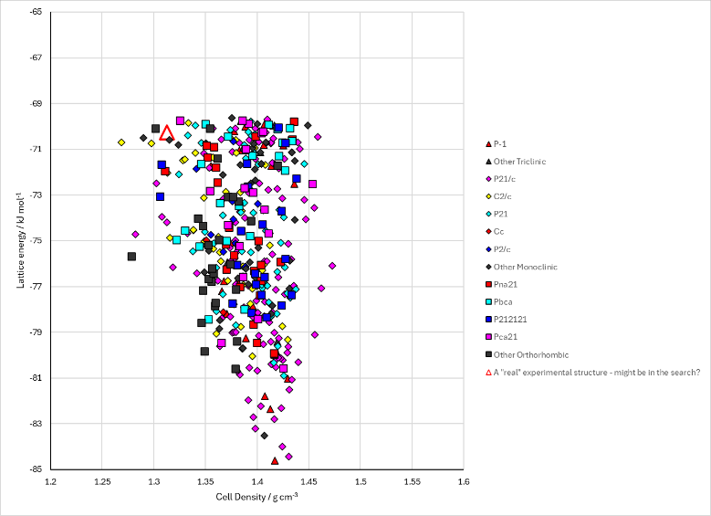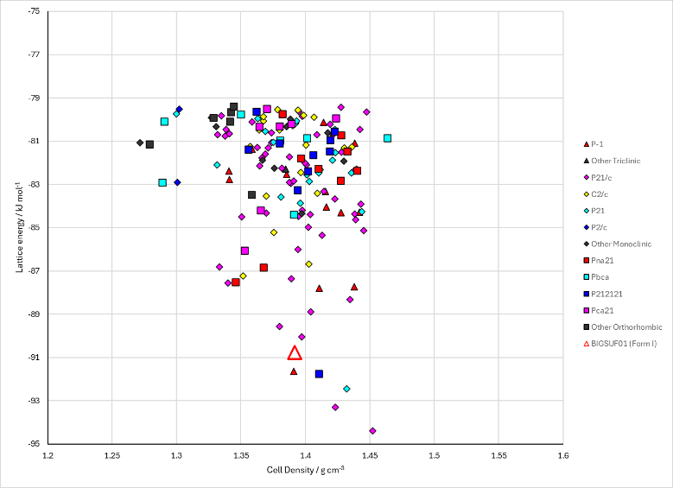
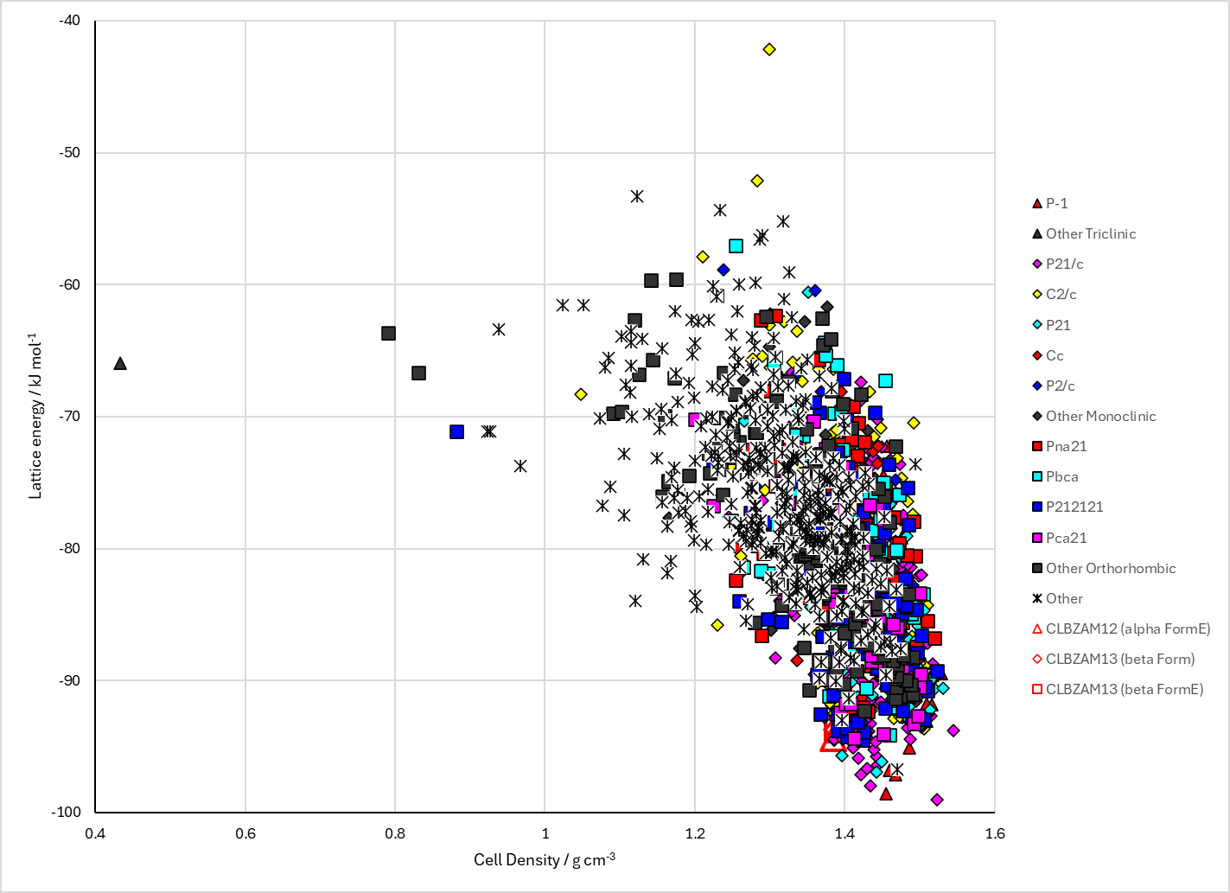
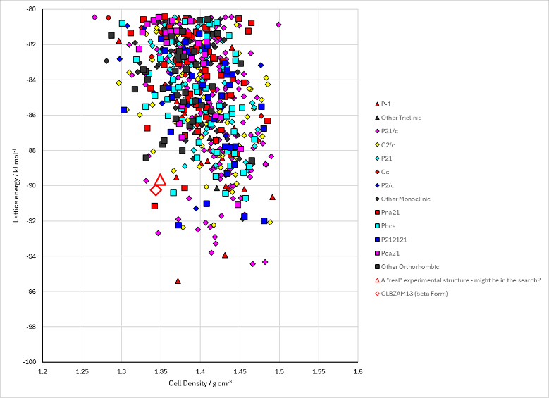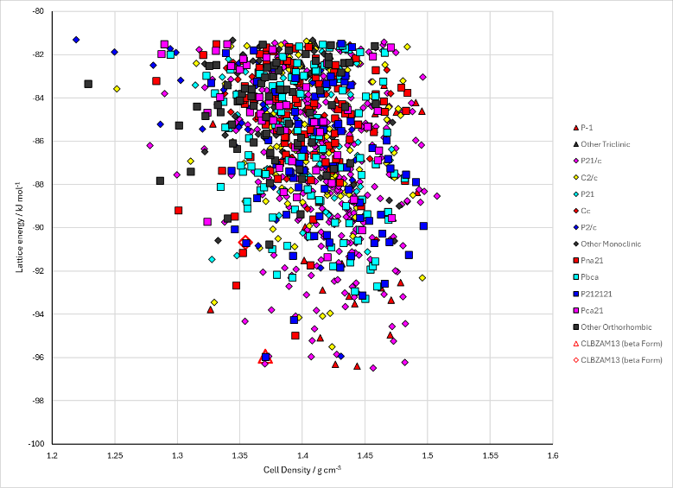
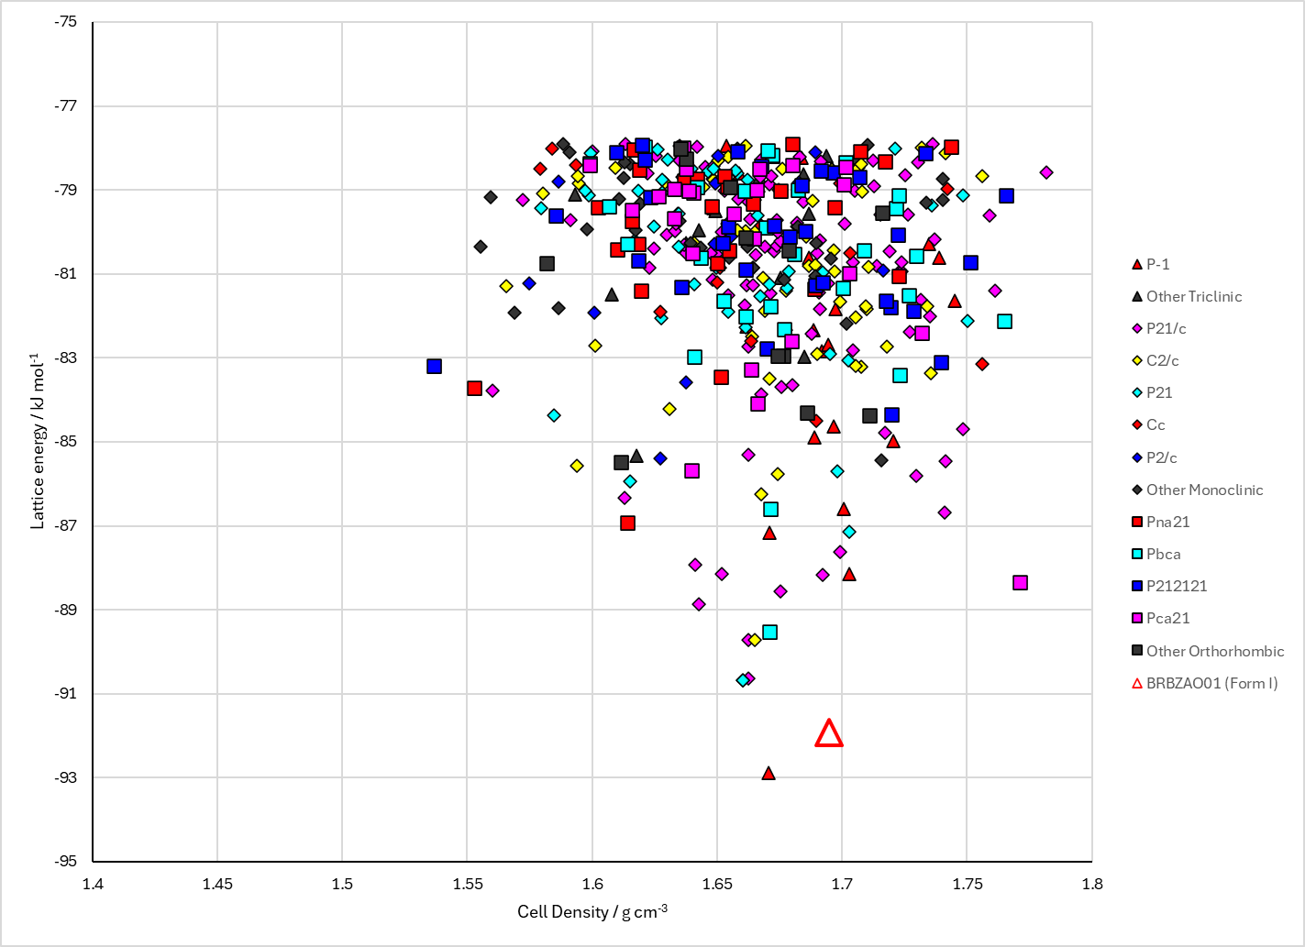
Figure 2. Crystal energy landscape of the 2-halobenzamides from previous work. 1st box: Fluorobenzamide. Left: from Study_ID=1. Right: from Study_ID=1. 2nd box: Chlorobenzamide. Top: from Study_ID=10. Bottom left: from Study_ID=0. Bottom right: from Study_ID=2. 3rd box: Bromobenzamide, Study_ID=0.

CSD structures (CSD version 6.01)
Table 1. Crystallographic information for CSD entries for 2-halobenzamides. Different polymorphs are coloured differently.
REFCODE | space group | Z’ | a / Å | b / Å | c / Å | α / ° | β / ° | γ / ° | density / g cm⁻³ | Form
BIGSUF | P21/a | 2.0 | 12.695 | 20.534 | 5.133 | 90.0 | 97.8 | 90.0 | 1.3941 | None
BIGSUF01 | P21/c | 2 | 5.126(<1) | 20.368(1) | 12.322(1) | 90 | 96.69(<1) | 90 | 1.447 | None
CLBZAM10 | P21/n | 1.0 | 14.127 | 10.683 | 5.051 | 90.0 | 90.2 | 90.0 | 1.3556 | alpha form
CLBZAM11 | P212121 | 1.0 | 14.0300 | 10.599 | 5.064 | 90.0 | 90.0 | 90.0 | 1.3723 | beta form
CLBZAM12 | P21/n | 1.0 | 5.05934 | 10.3235 | 14.2631 | 90.0 | 92.187 | 90.0 | 1.3881 | alpha form
CLBZAM13 | P212121 | 1.0 | 5.06073 | 10.3791 | 13.9351 | 90.0 | 90.0 | 90.0 | 1.4118 | beta form
BRBZAO | P21/a | 1.0 | 13.92 | 11.43 | 5.02000 | 90.0 | 107.0 | 90.0 | 1.7394 | None
BRBZAO01 | P21/n | 1.0 | 5.0263 | 10.9683 | 13.3113 | 90.0 | 93.465 | 90.0 | 1.8138 | None
BRBZAO02 | P21/n | 1.o | 5.024(<1) | 11.402(1) | 13.313(1) | 90 | 93.76(<1) | 90 | 1.746 | None

CLBZAM11 and CLBZAM13 are notionally the same form. However Louise can’t overlay them in Mercury and they have different structure matches. The are possibly enantiomers (needs more investigation, which I don’t have time for!).
Two other polymorphs of 2-chlorobenzamide are reported, CLBZAM02 gamma and CLBZMA03 delta. Neither have space groups or full structures.
Table 2. Experimental information for CSD entries for XXX.
REFCODE | space group | R factor | T / K | Year | Comments
BIGSUF | P21/a | 7.60 | None | 1982 | 10.1246/bcsj.55.1643
BIGSUF01 | P21/c | 4.39 | 100 | 2024 | 10.1021/acs.cgd.4c00517
CLBZAM10 | P21/n | 9.700 | None | 1974 | 10.1107/S0567740874007801
CLBZAM11 | P212121 | 6.5 | None | 1974 | 10.1107/S0567740874007801
CLBZAM12 | P21/n | 3.0 | 150 K | 2016 | 10.1021/acs.cgd.6b00973
CLBZAM13 | P212121 | 2.2 | 150 K | 2016 | 10.1021/acs.cgd.6b00973
BRBZAO | P21/a | 16.0 | None | 1972 | None
BRBZAO01 | P21/n | 1.97 | 100 K | 2015 | 10.1039/C5CY00627A
BRBZAO02 | p21/N | 2.69 | 296 k | 2021 | 10.1021/acs.cgd.0c01119

Make this table include whether polymorphs are solution-grown, sublimation grown, templated or otherwise. Add references.

Other notes
There was no .pot file for CLBZAM Study_ID = 10. The pote.dat files were compared for Bob’s search and Louise’s search, and differed only in the H_F2 ClF1 cross term.
Bob’s search
BUCK |  | H_F2 |  | H_F2 |  | 52.12899 |  | 0.214592 |  | 0.222819 |  | 0 |  | 70
BUCK |  | ClF1 |  | ClF1 |  | 9583.58 |  | 0.2849 |  | 80.22445 |  | 0 |  | 70
BUCK |  | ClF1 |  | H_F2 |  | 446.9519 |  | 0.214592 |  | 2.373693 |  | 0 |  | 70
Louise’s search
BUCK |  | H_F2 |  | H_F2 |  | 52.12899 |  | 0.214592 |  | 0.222819 |  | 0 |  | 70
BUCK |  | ClF1 |  | ClF1 |  | 9583.58 |  | 0.2849 |  | 80.22445 |  | 0 |  | 70
BUCK |  | ClF1 |  | H_F2 |  | 706.8114 |  | 0.244798 |  | 4.227947 |  | 0 |  | 70
Anastasia’s search
BUCK | HP |  | CODA |  | HP |  | CODA | 52.12899 | 0.214592 |  | 0.222819 |  | 0 |  | 70
BUCK | CL |  | CODA |  | CL |  | CODA | 5905.001 | 0.299159 |  | 86.7168 |  | 0 |  | 70
BUCK | CL |  | CODA |  | HP |  | CODA | 554.8123 | 0.256857 |  | 4.395825 |  | 0 |  | 70
Cross potential from crosspot
BUCK |  | H_F2 |  | ClF1 |  | 706.8114 |  | 0.244798 |  | 4.227947 |  | 0 |  | 70
Anastasia’s cross potential from crosspot
BUCK |  | H_F2 |  | ClF1 |  | 554.8168 |  | 0.249915 |  | 4.395697 |  | 0 |  | 70

The chlorine potential was different in the case of Anastasia’s search. The cross term was consistent (within rounding errors in Excel). The cross potential used by Bob’s search was wrong.

