ChloroDibenzosuberenonePiperidine
(Last updated April 2026)
Figure 1. The molecular diagram of ChloroDibenzosuberenonePiperidine.

CSP studies
REFCODE | GSKNCH
Formula | C21 H20 N1 Cl1
Common Name | Chloro-Dibenzosuberenone Piperidine Derivative
IUPAC Systematic Name | 4-(3-Chloro-dibenzo[a,d]cyclohepten-5-ylidene)-1-methyl-piperidine
Other Names | (SKF-35639/X4309)
CSD Refcodes
Search Identifier | A
Scientist | Not sure
Date | pre-2010
Publication | No publication planned.
Energy model | 1
Study_ID | 0
Programs | MOLPAK, DMAREL (4.1.1)
Location on S Drive | \CHEMISTRY_CPOSS\0-EarlySearches\home\louise_price.eminerals\chlorodibenzosuberone
Potential Description | MP2 6-31G(d,p) DMA + fit.pots (Williams old N,C,H,Cl)
Intramolecular Description | MP2 energy for SCF 6-31G(d,p) optimised

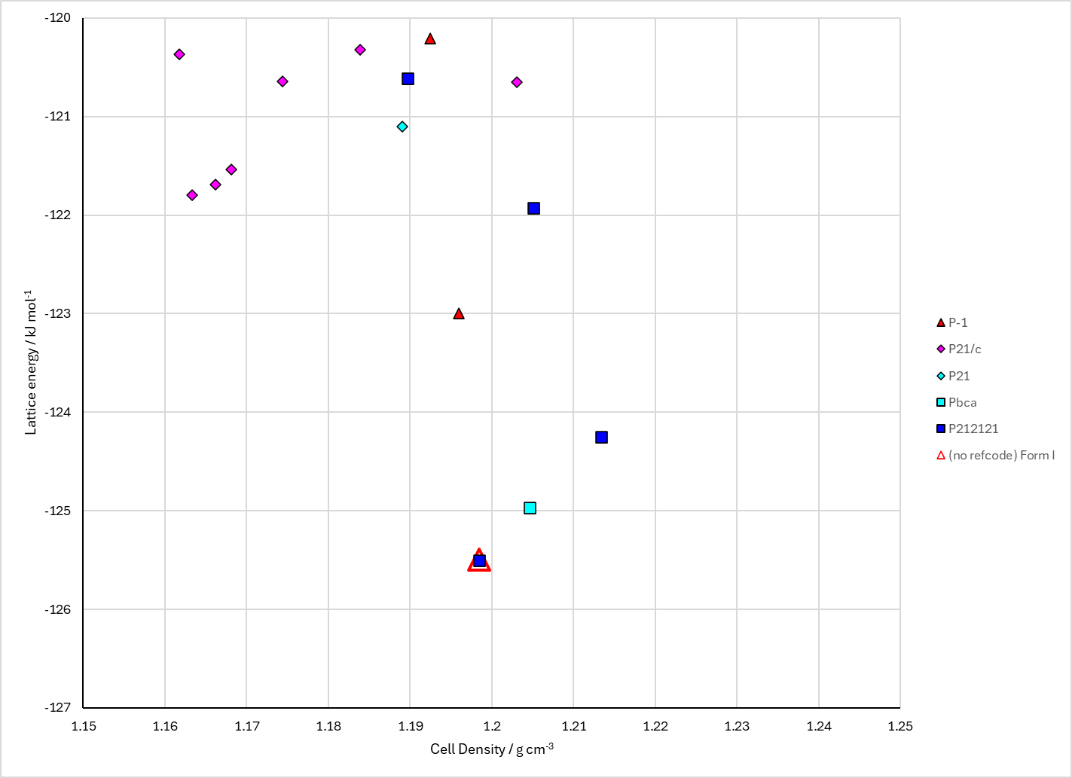
Figure 2. Crystal energy landscape of ChloroDibenzosuberenonePiperidine from previous work.

CSD structures (CSD version 6.01 with Feb 2026 update)
We have got this recorded as having one experimental form, yet it is not on the CSD.
Table 1. Crystallographic information for CSD entries for ChloroDibenzosuberenonePiperidine. Different polymorphs are coloured differently.
REFCODE | space group | Z’ | a / Å | b / Å | c / Å | α / ° | β / ° | γ / ° | density / g cm⁻³ | Form

Table 2. Experimental information for CSD entries for ChloroDibenzosuberenonePiperidine.
REFCODE | space group | R factor | T / K | Year | Comments

Make this table include whether polymorphs are solution-grown, sublimation grown, templated or otherwise. Add references.

Other notes

