Dibenzosuberenone
(Last updated April 2026)
Figure 1. The molecular diagram of Dibenzosuberenone.

CSP studies
REFCODE | DBTROP
Formula | C15 H10 O1
Common Name | Dibenzosuberenone
IUPAC Systematic Name | Dibenzo[a,d]cyclohepten-5-one
Other Names | GR157788X/X4302
CSD Refcodes | DBTROP02
Search Identifier | A
Scientist | Not sure
Date | pre-2010
Publication | No publication planned.
Energy model | 1
Study_ID | 0
Programs | MOLPAK, DMAREL (4.1.1)
Location on S Drive | \CHEMISTRY_CPOSS\0-EarlySearches\home\louise_price.eminerals\dibenzosuberenone
Potential Description | MP2 6-31G(d,p) DMA + fit.pots (Williams old O,C,H)
Intramolecular Description | MP2 energy for SCF 6-31G(d,p) optimised

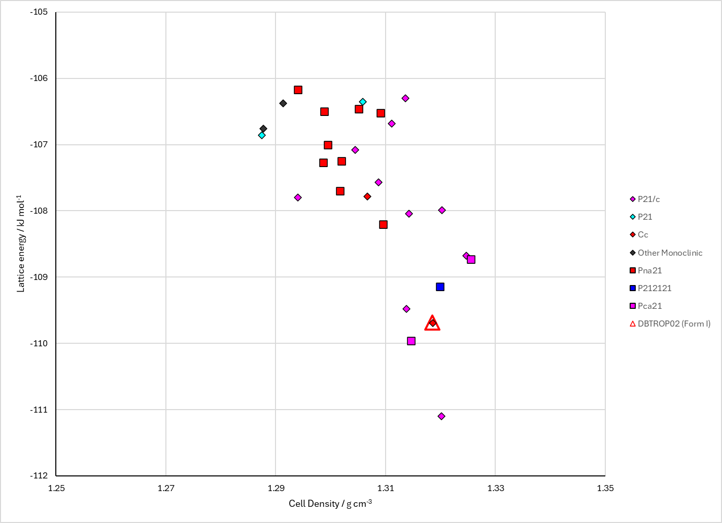
Figure 2. Crystal energy landscape of Dibenzosuberenone from previous work.

CSD structures (CSD version 6.01 with Feb 2026 update)

Table 1. Crystallographic information for CSD entries for Dibenzosuberenone. Different polymorphs are coloured differently.
REFCODE | space group | Z’ | a / Å | b / Å | c / Å | α / ° | β / ° | γ / ° | density / g cm⁻³ | Form
DBTROP02 | Cc | 1.0 | 24.924 | 3.93 | 14.429 | 90.0 | 133.49 | 90.0 | 1.3359 | None

Table 2. Experimental information for CSD entries for Dibenzosuberenone.
REFCODE | space group | R factor | T / K | Year | Comments
DBTROP02 | Cc | 4.5 | at 293 K | 1984 | 10.1107/S010827018400473X

Make this table include whether polymorphs are solution-grown, sublimation grown, templated or otherwise. Add references.

Other notes

