Bipyridine 4-aminobenzoic acid 1-1 cocrystal
(Last updated April 2026)
Figure 1. The molecular diagram of bipyridine and 4-aminobenzoic acid.

CSP studies
REFCODE | UCLPKA
Formula | C7 H7 N1 O2 - C8 H7 N1 O4
Common Name | 4-aminobenzoic acid - 2,2'-bipyridyl
IUPAC Systematic Name | 4-aminobenzoic acid - 2,2'-bipyridyl
Other Names
CSD Refcodes
Search Identifier | A
Scientist | Nizar Issa / Panos Karamertzanis
Date | 2009
Publication | See Study_ID=12
Energy model | 2
Study_ID | 12
Programs | Flexible CrystalPredictor (1), DMAflex-Q, DMAflex (single iteration), DMACRYS (1.1.0)
Location on S Drive | \CHEMISTRY_CPOSS\0-EarlySearches\home\louise_price.eminerals\aminobenzoic_acid-bipyridyl1-1_will_sp
Potential Description | DMAflex DMA + Williams
Intramolecular Description | SCF
Energy model | 1
Study_ID | 11
Programs | Study_ID=11, DMAflex, DMACRYS (1.1.0)
Location on S Drive | \CHEMISTRY_CPOSS\0-EarlySearches\home\louise_price.eminerals\aminobenzoic_acid-bipyridyl1-1_will_full
Potential Description | Single point DMAflex DMA + Williams
Intramolecular Description | SCF
Energy model | 3
Study_ID | 10
Programs | Study_ID=11 or 12 (not sure), DMAREL (4.3.6)
Location on S Drive | \CHEMISTRY_CPOSS\0-EarlySearches\home\louise_price.eminerals\aminobenzoic_acid-bipyridyl1-1_fit
Potential Description | DMAflex DMA + FIT
Intramolecular Description | SCF

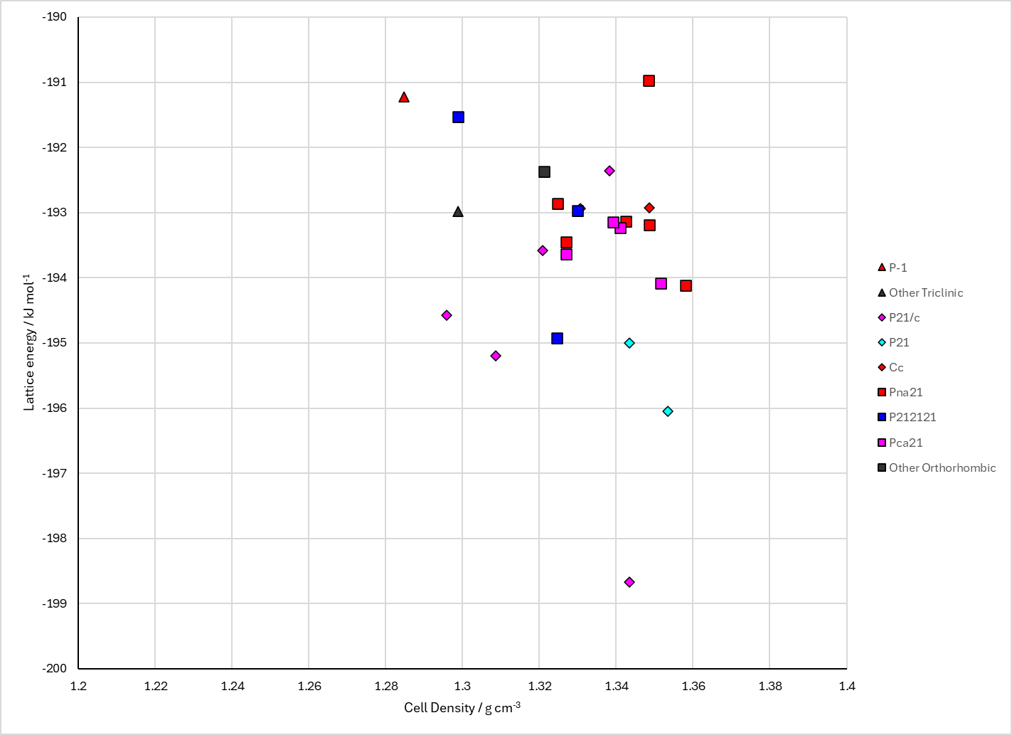
Figure 2. Crystal energy landscape of the bipyridine and 4-aminobenzoic acid 1-1 cocrystal from previous work.

CSD structures (CSD version 6.01 with Feb 2026 update)

Table 1. Crystallographic information for CSD entries for the bipyridine and 4-aminobenzoic acid 1-1 cocrystal. Different polymorphs are coloured differently.
REFCODE | space group | Z’ | a / Å | b / Å | c / Å | α / ° | β / ° | γ / ° | density / g cm⁻³ | Form

Table 2. Experimental information for CSD entries for the bipyridine and 4-aminobenzoic acid 1-1 cocrystal.
REFCODE | space group | R factor | T / K | Year | Comments

Make this table include whether polymorphs are solution-grown, sublimation grown, templated or otherwise. Add references.

Other notes

