Bipyridine 4-aminobenzoic acid 1-2 cocrystal
(Last updated April 2026)

Figure 1. The molecular diagram of the bipyridine and 4-aminobenzoic acid 1-2 cocrystal.

CSP studies
REFCODE | DAQYUQ
Formula | (C7 H7 N1 O2)2 - C8 H7 N1 O4
Common Name | 2 molecules of 4-aminobenzoic acid - 1 molecule of 2,2'-bipyridyl
IUPAC Systematic Name | 2 molecules of 4-aminobenzoic acid - 1 molecule of 2,2'-bipyridyl
Other Names
CSD Refcodes | DAQYUQ
Search Identifier | A
Scientist | Nizar Issa / Panos Karamertzanis
Date | 2009
Publication | Karamertzanis PG, Kazantsev AV, Issa N, Welch GWA, Adjiman CS, Pantelides CC, Price SL 2009. J Chem Theory Comput 5, 1432-1448.
Energy model | 2
Study_ID | 12
Programs | Study_ID=11, DMAflex, DMACRYS (1.1.0)
Location on S Drive | \CHEMISTRY_CPOSS\0-EarlySearches\home\louise_price.eminerals\aminobenzoic_acid-bipyridyl2-1_will_full
Potential Description | DMAflex DMA + Williams
Intramolecular Description | SCF
Energy model | 1
Study_ID | 11
Programs | Flexible CrystalPredictor (1), DMAflex-Q, DMAflex (single iteration), DMACRYS (1.1.0)
Location on S Drive | \CHEMISTRY_CPOSS\0-EarlySearches\home\louise_price.eminerals\aminobenzoic_acid-bipyridyl2-1_will_sp
Potential Description | Single point DMAflex DMA + Williams
Intramolecular Description | SCF
Energy model | 3
Study_ID | 10
Programs | Study_ID=11 or 12 (not sure), DMAREL (4.3.6)
Location on S Drive | \CHEMISTRY_CPOSS\0-EarlySearches\home\louise_price.eminerals\aminobenzoic_acid-bipyridyl2-1_fit
Potential Description | DMAflex DMA + FIT
Intramolecular Description | SCF

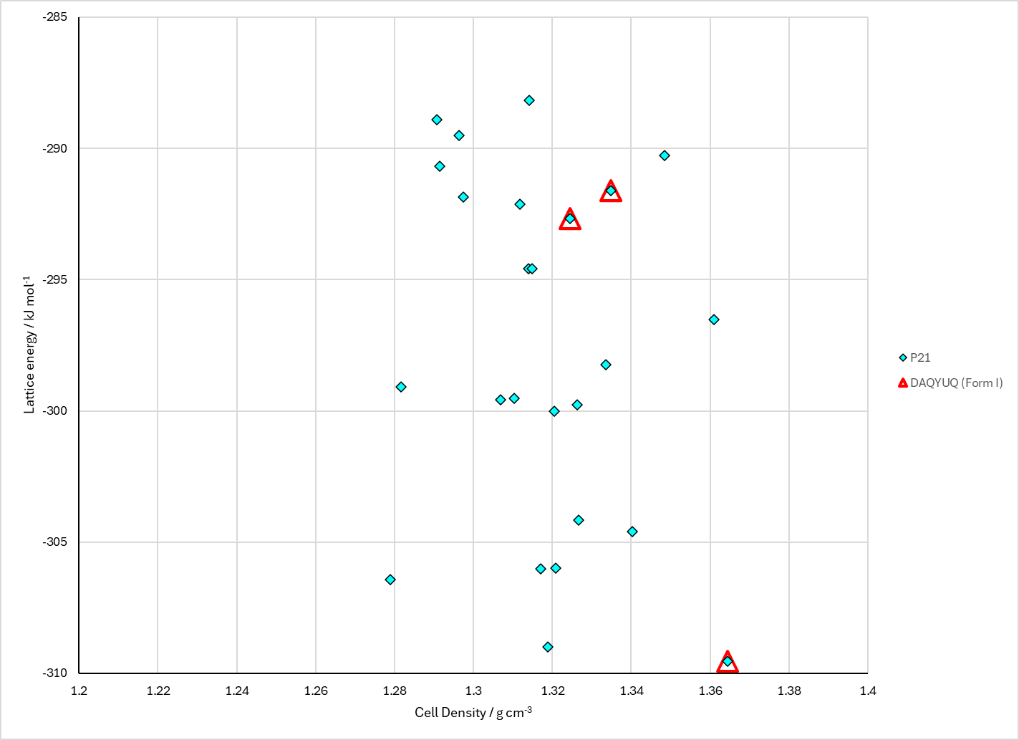
Figure 2. Crystal energy landscape of the bipyridine and 4-aminobenzoic acid 1-2 cocrystal from previous work.

CSD structures (CSD version 6.01 with Feb 2026 update)

Table 1. Crystallographic information for CSD entries for the bipyridine and 4-aminobenzoic acid 1-2 cocrystal. Different polymorphs are coloured differently.
REFCODE | space group | Z’ | a / Å | b / Å | c / Å | α / ° | β / ° | γ / ° | density / g cm⁻³ | Form
DAQYUQ | P21/c | 1.0 | 15.8195 | 4.3087 | 16.466 | 90.0 | 107.173 | 90.0 | 1.8168 | None

Table 2. Experimental information for CSD entries for the bipyridine and 4-aminobenzoic acid 1-2 cocrystal.
REFCODE | space group | R factor | T / K | Year | Comments
DAQYUQ | P21/c | 5.73 | at 298 K | 2005 | 10.1021/cg0497391

Make this table include whether polymorphs are solution-grown, sublimation grown, templated or otherwise. Add references.

Other notes

