1,4-dicyanobenzene Succinic Acid Cocrystal
(Last updated April 2026)
Figure 1. The molecular diagram of Dicyanobenzene and Succinic Acid.

CSP studies
REFCODE | UCLNIB
Formula | C6 N2 H4 - C4 O4 H6
Common Name | 1,4-Dicyanobenzene - Succinic Acid cocrystal
IUPAC Systematic Name | 1,4-Dicyanobenzene - Butan-1,4-dioic acid
Other Names
CSD Refcodes
Search Identifier | A
Scientist | Nizar Issa / Panos Karamertzanis
Date | 2012
Publication | Issa N, Barnett SA, Mohamed S, Braun DE, Copley RCB, Tocher DA, Price SL 2012. CrystEngComm 14, 2454-2464.
Energy model | 2
Study_ID | 10
Programs | Study_ID=20, CrystalOptimizer, DMACRYS (2.0.2)
Location on S Drive | \CHEMISTRY_CPOSS\SuccinicAcidCocrystals\Dicyanobenzene_SuccinicAcid_CO
Potential Description | CrystalOptimizer HF/6-31G(d,p) Intra, GDMA2.2(MP2/6-31G(d,p)) DMA + FIT
Intramolecular Description | HF/6-31G(d,p)
Energy model | 1
Study_ID | 20
Programs | Rigid CrystalPredictor (1), DMACRYS (2.0.2)
Location on S Drive | \CHEMISTRY_CPOSS\SuccinicAcidCocrystals\Dicyanobenzene_SuccinicAcid
Potential Description | Rigid CrystalPredictor + MP2 6-31G(d,p) DMA +FIT
Intramolecular Description | MP2/6-31G(d,p)

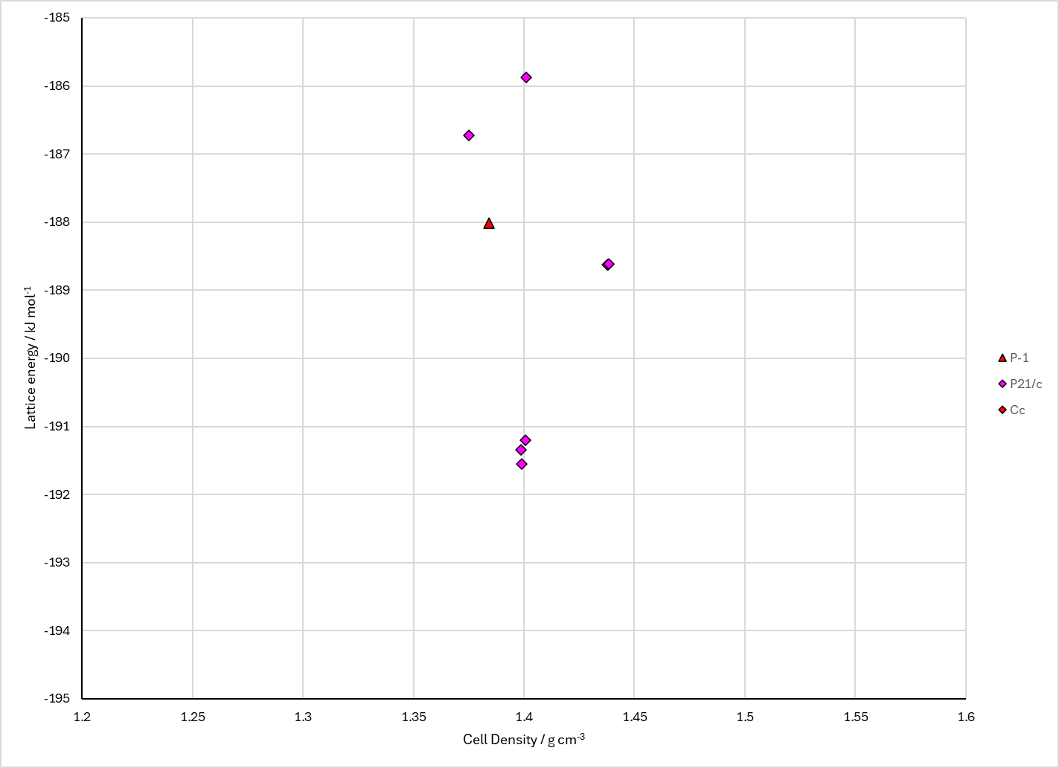
Figure 2. Crystal energy landscape of the Dicyanobenzene and Succinic Acid cocrystal from previous work.

CSD structures (CSD version 6.01 with Feb 2026 update)

Table 1. Crystallographic information for CSD entries for the Dicyanobenzene and Succinic Acid cocrystal. Different polymorphs are coloured differently.
REFCODE | space group | Z’ | a / Å | b / Å | c / Å | α / ° | β / ° | γ / ° | density / g cm⁻³ | Form

Table 2. Experimental information for CSD entries for the Dicyanobenzene and Succinic Acid cocrystal.
REFCODE | space group | R factor | T / K | Year | Comments

Make this table include whether polymorphs are solution-grown, sublimation grown, templated or otherwise. Add references.

Other notes

