4-aminobenzoic acid
(Last updated April 2026)
Figure 1. The molecular diagram of 4-aminobenzoic acid.

CSP studies
REFCODE | AMBNAC
Formula | C7 H7 N1 O2
Common Name | p-Aminobenzoic acid
IUPAC Systematic Name | 4-Aminobenzoic acid
Other Names
CSD Refcodes | AMBNAC19, AMBNAC12, AMBNAC16, AMBNAC09
Search Identifier | A
Scientist | Nizar Issa / Panos Karamertzanis
Date | 2009
Publication | Karamertzanis PG, Kazantsev AV, Issa N, Welch GWA, Adjiman CS, Pantelides CC, Price SL 2009. J Chem Theory Comput 5, 1432-1448.
Energy model | 2
Study_ID | 12
Programs | Study_ID=11, DMAflex, DMACRYS (1.1.0)
Location on S Drive | \CHEMISTRY_CPOSS\0-EarlySearches\home\louise_price.eminerals\aminobenzoic_acid_will_full
Potential Description | DMAflex DMA + WILLIAMS
Intramolecular Description | SCF
Energy model | 1
Study_ID | 11
Programs | Flexible CrystalPredictor (1), DMAflex-Q, DMAflex (single iteration), DMACRYS (1.1.0)
Location on S Drive | \CHEMISTRY_CPOSS\0-EarlySearches\home\louise_price.eminerals\aminobenzoic_acid_will_singlepoint
Potential Description | DMAflex DMA + WILLIAMS (single point following DMAflex-Quick)
Intramolecular Description | SCF
Energy model | 3
Study_ID | 10
Programs | Study_ID=12, DMAREL (4.3.6)
Location on S Drive | \CHEMISTRY_CPOSS\0-EarlySearches\home\louise_price.eminerals\aminobenzoic_acid_fit
Potential Description | DMAflex DMA + FIT
Intramolecular Description | SCF

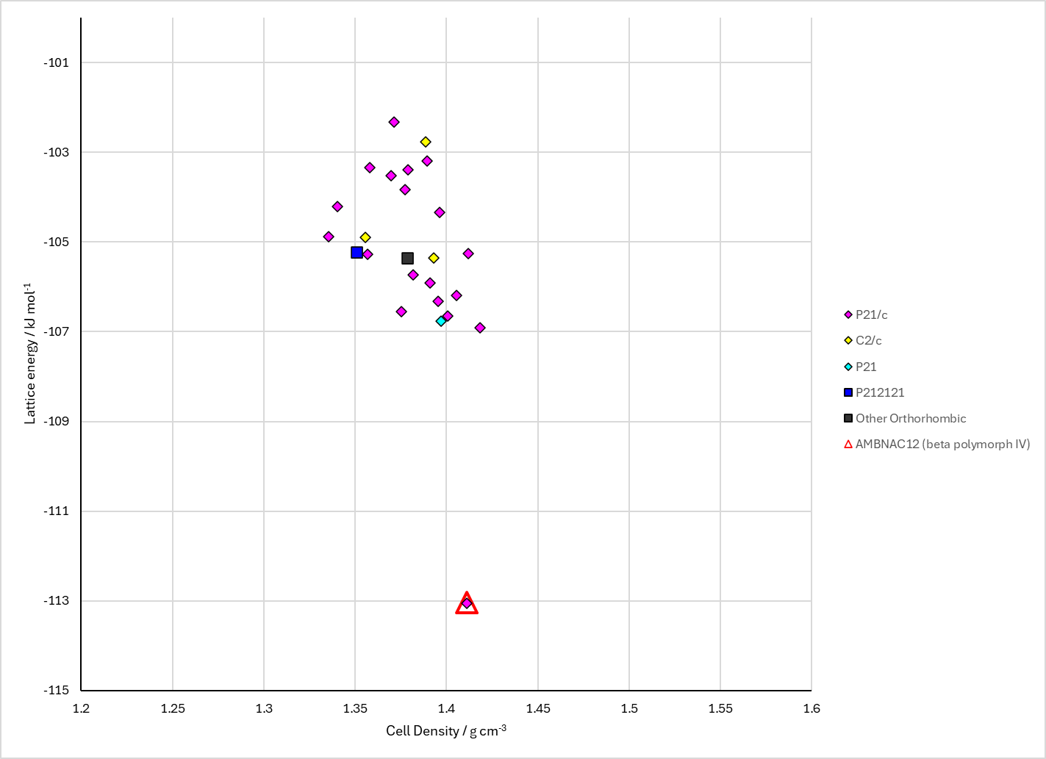
Figure 2. Crystal energy landscape of 4-aminobenzoic acid from previous work.

CSD structures (CSD version 6.01 with Feb 2026 update)
Table 1. Crystallographic information for CSD entries for 4-aminobenzoic acid. Different polymorphs are coloured differently.
REFCODE | space group | Z’ | a / Å | b / Å | c / Å | α / ° | β / ° | γ / ° | density / g cm⁻³ | Form
AMBNAC | P21/c | 1.0 | 6.275 | 8.55 | 12.8 | 90.0 | 108.0 | 90.0 | 1.3946 | beta polymorph IV
AMBNAC01 | P21/n | 2.0 | 18.5510 | 3.86 | 18.642 | 90.0 | 93.56 | 90.0 | 1.3673 | alpha polymorph I
AMBNAC04 | P21/n | 1.0 | 6.2782 | 8.5831 | 12.3649 | 90.0 | 100.133 | 90.0 | 1.3887 | beta polymorph IV
AMBNAC06 | P21/n | 2.0 | 18.5712 | 3.8431 | 18.6321 | 90.0 | 93.67 | 90.0 | 1.3727 | alpha polymorph I
AMBNAC07 | P21/n | 2.0 | 18.562 | 3.732 | 18.568 | 90.0 | 93.993 | 90.0 | 1.4197 | alpha polymorph I
AMBNAC08 | P21/n | 1.0 | 6.24360 | 8.4577 | 12.3655 | 90.0 | 100.19800 | 90.0 | 1.4173 | beta polymorph IV
AMBNAC09 | Pna21 | 2.0 | 26.9945 | 3.7322 | 12.6731 | 90.0 | 90.0 | 90.0 | 1.4268 | polymorph V
AMBNAC12 | P21/n | 1.0 | 6.2264 | 8.444 | 12.339 | 90.0 | 100.299 | 90.0 | 1.4270 | beta polymorph IV
AMBNAC13 | P21/n | 2.0 | 18.5413 | 3.77083 | 18.5858 | 90.0 | 93.6727 | 90.0 | 1.4048 | alpha polymorph
AMBNAC14 | Pn | 1.0 | 6.4341 | 4.6151 | 10.5313 | 90.0 | 100.73 | 90.0 | 1.4823 | delta polymorph
AMBNAC15 | Pn | 1.0 | 6.43420 | 4.6146 | 10.5397 | 90.0 | 100.667 | 90.0 | 1.4809 | delta polymorph
AMBNAC16 | Pn | 1.0 | 6.45510 | 4.674 | 10.547 | 90.0 | 100.754 | 90.0 | 1.4568 | delta polymorph
AMBNAC17 | Pn | 1.0 | 6.5086 | 4.6661 | 10.7596 | 90.0 | 100.685 | 90.0 | 1.4183 | delta polymorph
AMBNAC18 | Pn | 1.0 | 6.40030 | 4.59810 | 10.4452 | 90.0 | 100.748 | 90.0 | 1.5080 | delta polymorph
AMBNAC19 | P21/n | 2.0 | 18.5452 | 3.7341 | 18.5484 | 90.0 | 93.79 | 90.0 | 1.4214 | alpha polymorph I
AMBNAC22 | P21/n | 2.0 | 18.5057 | 3.8389 | 18.5953 | 90.0 | 93.59 | 90.0 | 1.3817 | alpha polymorph I

Table 2. Experimental information for CSD entries for 4-aminobenzoic acid.
REFCODE | space group | R factor | T / K | Year | Comments
AMBNAC | P21/c | 17.0 | None | 1966 | None
AMBNAC01 | P21/n | 7.3 | None | 1967 | 10.1107/S0365110X67001720
AMBNAC04 | P21/n | 4.99 | at 298 K | 2005 | 10.1107/S160053680500961X
AMBNAC06 | P21/n | 6.560 | at 293 K | 2007 | 10.1107/S0108270107022469
AMBNAC07 | P21/n | 5.156 | 101.2 K | 2014 | None
AMBNAC08 | P21/n | 5.678 | 102.5 K | 2014 | None
AMBNAC09 | Pna21 | 5.1 | 100 K | 2014 | 10.1107/S2053229614002447
AMBNAC12 | P21/n | 3.0 | 90 K | 2015 | None
AMBNAC13 | P21/n | 5.050 | 183 K | 2017 | 10.1039/C6CE02222G
AMBNAC14 | Pn | 3.39 | 296.1 K | 2019 | 10.1039/C8CE01882K
AMBNAC15 | Pn | 4.100 | 296.1 K | 2019 | 10.1039/C8CE01882K
AMBNAC16 | Pn | 2.87 | 99.8 K | 2019 | 10.1039/C8CE01882K
AMBNAC17 | Pn | 4.08 | 295.0 K | 2019 | 10.1039/C8CE01882K
AMBNAC18 | Pn | 2.76 | 295.0 K | 2019 | 10.1039/C8CE01882K
AMBNAC19 | P21/n | 4.72 | 106 K | 2019 | 10.1007/s10870-019-00771-y
AMBNAC22 | P21/n | 4.21 | 296 K | 2024 | None

Make this table include whether polymorphs are solution-grown, sublimation grown, templated or otherwise. Add references.

Other notes

