Bipyridine
(Last updated April 2026)
Figure 1. The molecular diagram of Bipyridine.

CSP studies
REFCODE | BIPYRL
Formula | C10 H8 N2
Common Name | 2,2'-Bipyridyl
IUPAC Systematic Name | 2,2'-Bipyridyl
Other Names | 2,2'-Bipyridyl
CSD Refcodes | BIPYRL04
Search Identifier | A
Scientist | Nizar Issa / Panos Karamertzanis
Date | 2009
Publication | Karamertzanis PG, Kazantsev AV, Issa N, Welch GWA, Adjiman CS, Pantelides CC, Price SL 2009. J Chem Theory Comput 5, 1432-1448.
Energy model | 2
Study_ID | 12
Programs | Study_ID=11, DMAflex, DMACRYS (1.0.1 and 1.1.0)
Location on S Drive | \CHEMISTRY_CPOSS\0-EarlySearches\home\louise_price.eminerals\bipyridyl_will_full
Potential Description | DMAflex DMA + WILLIAMS
Intramolecular Description | SCF
Energy model | 1
Study_ID | 11
Programs | Flexible CrystalPredictor (1), DMAflex-Q, DMAflex (single iteration), DMACRYS (1.0.1)
Location on S Drive | \CHEMISTRY_CPOSS\0-EarlySearches\home\louise_price.eminerals\bipyridyl_will_singlepoint
Potential Description | DMAflex DMA + WILLIAMS (single point following DMAflex-Quick)
Intramolecular Description | SCF
Energy model | 3
Study_ID | 10
Programs | Study_ID=11, DMAREL (4.3.6)
Location on S Drive | \CHEMISTRY_CPOSS\0-EarlySearches\home\louise_price.eminerals\bipyridine_fit
Potential Description | DMAflex DMA + FIT
Intramolecular Description | SCF
Search Identifier | B
Scientist | Nizar Issa / Panos Karamertzanis
Date | 2012
Publication | Issa N, Barnett SA, Mohamed S, Braun DE, Copley RCB, Tocher DA, Price SL 2012. CrystEngComm 14, 2454-2464.
Energy model | 2
Study_ID | 13
Programs | Study_ID=20, CrystalOptimizer, DMACRYS (2.0.2)
Location on S Drive | \CHEMISTRY_CPOSS\SuccinicAcidCocrystals\Bipyridine_CO
Potential Description | CrystalOptimizer HF/6-31G(d,p) Intra, GDMA2.2(MP2/6-31G(d,p)) DMA + FIT
Intramolecular Description | HF/6-31G(d,p)
Energy model | 1
Study_ID | 20
Programs | Rigid CrystalPredictor (1), DMACRYS (2.0.2)
Location on S Drive | \CHEMISTRY_CPOSS\SuccinicAcidCocrystals\Bipyridine
Potential Description | Rigid CrystalPredictor + MP2 6-31G(d,p) DMA +FIT
Intramolecular Description | MP2/6-31G(d,p)

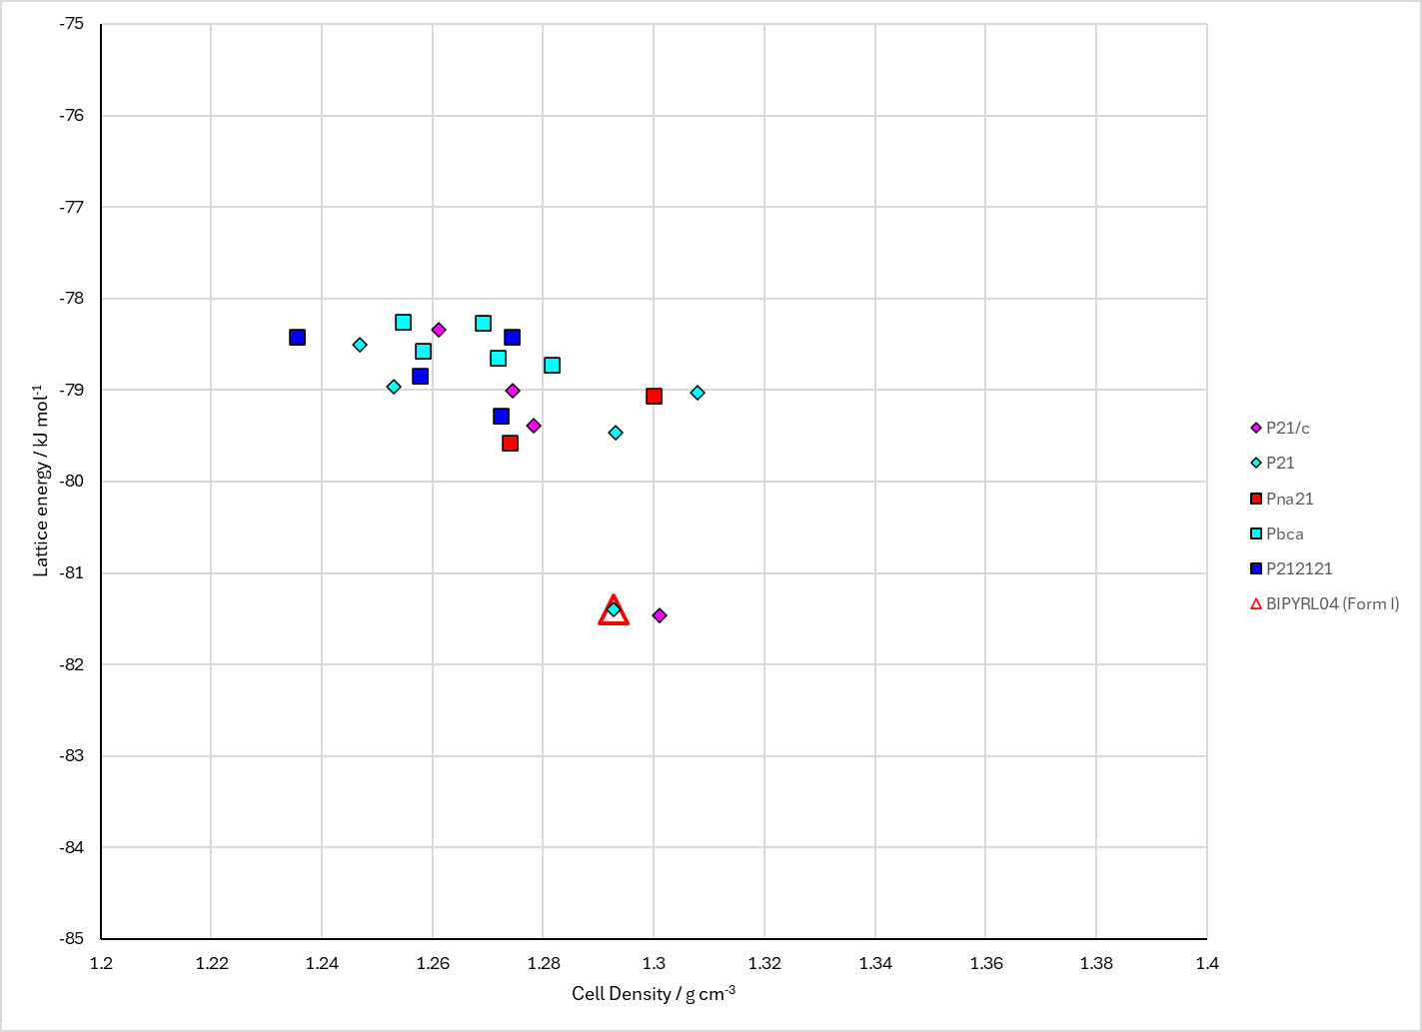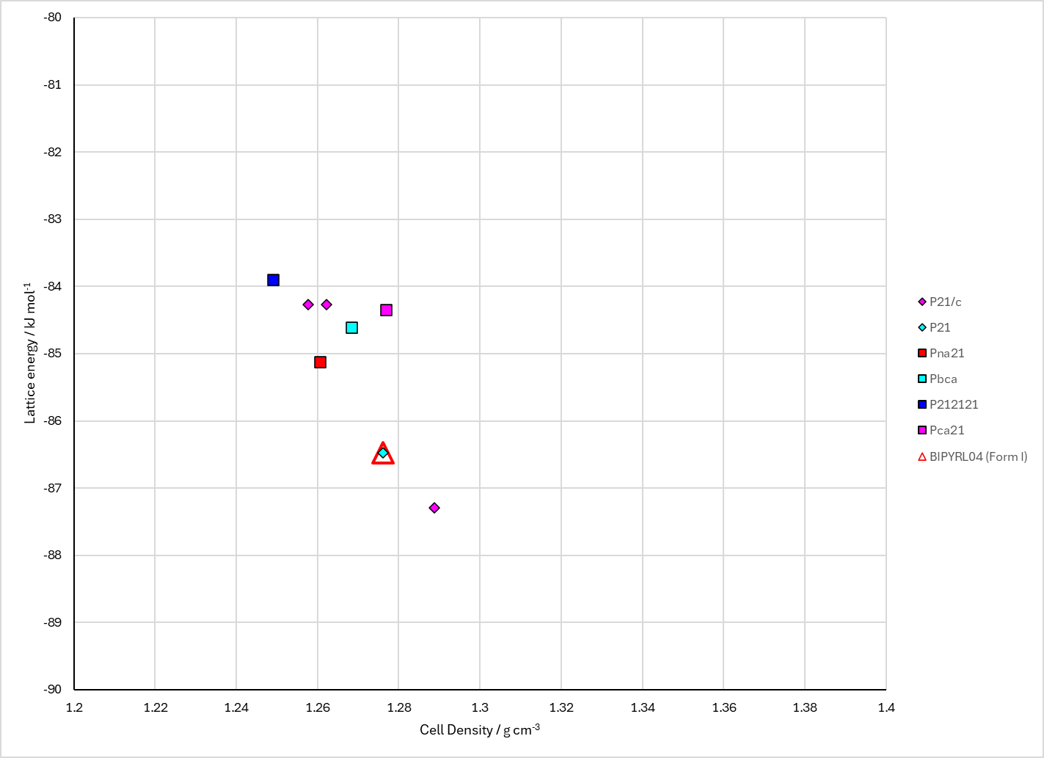
Figure 2. Crystal energy landscape of Bipyridine from previous work. Left: Energy Model A2. Right: Energy Model B2.

CSD structures (CSD version 6.01 with Feb 2026 update)

Table 1. Crystallographic information for CSD entries for Bipyridine. Different polymorphs are coloured differently.
REFCODE | space group | Z’ | a / Å | b / Å | c / Å | α / ° | β / ° | γ / ° | density / g cm⁻³ | Form
BIPYRL | P21/c | 0.5 | 5.66 | 6.24 | 13.46 | 90.0 | 118.72999 | 90.0 | 1.2442 | None
BIPYRL03 | P21/c | 0.5 | 5.485 | 6.17700 | 12.356 | 90.0 | 110.83 | 90.0 | 1.3256 | None
BIPYRL04 | P21/n | 0.5 | 5.4862 | 6.1657 | 11.6094 | 90.0 | 95.276 | 90.0 | 1.3264 | None
BIPYRL05 | P21/n | 0.5 | 5.613 | 6.191 | 11.708 | 90.0 | 94.14 | 90.0 | 1.27 | None
BIPYRL06 | P21/n | 0.5 | 5.480 | 6.161 | 11.613 | 90.0 | 95.46 | 90.0 | 1.329 | None

Table 2. Experimental information for CSD entries for Bipyridine.
REFCODE | space group | R factor | T / K | Year | Comments
BIPYRL | P21/c | 15.0 | None | 1956 | 10.1107/S0365110X56002175
BIPYRL03 | P21/c | 5.8 | at -163 deg.C | 1981 | 10.1021/ja00406a048
BIPYRL04 | P21/n | 2.98 | at 123 K | 2002 | 10.1002/1521-3765
BIPYRL05 | P21/n | 4.22 | at 296 K | 2024 | None
BIPYRL06 | P21/n | 4.16 | at 100 K | 2026 | 10.1016/j.poly.2025.117905

Make this table include whether polymorphs are solution-grown, sublimation grown, templated or otherwise. Add references.

Other notes

