1,4-dicyanobenzene
(Last updated April 2026)
Figure 1. The molecular diagram of Dicyanobenzene.

CSP studies
REFCODE | TEPNIT
Formula | C8 H4 N2
Common Name | 1,4-dicyanobenzene
IUPAC Systematic Name | 1,4-Dicyanobenzene
Other Names
CSD Refcodes | TEPNIT06, TEPNIT16
Search Identifier | A
Scientist | Sarah Barnett
Date | pre-2010
Publication | No publication planned.
Energy model | 1
Study_ID | 0
Programs | MOLPAK, DMAREL (4.1.1)
Location on S Drive | \CHEMISTRY_CPOSS\0-EarlySearches\home\louise_price.eminerals\1,4-dicyanobenzene\1,4-dicyanobenzene_fit
Potential Description | DMA + FIT
Intramolecular Description | MP2/6-31G(d,p)
Search Identifier | B
Scientist | Sarah Barnett
Date | pre-2010
Publication | No publication planned.
Energy model | 1
Study_ID | 1
Programs | MOLPAK, DMACRYS (1.0.1)
Location on S Drive | \CHEMISTRY_CPOSS\0-EarlySearches\home\louise_price.eminerals\1,4-dicyanobenzene\1,4-dicyanobenzene_will
Potential Description | DMA + Will01
Intramolecular Description | MP2/6-31G(d,p)
Search Identifier | C
Scientist | Nizar Issa / Panos Karamertzanis
Date | 2012
Publication | Issa N, Barnett SA, Mohamed S, Braun DE, Copley RCB, Tocher DA, Price SL 2012. CrystEngComm 14, 2454-2464.
Energy model | 1
Study_ID | 20
Programs | Rigid CrystalPredictor (1), DMACRYS (2.0.2)
Location on S Drive | \CHEMISTRY_CPOSS\SuccinicAcidCocrystals\Dicyanobenzene
Potential Description | Rigid CrystalPredictor + MP2 6-31G(d,p) DMA +FIT
Intramolecular Description | MP2/6-31G(d,p)

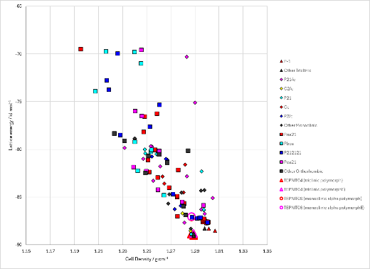 | 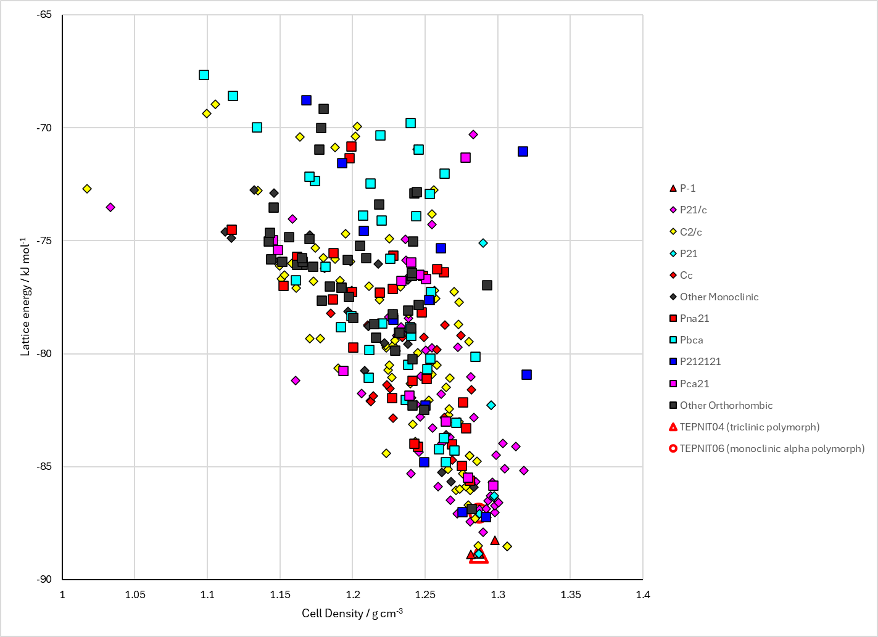
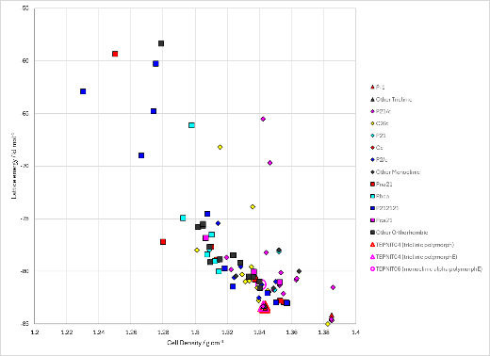
Figure 2. Crystal energy landscape of Dicyanobenzene from previous work. Top left: Energy model A1. Bottom left: Energy model B1. Right: Energy model C1.

CSD structures (CSD version 6.01 with Feb 2026 update)

Table 1. Crystallographic information for CSD entries for Dicyanobenzene. Different polymorphs are coloured differently.
REFCODE | space group | Z’ | a / Å | b / Å | c / Å | α / ° | β / ° | γ / ° | density / g cm⁻³ | Form
TEPNIT02 | P-1 | 0.5 | 3.839 | 6.579 | 7.333 | 114.48 | 93.59 | 96.97 | 1.2817 | triclinic polymorph
TEPNIT04 | P-1 | 0.5 | 3.847 | 6.585 | 7.322 | 114.5 | 93.600000 | 96.9 | 1.2797 | triclinic polymorph
TEPNIT05 | P-1 | 0.5 | 3.843 | 6.575 | 7.313 | 114.5 | 93.530000 | 96.990000 | 1.2847 | triclinic polymorph
TEPNIT06 | P21/c | 0.5 | 3.868 | 7.08 | 12.127 | 90.0 | 97.210000 | 90.0 | 1.2915 | monoclinic alpha polymorph
TEPNIT10 | P-1 | 0.5 | 7.31800 | 7.54400 | 3.841 | 80.45 | 93.570000 | 127.44000 | 1.2830 | triclinic polymorph
TEPNIT11 | P-1 | 0.5 | 3.843 | 6.575 | 7.313 | 114.5 | 93.530000 | 96.990000 | 1.2847 | triclinic polymorph
TEPNIT12 | P-1 | 0.5 | 3.852 | 6.589 | 7.331 | 114.521 | 93.568 | 96.948000 | 1.2760 | triclinic polymorph
TEPNIT13 | P-1 | 0.5 | 3.835 | 6.57600 | 7.3 | 114.64 | 93.51 | 96.88 | 1.2905 | triclinic polymorph
TEPNIT14 | P-1 | 0.5 | 3.781 | 6.45 | 7.27000 | 114.297 | 92.785000 | 97.812000 | 1.3380 | triclinic polymorph
TEPNIT15 | P-1 | 0.5 | 3.7944 | 6.4919 | 7.2854 | 114.209 | 92.982 | 97.655 | 1.3208 | None

Table 2. Experimental information for CSD entries for Dicyanobenzene.
REFCODE | space group | R factor | T / K | Year | Comments
TEPNIT02 | P-1 | 5.8 | None | 1978 | 10.1107/S056774087801016X
TEPNIT04 | P-1 | 3.7 | None | 1982 | None
TEPNIT05 | P-1 | 4.18 | None | 1984 | 10.1016/0022-2860(84)80251-3
TEPNIT06 | P21/c | 5.0 | None | 1996 | 10.3891/acta.chem.scand.50-1164
TEPNIT10 | P-1 | 6.9 | None | 1977 | 10.1107/S0567740877005950
TEPNIT11 | P-1 | 4.26 | None | 1984 | 10.1016/0022-2860(84)80251-3
TEPNIT12 | P-1 | 4.68 | 298 K | 2019 | 10.1002/anie.201905769
TEPNIT13 | P-1 | 6.01 | 298 K | 2019 | 10.1002/anie.201905769
TEPNIT14 | P-1 | 5.029 | 100.0 K | 2020 | 10.1021/acs.jpcc.0c01762
TEPNIT15 | P-1 | 11.14 | 193 K | 2024 | None

Make this table include whether polymorphs are solution-grown, sublimation grown, templated or otherwise. Add references.

Other notes

