4-nitrophenyl acetic acid
(Last updated April 2026)
Figure 1. The molecular diagram of 4-nitrophenyl acetic acid.

CSP studies
REFCODE | SEMTAF
Formula | C8 H7 N1 O4
Common Name | p-nitrophenylacetic acid
IUPAC Systematic Name | 4-Nitrophenylacetic acid
Other Names
CSD Refcodes | SEMTAF01, SEMTAF02
Search Identifier | A
Scientist | Nizar Issa / Panos Karamertzanis
Date | 2009
Publication | Karamertzanis PG, Kazantsev AV, Issa N, Welch GWA, Adjiman CS, Pantelides CC, Price SL 2009. J Chem Theory Comput 5, 1432-1448.
Energy model | 2
Study_ID | 12
Programs | Study_ID=11, DMAflex, DMACRYS (1.1.0)
Location on S Drive | \CHEMISTRY_CPOSS\0-EarlySearches\home\louise_price.eminerals\4-nitrophenylacetic_acid_will_full
Potential Description | DMAflex DMA + WILLIAMS
Intramolecular Description | SCF
Energy model | 1
Study_ID | 11
Programs | Flexible CrystalPredictor (1), DMAflex-Q, DMAflex (single iteration), DMACRYS (1.1.0)
Location on S Drive | \CHEMISTRY_CPOSS\0-EarlySearches\home\louise_price.eminerals\4-nitrophenylacetic_acid_will_singlepoint
Potential Description | DMAflex DMA + WILLIAMS (single point following DMAflex-Quick)
Intramolecular Description | SCF
Energy model | 3
Study_ID | 10
Programs | Study_ID=11 or 12 (not sure), DMAREL (4.3.6)
Location on S Drive | \CHEMISTRY_CPOSS\0-EarlySearches\home\louise_price.eminerals\4-nitrophenylaceticacid_fit
Potential Description | DMAflex DMA + FIT
Intramolecular Description | SCF

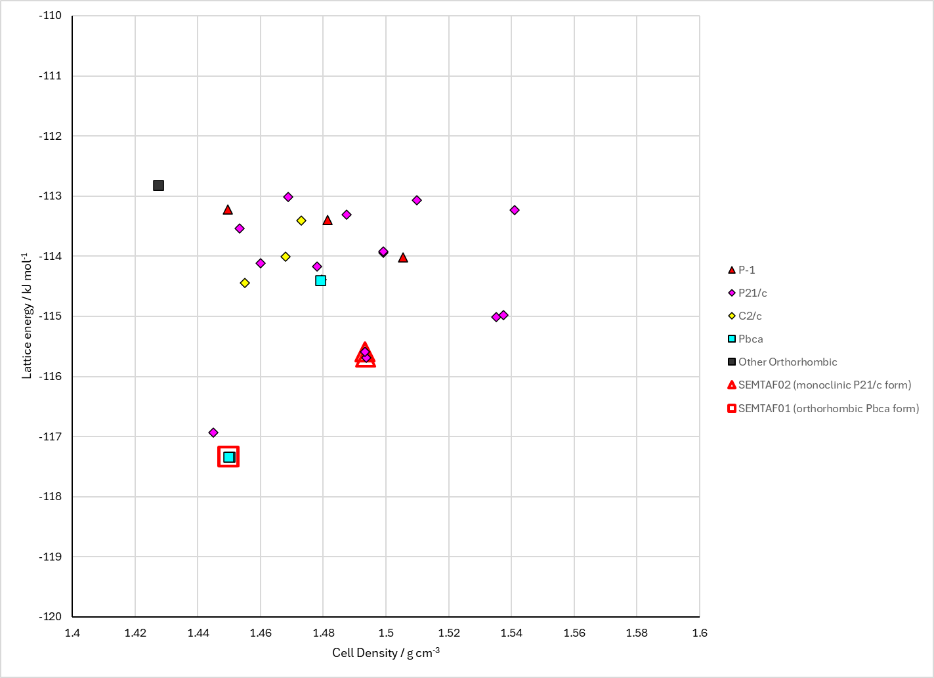
Figure 2. Crystal energy landscape of 4-nitrophenyl acetic acid from previous work.

CSD structures (CSD version 6.01 with Feb 2026 update)

Table 1. Crystallographic information for CSD entries for 4-nitrophenyl acetic acid. Different polymorphs are coloured differently.
REFCODE | space group | Z’ | a / Å | b / Å | c / Å | α / ° | β / ° | γ / ° | density / g cm⁻³ | Form
SEMTAF | Pbca | 1.0 | 15.096 | 7.15 | 15.923 | 90.0 | 90.0 | 90.0 | 1.4001 | orthorhombic Pbca polymorph
SEMTAF01 | Pbca | 1.0 | 14.9820 | 7.0102 | 15.885 | 90.0 | 90.0 | 90.0 | 1.4423 | orthorhombic Pbca polymorph
SEMTAF02 | P21/c | 1.0 | 6.1364 | 5.10340 | 25.4580 | 90.0 | 95.937 | 90.0 | 1.5173 | monoclinic P21/c polymorph

Table 2. Experimental information for CSD entries for 4-nitrophenyl acetic acid.
REFCODE | space group | R factor | T / K | Year | Comments
SEMTAF | Pbca | 6.5 | None | 1990 | 10.1107/S0108270189006451
SEMTAF01 | Pbca | 4.1 | at 110 K | 2006 | None
SEMTAF02 | P21/c | 5.36 | 150 K | 2016 | 10.1107/S2414314616019325

Make this table include whether polymorphs are solution-grown, sublimation grown, templated or otherwise. Add references.

Other notes

