Amino pyrimidine
(Last updated March 2026)
Figure 1. The molecular diagram of amino pyrimidine.

CSP studies
REFCODE | XAQNUZ
Formula | C5 H7 N3
Common Name | 4-methyl-pyrimidin-2-ylamine
IUPAC Systematic Name | 4-methyl-pyrimidin-2-ylamine
Other Names
CSD Refcodes | XAQNUZ
Search Identifier | A
Scientist | Panos Karamertzanis
Date | 2008
Publication | No publication planned (component of Blind Test XV)
Energy model | 1
Study_ID | 0
Programs | Mercury, DMAREL (4.1.1)
Location on S Drive | \CHEMISTRY_CPOSS\0-EarlySearches\home\louise_price.eminerals\blindtestbase
Potential Description | DMA + FIT
Intramolecular Description | MP2/6-31G(d,p)

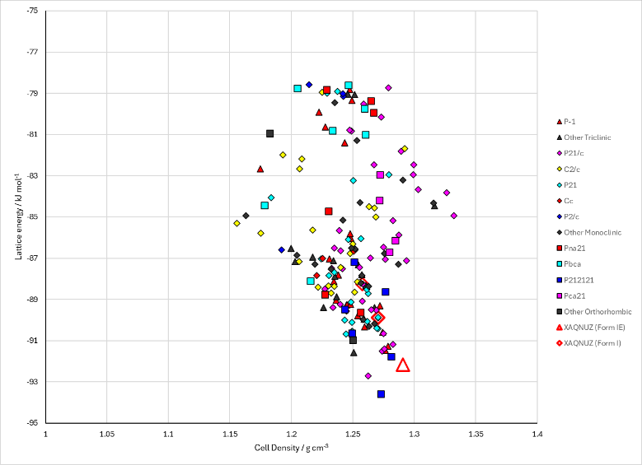
Figure 2. Crystal energy landscape of amino pyrimidine from previous work. Amino pyrimidine (Energy model A1).

CSD structures (CSD version 6.01)

Table 1. Crystallographic information for CSD entries for amino pyrimidine and otolic acid. Different polymorphs are coloured differently.
REFCODE | space group | Z’ | a / Å | b / Å | c / Å | α / ° | β / ° | γ / ° | density / g cm⁻³ | Form
XAQNUZ | P21/c | 1.0 | 5.8369 | 14.002 | 7.269 | 90.0 | 109.86 | 90.0 | 1.4759 | None

Table 2. Experimental information for CSD entries for amino pyrimidine and otolic acid.
REFCODE | space group | R factor | T / K | Year | Comments
XAQNUZ | P21/c | 4.75 | at 203 K | 2005 | 10.1524/zkri.220.4.325.61619

Make this table include whether polymorphs are solution-grown, sublimation grown, templated or otherwise. Add references.

Other notes

