Otolic acid
(Last updated March 2026)
Figure 1. The molecular diagram of otolic acid.

CSP studies
REFCODE | OTOLIC
Formula | C8 H8 O2
Common Name | otolic acid
IUPAC Systematic Name | 2-methyl benzoic acid
Other Names | o-Methyl benzoic acid; o-Toluic acid; 2-Toluic acid
CSD Refcodes | OTOLIC02
Search Identifier | A
Scientist | Panos Karamertzanis
Date | 2008
Publication | No publication planned (component of Blind Test XV)
Energy model | 1
Study_ID | 0
Programs | MOLPAK, DMAREL (4.1.1)
Location on S Drive | \CHEMISTRY_CPOSS\0-EarlySearches\home\louise_price.eminerals\otolic_acid
Potential Description | MP2 6-31G(d,p) DMA(1.1)+ fit.pots
Intramolecular Description | MP2 6-31G(d,p)
Search Identifier | B
Scientist | Panos Karamertzanis
Date | 2008
Publication | No publication planned (component of Blind Test XV)
Energy model | 1
Study_ID | 11
Programs | CrystalPredictor, dmaflex, DMAREL (4.3.6)
Location on S Drive | \CHEMISTRY_CPOSS\0-EarlySearches\home\louise_price.eminerals\otolic_acid_dmafl
Potential Description | DMAflex DMA + FIT
Intramolecular Description | MP2/6-31G(d,p)
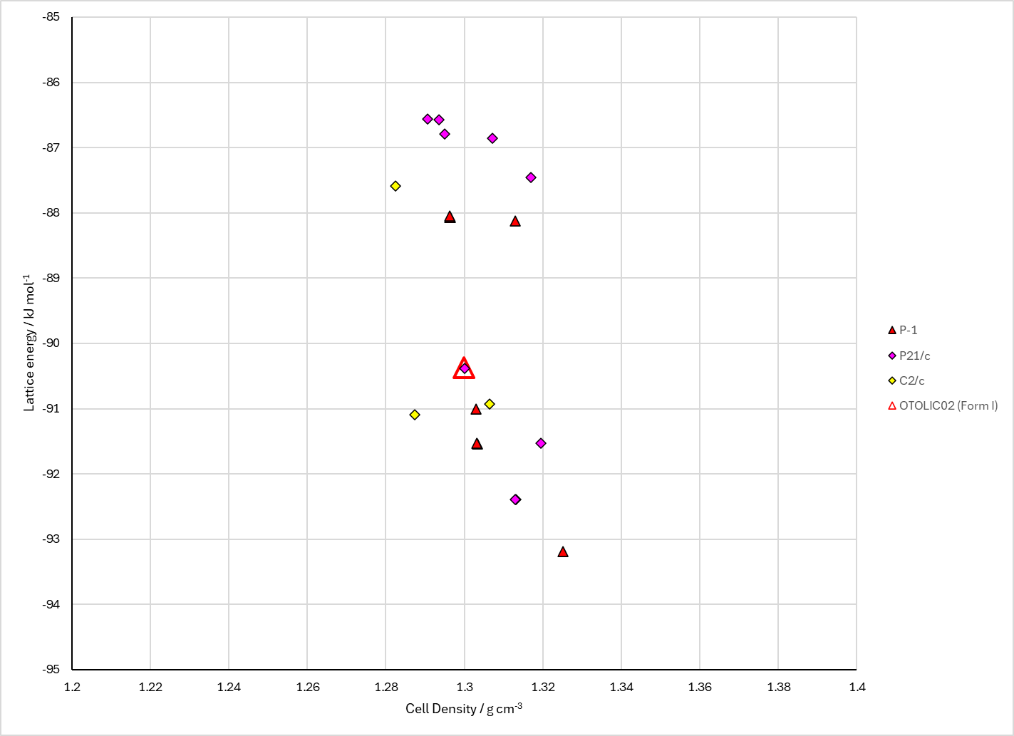
Figure 2. Crystal energy landscape of otolic acid from previous work. Otolic acid (Energy model B1).

CSD structures (CSD version 6.01)

Table 1. Crystallographic information for CSD entries for amino pyrimidine and otolic acid. Different polymorphs are coloured differently.
REFCODE | space group | Z’ | a / Å | b / Å | c / Å | α / ° | β / ° | γ / ° | density / g cm⁻³ | Form
OTOLIC01 | P21/n | 1.0 | 4.8335 | 19.384 | 7.82980 | 90.0 | 105.99000 | 90.0 | 1.2823 | Form I
OTOLIC02 | P21/n | 1.0 | 4.831 | 19.42 | 7.76080 | 90.0 | 106.87 | 90.0 | 1.2978 | Form I
OTOLIC04 | P21/n | 6.0 | 7.58860 | 68.3842 | 7.7121 | 90.0 | 94.396 | 90.0 | 1.3597 | Form IV

Table 2. Experimental information for CSD entries for amino pyrimidine and otolic acid.
REFCODE | space group | R factor | T / K | Year | Comments
OTOLIC01 | P21/n | 10.21 | at 298 K | 2008 | 10.1021/cg800371j
OTOLIC02 | P21/n | 5.26 | at 293 K | 2008 | 10.1039/b811438b
OTOLIC04 | P21/n | 3.47 | at 90 K | 2014 | None

Make this table include whether polymorphs are solution-grown, sublimation grown, templated or otherwise. Add references.

Other notes

