Galunisertib
(Last updated December 2025)
Figure 1. The molecular diagram of Galunisertib.

CSP studies
REFCODE | DORDUM
Formula | C22 H19 N5 O1
Common Name | Galunisertib, TGF-beta antagonist
IUPAC Systematic Name | 4-[2-(6-methylpyridin-2-yl)-5,6-dihydro-4H-pyrrolo[1,2-b]pyrazol-3-yl]quinoline-6-carboxamide
Other Names | LY2157299
CSD Refcodes | DORDUM09, DORDUM, DORDUM01, DORDUM02, DORDUM03, DORDUM04, DORDUM10, DORDUM05, DORDUM06, DORDUM07
Search Identifier | A
Scientist | Louise Price
Date | 2015-2019
Publication | Bhardwaj RM; McMahon JA; Nyman J; Price LS; Konar S; Oswald IDH; Pulham CR; Price SL; Reutzel-Edens SM, J. Am. Chem. Soc. 2019, 141, (35), 13887-13897.
Energy model | 2
Study_ID | 10
Programs | Study_ID=20, CrystalOptimizer (2.3), DMACRYS (2.0.8RC1)
Location on S Drive | CHEMISTRY_CPOSS\Galunisertib\TGFb_CrystalOptimizer
Potential Description | CrystalOptimizer PBE1PBE/6-31G(d,p) intramolecular + GDMA2.2(PBE1PBE/6-31G(d,p)) DMA + FIT
Intramolecular Description | PBE1PBE/6-31G(d,p)
Energy model | 3
Study_ID | 30
Programs | Study_ID=10, DMACRYS (2.0.8)
Location on S Drive | CHEMISTRY_CPOSS\Galunisertib\TGFb_PCM
Potential Description | GDMA2.2(PCMdielectric3(PBE1PBE/6-31G(d,p))) + FIT
Intramolecular Description | PCMdielectric=3(PBE1PBE/6-31G(d,p))
Energy model | 4
Study_ID | 11
Programs | Study_ID=10, CrystalOptimizer (2.3), DMACRYS (2.0.8RC1)
Location on S Drive | CHEMISTRY_CPOSS\Galunisertib\TGFb_WILL
Potential Description | CrystalOptimizer PBE1PBE/6-31G(d,p) intramolecular + GDMA2.2(PBE1PBE/6-31G(d,p)) DMA + WILL01
Intramolecular Description | PBE1PBE/6-31G(d,p)
Energy model | 1
Study_ID | 20
Programs | Flexible CrystalPredictor (1.6), Dmaflex-Quick, DMACRYS (2.0.8RC1)
Location on S Drive | CHEMISTRY_CPOSS\Galunisertib\TGFb_CrystalPredictor
Potential Description | CrystalPredictor / DMAflex-Q with 3 torsional degrees of freedom + rotated multipoles from PBE1PBE/6-31+G(d) + FIT (3 separate search regions)
Intramolecular Description | HF/6-31G(d,p)

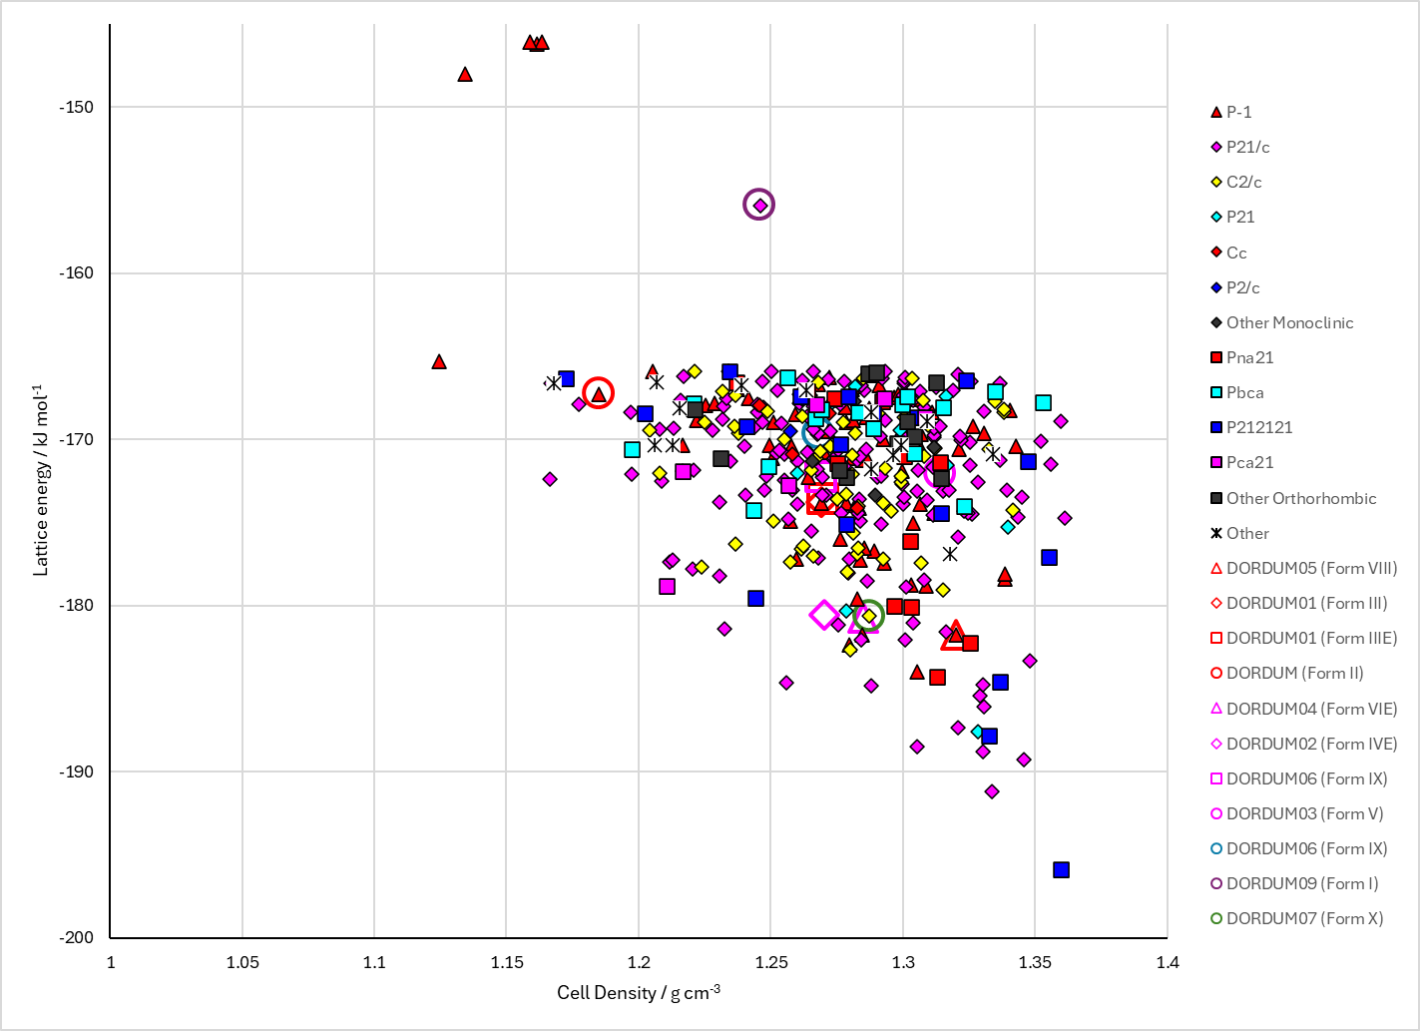
Figure 2. Crystal energy landscape of Galunisertib from previous work.

CSD structures (CSD version 5.43 with Mar, Jun, Sep and Nov 2022 updates)

Table 1. Crystallographic information for CSD entries for Galunisertib. Different polymorphs are coloured differently.
REFCODE | space group | Z’ | a / Å | b / Å | c / Å | α / ° | β / ° | γ / ° | density / g cm⁻³ | Form
DORDUM | P-1 | 1.0 | 8.2116 | 11.5104 | 11.8746 | 102.001 | 105.36800 | 102.349 | 1.2091 | II
DORDUM01 | P-1 | 1.0 | 7.7119 | 8.91110 | 14.617 | 81.906 | 78.799 | 75.258 | 1.2934 | III
DORDUM02 | P21/n | 2.0 | 18.9981 | 9.85320 | 21.8829 | 90.0 | 113.21900 | 90.0 | 1.3036 | IV
DORDUM03 | P21/c | 1.0 | 8.2599 | 19.6072 | 12.6913 | 90.0 | 116.545 | 90.0 | 1.3344 | V
DORDUM04 | P21/n | 1.0 | 10.727 | 14.4711 | 12.705 | 90.0 | 107.11200 | 90.0 | 1.3017 | VI
DORDUM05 | P-1 | 1.0 | 8.55370 | 11.3718 | 11.5674 | 65.784 | 105.495 | 77.315 | 1.3380 | VIII
DORDUM06 | P21/c | 1.0 | 11.3011 | 20.8473 | 8.10637 | 90.0 | 98.879 | 90.0 | 1.3003 | IX
DORDUM07 | C2/c | 1.0 | 27.938 | 8.0817 | 22.004 | 90.0 | 133.55 | 90.0 | 1.3628 | X
DORDUM08 | C2/c | 1.0 | 27.654 | 8.108 | 21.934 | 90.0 | 133.41 | 90.0 | 1.3735 | X
DORDUM09 | P21/n | 1.0 | 19.4305 | 11.3245 | 9.1511 | 90.0 | 95.302 | 90.0 | 1.2238 | I
DORDUM10 | P-1 | 2.0 | 8.134 | 12.6200 | 18.059 | 86.707000 | 100.09400 | 83.303 | 1.3580 | VII

Table 2. Experimental information for CSD entries for Galunisertib.
REFCODE | space group | R factor | T / K | Year | Comments
DORDUM | P-1 | 15.06 | 100 K | 2019 | 10.1021/jacs.9b06634
DORDUM01 | P-1 | 5.98 | 100 K | 2019 | 10.1021/jacs.9b06634
DORDUM02 | P21/n | 4.16 | 100 K | 2019 | 10.1021/jacs.9b06634
DORDUM03 | P21/c | 3.58 | 298 K | 2019 | 10.1021/jacs.9b06634
DORDUM04 | P21/n | 5.21 | 100 K | 2019 | 10.1021/jacs.9b06634
DORDUM05 | P-1 | 3.0 | 298 K | 2019 | 10.1021/jacs.9b06634
DORDUM06 | P21/c | 3.86 | 298 K | 2019 | 10.1021/jacs.9b06634
DORDUM07 | C2/c | 6.810 | 100 K | 2019 | 10.1021/jacs.9b06634
DORDUM08 | C2/c | 11.57 | 293 K | 2019 | 10.1021/jacs.9b06634
DORDUM09 | P21/n | 9.8 | 298 K | 2019 | 10.1021/jacs.9b06634
DORDUM10 | P-1 | 4.86 | 298 K | 2019 | 10.1021/jacs.9b06634

Make this table include whether polymorphs are solution-grown, sublimation grown, templated or otherwise. Add references.

Other notes

