Uric Acid
(Last updated January 2026)
Figure 1. The molecular diagram of Uric Acid.

CSP studies
REFCODE | URICAC
Formula | C5 H4 N4 O3
Common Name | Uric acid
IUPAC Systematic Name | 7,9-dihydro-1H-purine-2,6,8(3H)-trione
Other Names | 2,6,8-trioxypurine, 7,9-dihydro-1H-purine-2,6,8(3H)-trione, Lithic acid, Purine-2,6,8(1H,3H,9H)-trione, 1H-Purine-2,6,8-triol, 2,6,8-Trioxopurine, 2,6,8-Trioxypurine, 2,6,8-Trihydroxypurine, 8-Hydroxyxanthine, Purine-2,6,8-triol, Purine-3,6,8(1H,3H,9H)-trione, Uric oxide
CSD Refcodes | URICAC06
Search Identifier | A
Scientist | Pinky Pridhanani-Jethani / Tom Lewis
Date | 2004
Publication | Price, S. L., Patel, B., Pridhanani-Jethani, P., Torrisi, A., Trans. ACA, 39(2), 1-12 (2004)
Energy model | 1
Study_ID | 0
Programs | MOLPAK, DMAREL (3.0)
Location on S Drive | CHEMISTRY_CPOSS\0-EarlySearches\home\louise_price.eminerals\uric_acid
Potential Description | DMA + adjusted FIT
Intramolecular Description | MP2/6-31G(d,p)
Search Identifier | B
Scientist | Louise Price
Date | 2022
Publication | This is a project with Jen Swift
Energy model | 1
Study_ID | 1
Programs | MOLPAK, DMACRYS (2.0.8 or 2.3.1.1)
Location on S Drive | CHEMISTRY_CPOSS\uric_acid_2022
Potential Description | DMA + adjusted FIT
Intramolecular Description | MP2/6-31G(d,p)

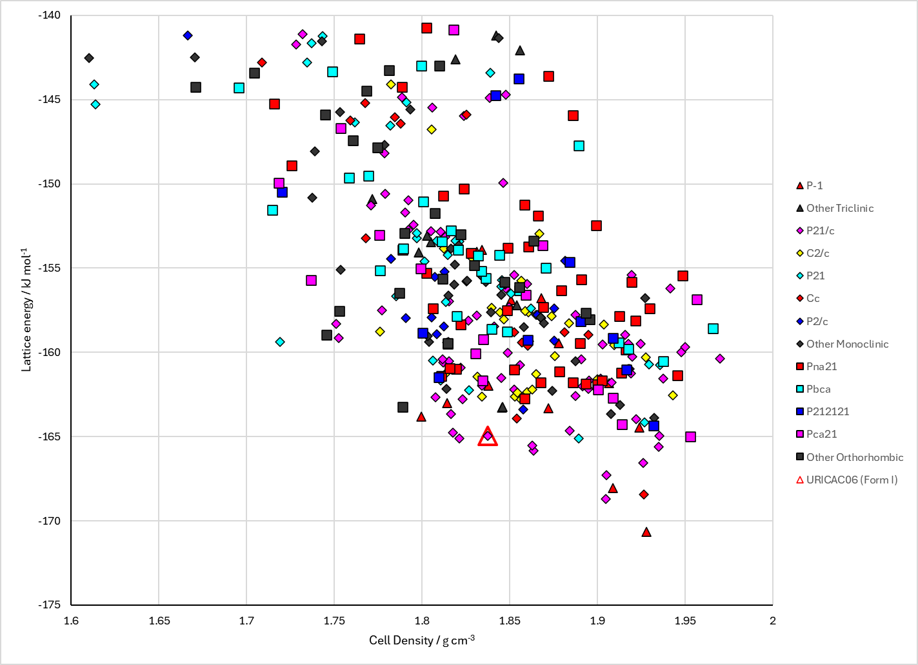
Figure 2. Crystal energy landscape of Uric Acid from previous work.

CSD structures (CSD version 6.01)

Table 1. Crystallographic information for CSD entries for Uric Acid. Different polymorphs are coloured differently.
REFCODE | space group | Z’ | a / Å | b / Å | c / Å | α / ° | β / ° | γ / ° | density / g cm⁻³ | Form
URICAC | P21/a | 1.0 | 14.464 | 7.40300 | 6.208 | 90.0 | 65.1 | 90.0 | 1.8519 | None
URICAC01 | P21/n | 1.0 | 6.22880 | 7.3113 | 13.1274 | 90.0 | 90.632 | 90.0 | 1.8678 | None
URICAC02 | P21/n | 1.0 | 6.2182 | 7.35300 | 13.1232 | 90.0 | 90.519 | 90.0 | 1.8610 | None
URICAC03 | P21/n | 1.0 | 6.211 | 7.3857 | 13.1213 | 90.0 | 90.447 | 90.0 | 1.8551 | None
URICAC04 | P21/n | 1.0 | 6.20250 | 7.41630 | 13.1147 | 90.0 | 90.378 | 90.0 | 1.8509 | None
URICAC05 | P21/n | 1.0 | 6.1963 | 7.4512 | 13.1114 | 90.0 | 90.282 | 90.0 | 1.8445 | None
URICAC06 | P21/n | 1.0 | 6.1898 | 7.48570 | 13.1103 | 90.0 | 90.217000 | 90.0 | 1.8381 | None
URICAC07 | P21/n | 1.0 | 6.23520 | 7.27560 | 13.1328 | 90.0 | 90.710000 | 90.0 | 1.8743 | None
URICAC08 | P21/n | 1.0 | 6.2302 | 7.23680 | 13.113 | 90.0 | 90.850000 | 90.0 | 1.8888 | None

Table 2. Experimental information for CSD entries for Uric Acid.
REFCODE | space group | R factor | T / K | Year | Comments
URICAC | P21/a | 6.600 | None | 1966 | 10.1107/S0365110X66000914
URICAC01 | P21/n | 5.56 | 173 K | 2019 | 10.3390/min9060373
URICAC02 | P21/n | 5.26 | 213 K | 2019 | 10.3390/min9060373
URICAC03 | P21/n | 4.81 | 243 K | 2019 | 10.3390/min9060373
URICAC04 | P21/n | 4.62 | 273 K | 2019 | 10.3390/min9060373
URICAC05 | P21/n | 4.2 | 303 K | 2019 | 10.3390/min9060373
URICAC06 | P21/n | 3.65 | 333 K | 2019 | 10.3390/min9060373
URICAC07 | P21/n | 5.5 | 130 K | 2019 | 10.3390/min9060373
URICAC08 | P21/n | 6.75 | 120 K | 2005 | None

Make this table include whether polymorphs are solution-grown, sublimation grown, templated or otherwise. Add references.

Other notes

