5-fluoroisatin
(Last updated February 2026)
Figure 1. The molecular diagram of 5-fluoroisatin.

CSP studies
REFCODE | WOCGOK
Formula | C8 H4 N1 O2 F1
Common Name | 5-Fluoroisatin
IUPAC Systematic Name | 5-Fluoroindoline-2,3-dione
Other Names
CSD Refcodes | WOCGOK01, WOCGOK02
Search Identifier | A
Scientist | Sharmarke Mohamed (Weijia Zhu, L Price)
Date | 2008
Publication | Mohamed S, Barnett SA, Tocher DA, Shankland K, Leech CK, Price SL 2008. CrystEngComm 10,399-404.
Energy model | 1
Study_ID | 0
Programs | MOLPAK, DMAREL (4.1.1)
Location on S Drive | \CHEMISTRY_CPOSS\0-EarlySearches\home\louise_price.eminerals\5-fluoroisatin
Potential Description | DMA + FIT + Williams F parameters
Intramolecular Description | MP2/aug-cc-pVDZ

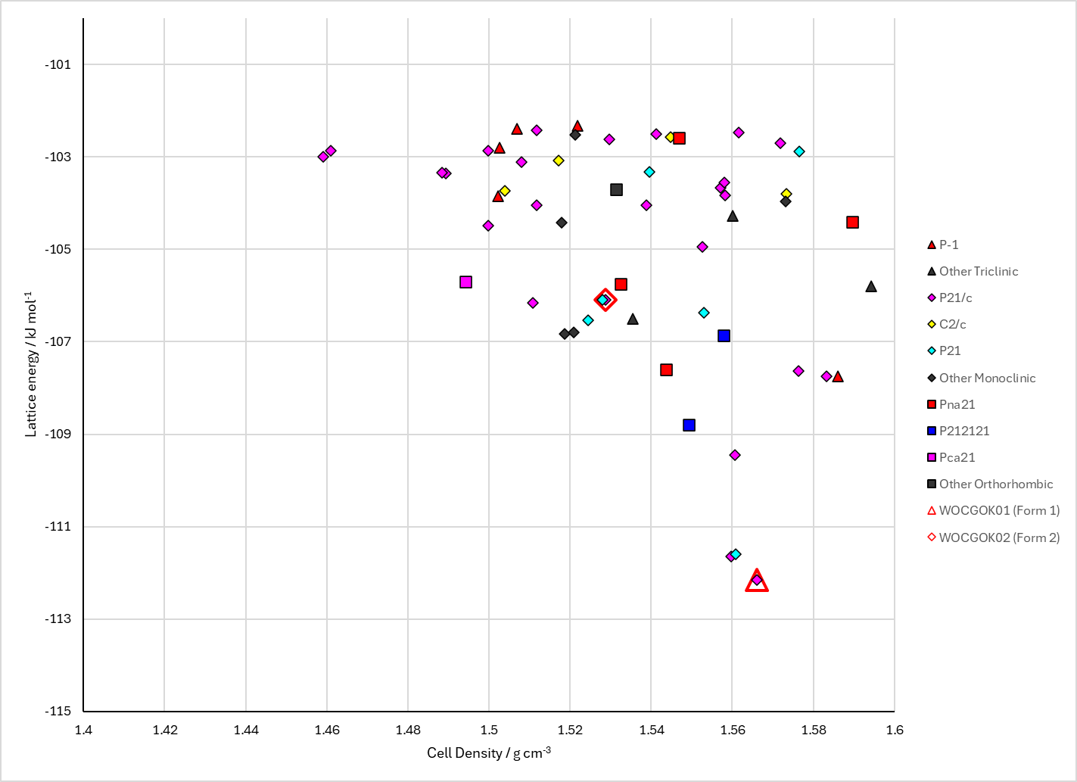
Figure 2. Crystal energy landscape of 5-fluoroisatin from previous work.

CSD structures (CSD version 6.01)

Table 1. Crystallographic information for CSD entries for 5-fluoroisatin. Different polymorphs are coloured differently.
REFCODE | space group | Z’ | a / Å | b / Å | c / Å | α / ° | β / ° | γ / ° | density / g cm⁻³ | Form
WOCGOK | P21/c | 1.0 | 3.789 | 12.2000 | 14.99 | 90.0 | 94.41 | 90.0 | 1.5874 | None
WOCGOK01 | P21/c | 1.0 | 3.71040 | 12.1407 | 14.766 | 90.0 | 93.397 | 90.0 | 1.6517 | Form 1
WOCGOK02 | P21/n | 1.0 | 4.8425 | 24.45 | 5.78180 | 90.0 | 99.096 | 90.0 | 1.6225 | Form 2

Table 2. Experimental information for CSD entries for 5-fluoroisatin.
REFCODE | space group | R factor | T / K | Year | Comments
WOCGOK | P21/c | 5.3 | None | 2000 | 10.1107/S0108270100010568
WOCGOK01 | P21/c | 5.99 | 100 K | 2020 | 10.1039/C9CE01659G
WOCGOK02 | P21/n | 6.75 | 100 K | 2020 | 10.1039/C9CE01659G

Make this table include whether polymorphs are solution-grown, sublimation grown, templated or otherwise. Add references.

Other notes

