7-fluoroisatin
(Last updated February 2026)
Figure 1. The molecular diagram of 7-fluoroisatin.

CSP studies
REFCODE | NIZVAU
Formula | C8 H4 N1 O2 F1
Common Name | 7-Fluoroisatin
IUPAC Systematic Name | 7-Fluoroindoline-2,3-dione
Other Names
CSD Refcodes | NIZVAU, NIZVAU01, NIZVAU02
Search Identifier | A
Scientist | Sharmarke Mohamed (Weijia Zhu)
Date | 2008
Publication | Mohamed S, Barnett SA, Tocher DA, Shankland K, Leech CK, Price SL 2008. CrystEngComm 10, 399-404.
Energy model | 1
Study_ID | 0
Programs | MOLPAK, DMAREL (4.1.1)
Location on S Drive | \CHEMISTRY_CPOSS\0-EarlySearches\home\louise_price.eminerals\7-fluoroisatin
Potential Description | DMA + FIT + Williams F parameters
Intramolecular Description | MP2/augg-cc-pvdz

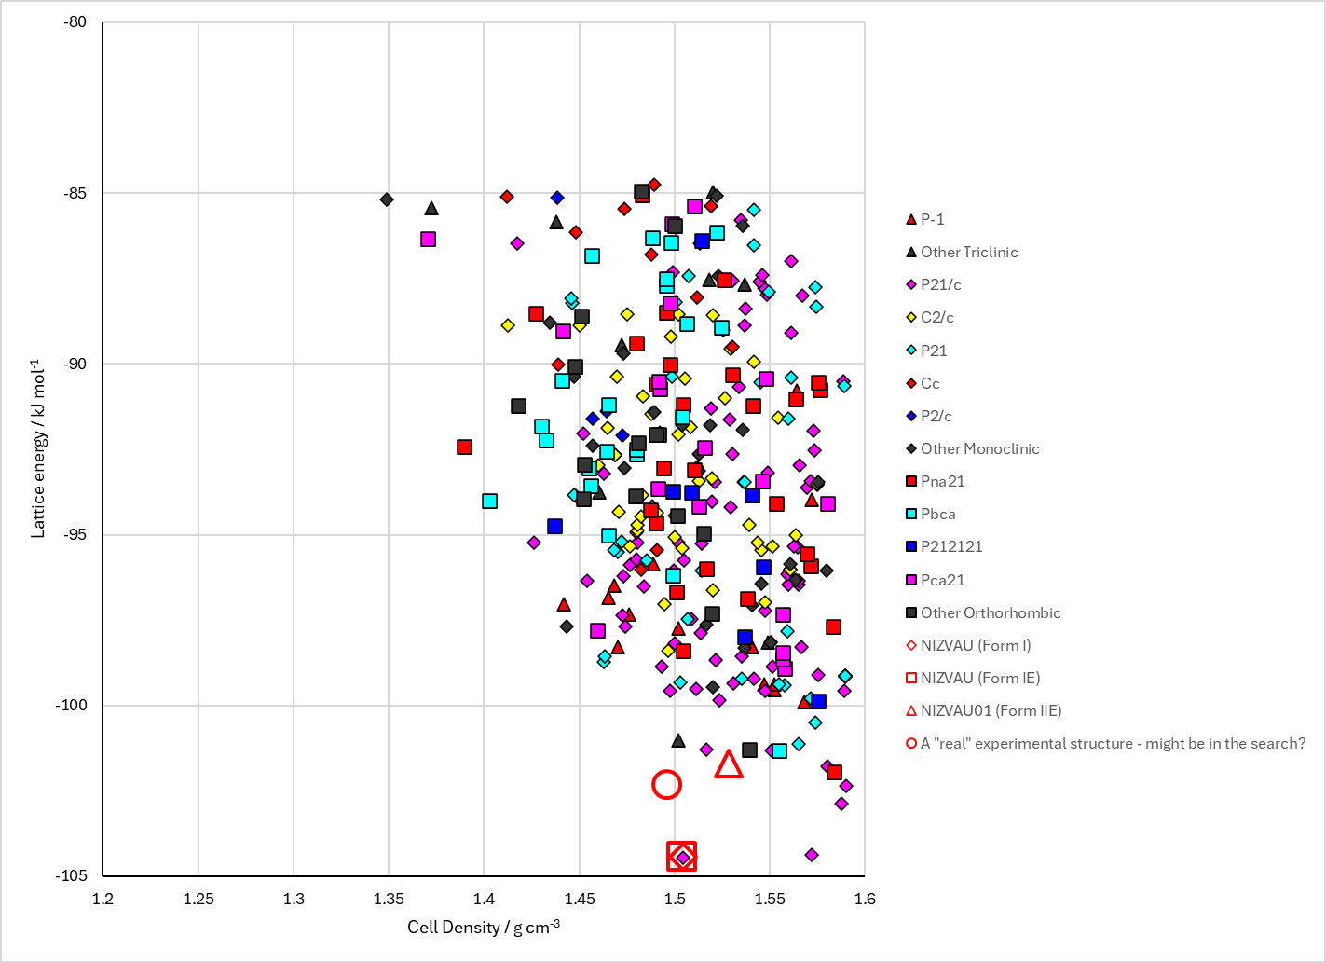
Figure 2. Crystal energy landscape of 7-fluoroisatin from previous work.

CSD structures (CSD version 6.01)

Table 1. Crystallographic information for CSD entries for 7-fluoroisatin. Different polymorphs are coloured differently.
REFCODE | space group | Z’ | a / Å | b / Å | c / Å | α / ° | β / ° | γ / ° | density / g cm⁻³ | Form
NIZVAU | P21/c | 1.0 | 3.79560 | 11.9933 | 14.9907 | 90.0 | 90.631 | 90.0 | 1.6072 | Form I
NIZVAU01 | P-1 | 2.0 | 8.12070 | 8.23510 | 12.394 | 70.87 | 85.834 | 61.023 | 1.6097 | Form II
NIZVAU02 | P21/a | 2.0 | 7.1988 | 12.7677 | 14.9468 | 90.0 | 91.702 | 90.0 | 1.5973 | Form III

Table 2. Experimental information for CSD entries for 7-fluoroisatin.
REFCODE | space group | R factor | T / K | Year | Comments
NIZVAU | P21/c | 3.04 | at 123 K | 2008 | From most solvents¹
NIZVAU01 | P-1 | 3.4 | at 123 K | 2008 | From tetrahydrofuran and 2-propanol¹
NIZVAU02 | P21/a | 7.87 | at 123 K | 2008 | From ethanol¹

Make this table include whether polymorphs are solution-grown, sublimation grown, templated or otherwise. Add references.

Other notes

(1) Mohamed, S.; Barnett, S. A.; Tocher, D. A.; Shankland, K.; Leech, C. K.; Price, S. L. Discovery of three polymorphs of 7-fluoroisatin reveals challenges in using computational crystal structure prediction as a complement to experimental screening. CrystEngComm 2008, 10, 399-404.

