Morpholin-4-ium (4-aminophenyl)sulfonyl-(5-methylisoxazol-3-yl)azanide (Blind Test XXXIII)
(Last updated February 2026)
Figure 1. The molecular diagram of Morpholin-4-ium (4-aminophenyl)sulfonyl-(5-methylisoxazol-3-yl)azanide.

CSP studies
REFCODE | ZEGWAN
Formula | C4 H10 N1 O1 + . C10 H10 N3 O3 S1 -
Common Name | Blind Test XXXIIII
IUPAC Systematic Name | Morpholin-4-ium (4-aminophenyl)sulfonyl-(5-methylisoxazol-3-yl)azanide
Other Names
CSD Refcodes | ZEGWAN, ZEGWAN01
Search Identifier | A
Scientist | Rui Guo
Date | September 2021
Publication | Hunnisett LM, et al, Acta Cryst B, 2024, 80(6), 517-547
Energy model | 1
Study_ID | 10
Programs | CrystalPredictor (2.4.3.2), CrystalOptimizer (2.4.8), DMACRYS (2.3.1.1)
Location on S Drive | CHEMISTRY_CPOSS\BlindTest2020-2022\XXXIII\CrystOpt1\
Potential Description | CrystalOptimizer PBE1PBE/6-31+G(d,p) intramolecular + GDMA2.2(PCM,E=11(PBE1PBE/6-31+G(d,p))) DMA + FIT + Scheraga SO2 parameters
Intramolecular Description | PCM11(PBE1PBE/6-31+G(d,p))
Search Identifier | B
Scientist | Louise Price, Rui Guo
Date | June 2022
Publication | Hunnisett LM, et al, Acta Cryst B, 2024, 80(6), 548-574
Energy model | 1
Study_ID | 11
Programs | CCDC supplied structures, CrystalOptimizer (2.4.8), DMACRYS (2.3.1.1)
Location on S Drive | CHEMISTRY_CPOSS\BlindTest2020-2022\XXXIII\CrystOpt2\
Potential Description | CrystalOptimizer PBE1PBE/6-31+G(d,p) intramolecular + GDMA2.2(PCM,E=11(PBE1PBE/6-31+G(d,p))) DMA + FIT + Scheraga SO2 parameters
Intramolecular Description | PCM11(PBE1PBE/6-31+G(d,p))

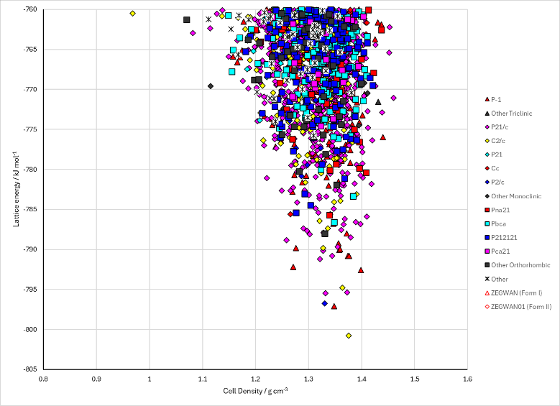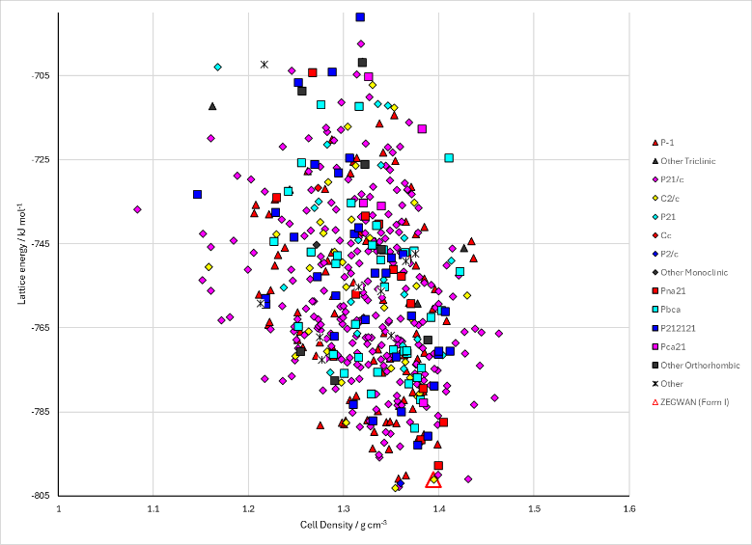
Figure 2. Crystal energy landscape of Morpholin-4-ium (4-aminophenyl)sulfonyl-(5-methylisoxazol-3-yl)azanide from previous work. Left: Energy Model A1. Right: Energy Model B1.

CSD structures (CSD version 6.01)

Table 1. Crystallographic information for CSD entries for Morpholin-4-ium (4-aminophenyl)sulfonyl-(5-methylisoxazol-3-yl)azanide. Different polymorphs are coloured differently.
REFCODE | space group | Z’ | a / Å | b / Å | c / Å | α / ° | β / ° | γ / ° | density / g cm⁻³ | Form
ZEGWAN | C2/c | 1 | 24.9972 | 10.5875 | 12.9323 | 90 | 104.502 | 90 | 1.365 | I
ZEGWAN01 | Pna21 | 1 | 11.7407 | 12.4207 | 11.3775 | 90 | 90 | 90 | 1.363 | II

Table 2. Experimental information for CSD entries for Morpholin-4-ium (4-aminophenyl)sulfonyl-(5-methylisoxazol-3-yl)azanide.
REFCODE | space group | R factor | T / K | Year | Comments
ZEGWAN | C2/c | 3.58 | 296 | 2022 | Private communication; also 10.1107/S2052520624007492
ZEGWAN01 | Pna21 | 2.32 | 297 | 2022 | Private communication; also 10.1107/S2052520624007492

Make this table include whether polymorphs are solution-grown, sublimation grown, templated or otherwise. Add references.

Other notes

