Ephedrinium Tartrate
(Last updated May 2026)
Figure 1. The molecular diagram of Ephedrinium Tartrate.

CSP studies
REFCODE | WEMGEC
Formula | C10 H16 N1 O1 - C4 H5 O6
Common Name | Ephedrine Tartrate
IUPAC Systematic Name | Ephedrinium Tartrate
Other Names
CSD Refcodes | WEMGEC
Search Identifier | A
Scientist | Matthew Habgood
Date | 2012
Publication | Wu H, Habgood M, Parker JE, Reeves-McLaren N, Cockcroft JK, Vickers M, West AR, Jones AG 2013. CrystEngComm 15, 1853-1859.
Energy model | 2
Study_ID | 30
Programs | Study_ID=10, DMACRYS (2.0.4)
Location on S Drive | \CHEMISTRY_CPOSS\EphedriniumTartrate\PCM
Potential Description | GDMA2.2(PCMdielectric3(MP2/6-31G(d,p))) + FIT
Intramolecular Description | PCM3(MP2/6-32G(d,p))
Energy model | 1
Study_ID | 10
Programs | Flexible CrystalPredictor, CrystalOptimizer, DMACRYS (2.0.4)
Location on S Drive | \CHEMISTRY_CPOSS\EphedriniumTartrate\CrystalOptimizer
Potential Description | CrystalOptimizer with 12 degrees of freedom, GDMA2.2 (MP2/6-31G(d,p)) + FIT
Intramolecular Description | HF/6-31G(d,p)

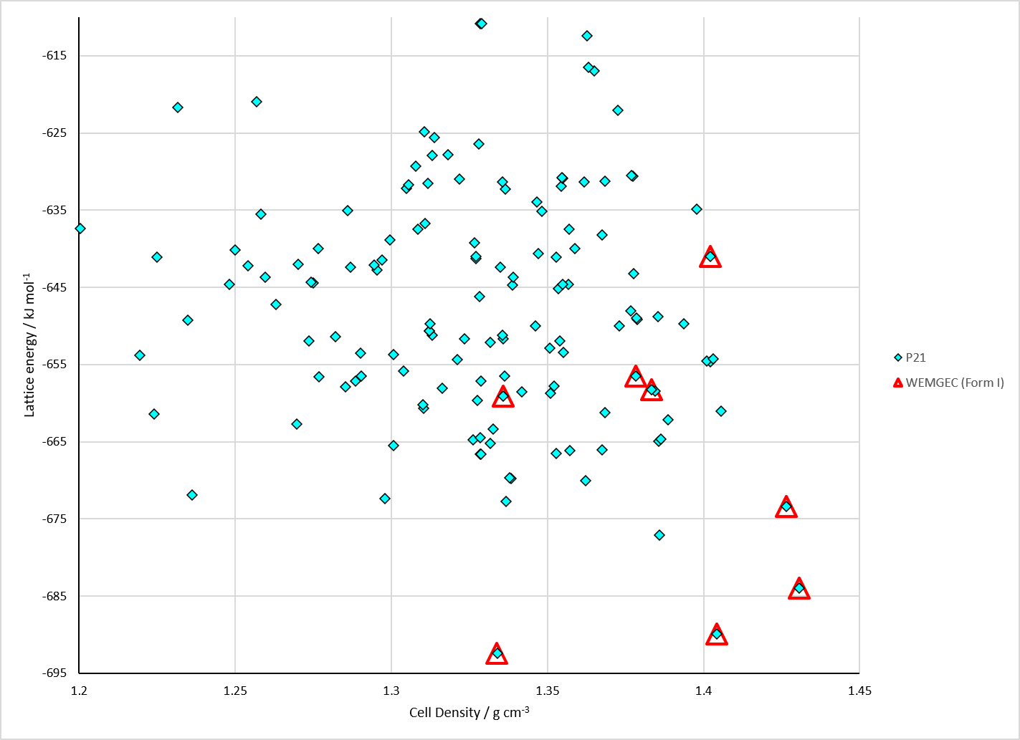
Figure 2. Crystal energy landscape of Ephedrinium Tartrate from previous work. Energy model = A2.

CSD structures (CSD version 6.01 with Feb 2026 update)

Table 1. Crystallographic information for CSD entries for Ephedrinium Tartrate. Different polymorphs are coloured differently.
REFCODE | space group | Z’ | a / Å | b / Å | c / Å | α / ° | β / ° | γ / ° | density / g cm⁻³ | Form
WEMGEC | P21 | 1.0 | 18.8281 | 7.19429 | 5.73035 | 90.0 | 95.961260 | 90.0 | 1.3564 | None

Table 2. Experimental information for CSD entries for Ephedrinium Tartrate.
REFCODE | space group | R factor | T / K | Year | Comments
WEMGEC | P21 | None | at 295 K | 2013 | 10.1039/c2ce26097b

Make this table include whether polymorphs are solution-grown, sublimation grown, templated or otherwise. Add references.

Other notes

