N,N'-(1,1'dynaphthyl)-bis-2-clorobenzamide (Blind Test XXVI)
(Last updated February 2026)
Figure 1. The molecular diagram of N,N'-(1,1'dynaphthyl)-bis-2-clorobenzamide.

CSP studies
REFCODE | XAFQIH
Formula | C34 H22 N2 O2 Cl2
Common Name
IUPAC Systematic Name | N,N'-(1,1'dynaphthyl)-bis-2-clorobenzamide
Other Names | Blind Test XXVI
CSD Refcodes | XAFQIH
Search Identifier | A
Scientist | Luca Iuzzolino
Date | 2015
Publication | See Study_IDs 10 and 30
Energy model | 1
Study_ID | 20
Programs | Rigid CrystalPredictor, DMACRYS (2.0.8)
Location on S Drive | \CHEMISTRY_CPOSS\BlindTest2015\XAFQIH\CrystPred
Potential Description | CrystalPredictor2.1(rigid) + DMACRYS +GDMA2.2(PBE1PBE/6-31G(d,p) + FIT
Intramolecular Description | PBE1PBE/6-31G(d,p)
Search Identifier | B
Scientist | Luca Iuzzolino
Date | 2015
Publication | Reilly, AM et al, Acta Cryst. B, (2016) 72, 439-459 (List 1)
Energy model | 2
Study_ID | 10
Programs | Study_ID=11, CrystalOptimizer, DMACRYS (2.2.0.1)
Location on S Drive | \CHEMISTRY_CPOSS\BlindTest2015\XAFQIH\CrystOpt
Potential Description | CrystalPredictor1.6 + CrystalOptimizer with GDMA2.2(PBE1PBE/6-31G(d,p)) + FIT
Intramolecular Description | PBE1PBE/6-31G(d,p)
Energy model | 3
Study_ID | 30
Programs | Study_ID=10, DMACRYS (2.2.0.1)
Location on S Drive | \CHEMISTRY_CPOSS\BlindTest2015\XAFQIH\PCM
Potential Description | GDMA2.2(PCMdielectric3(PBE1PBE/6-31G(d,p))) + FIT
Intramolecular Description | PCM3(PBE0/6-31G(d,p))
Energy model | 4
Study_ID | 12
Programs | Study_ID=10, CrystalOptimizer, DMACRYS (2.2.0.1)
Location on S Drive | \CHEMISTRY_CPOSS\BlindTest2015\XAFQIH\CrystOpt_Will
Potential Description | CrystalPredictor1.6 + CrystalOptimizer with GDMA2.2(PBE1PBE/6-31G(d,p)) + Will
Intramolecular Description | PBE1PBE/6-31G(d,p)
Energy model | 1
Study_ID | 11
Programs | Study_ID=20, Single step CrystalOptimizer, DMACRYS (2.2.0.1)
Location on S Drive | \CHEMISTRY_CPOSS\BlindTest2015\XAFQIH\CrystOpt_1
Potential Description | CrystalPredictor1.6 + single step CrystalOptimizer with GDMA2.2(PBE1PBE/6-31G(d,p)) + FIT
Intramolecular Description | PBE1PBE/6-31G(d,p)
Search Identifier | C
Scientist | Luca Iuzzolino
Date | 2018
Publication | Iuzzolino, L.; McCabe, P.; Price, S. L.; Brandenburg, J. G., Faraday Discussions 2018, 211, 275-296.
Energy model | 1
Study_ID | 60
Programs | Rigid CrystalPredictor, DFTB3-D3, DMACRYS (2.2.0.1)
Location on S Drive | \CHEMISTRY_CPOSS\LucasSearches\BlindTest_XXVI
Potential Description | CrystalPredictor, followed by DFTB3-D3 refinement, followed by DMACRYS with GDMA2.2(PBE0/6-31G(d,p)) + FIT
Intramolecular Description | PBE0/6-31G(d,p)

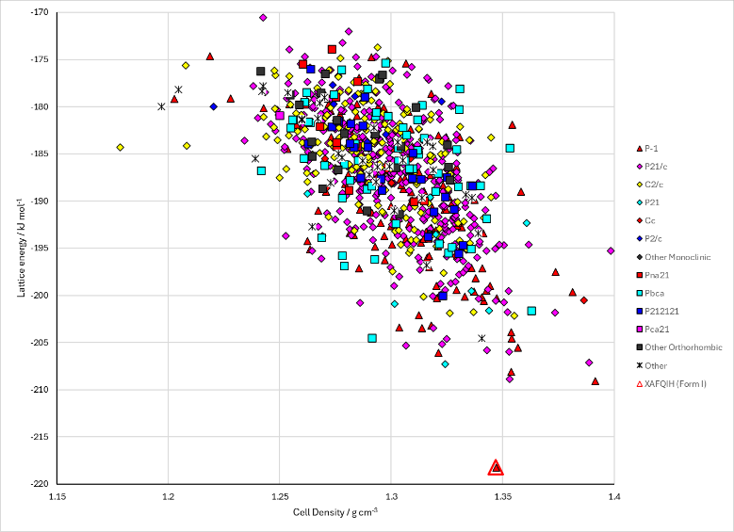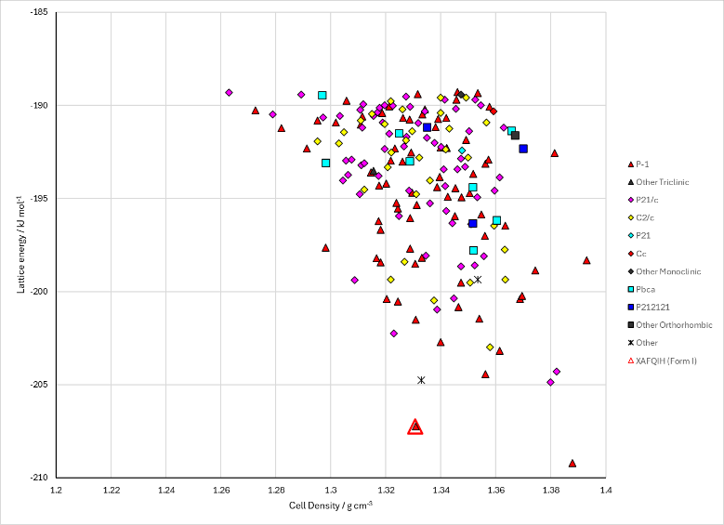
Figure 2. Crystal energy landscape of N,N’-(1,1’dynaphthyl)-bis-2-clorobenzamide from previous work. Left: Energy Model B3. Right: Energy Model C1.

CSD structures (CSD version 6.01)

Table 1. Crystallographic information for CSD entries for N,N’-(1,1’dynaphthyl)-bis-2-clorobenzamide. Different polymorphs are coloured differently.
REFCODE | space group | Z’ | a / Å | b / Å | c / Å | α / ° | β / ° | γ / ° | density / g cm⁻³ | Form
XAFQIH | P-1 | 1.0 | 10.4022 | 11.0302 | 14.1789 | 76.829000 | 73.331 | 63.47 | 1.3463 | None

Table 2. Experimental information for CSD entries for N,N’-(1,1’dynaphthyl)-bis-2-clorobenzamide.
REFCODE | space group | R factor | T / K | Year | Comments
XAFQIH | P-1 | 4.91 | 298 K | 2016 | Private communication

Make this table include whether polymorphs are solution-grown, sublimation grown, templated or otherwise. Add references.

Other notes
I cannot remember how the structures were renamed between the CrystalPredictor search (A1) and the CrystalOptimizer single step (B1). Attempting structure matching was not successful, finding only 24 matches among the first 167 structures (in CrystOpt_1, so had to have come from CrystPred and not changed very much). This was in 4 days. The paper does not have details.

