Salt and cocrystal:
4-cyanopyridine 4-fluorobenzoic acid
(Last updated February 2026)
Figure 1. The molecular diagram of 4-cyanopyridine 4-fluorobenzoic acid and 4-cyanopyridinium 4-fluorobenzoate.

CSP studies
REFCODE | SARKII
Formula | C6 H4 N2 - C7 H5 O2 F
Common Name | 4-cyanopyridine 4-fluorobenzoic acid
IUPAC Systematic Name | 4-cyanopyridine 4-fluorobenzoic acid
Other Names
CSD Refcodes | SARKII
Search Identifier | A
Scientist | Sharmarke Mohamed
Date | 2011
Publication | Mohamed S, Tocher DA, Price SL 2011. Int J Pharm 218
Energy model | 1
Study_ID | 20
Programs | Rigid CrystalPredictor, DMACRYS (2.0.2)
Location on S Drive | CHEMISTRY_CPOSS\SaltOrCocrystal-IntJPharm2011\cyanopyridinefluorobenzoicacid\4cyanopyridine-4fluorobenzoicacid
Potential Description | DMA(MP2 6-31(d,p)) + FIT + Theresa Beyer OH parameters
Intramolecular Description | MP2/6-31G(d,p)
REFCODE | UCLSME
Formula | C6 H5 N2 - C7 H4 O2 F1
Common Name | 4-cyanopyridinium 4-fluorobenzoate
IUPAC Systematic Name | 4-cyanopyridinium 4-fluorobenzoate
Other Names
CSD Refcodes
Search Identifier | A
Scientist | Sharmarke Mohamed
Date | 2011
Publication | Mohamed S, Tocher DA, Price SL 2011. Int J Pharm 218
Energy model | 1
Study_ID | 20
Programs | Rigid CrystalPredictor, DMACRYS (2.0.2)
Location on S Drive | CHEMISTRY_CPOSS\SaltOrCocrystal-IntJPharm2011\cyanopyridinefluorobenzoicacid\4cyanopyridinium-4fluorobenzoate
Potential Description | DMA(MP2 6-31(d,p)) + FIT + Theresa Beyer OH parameters
Intramolecular Description | MP2/6-31G(d,p)

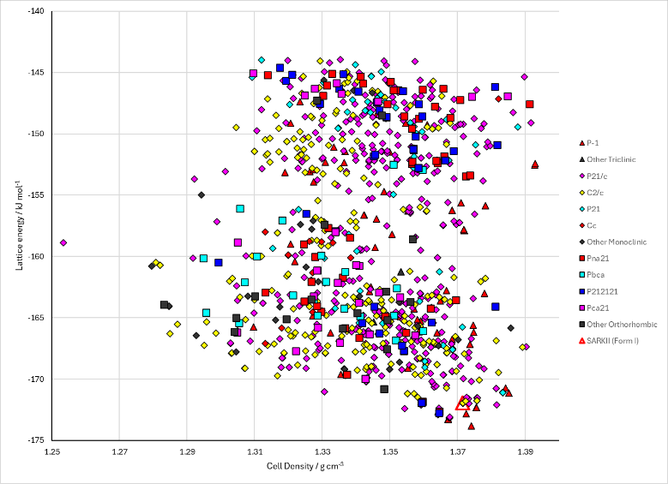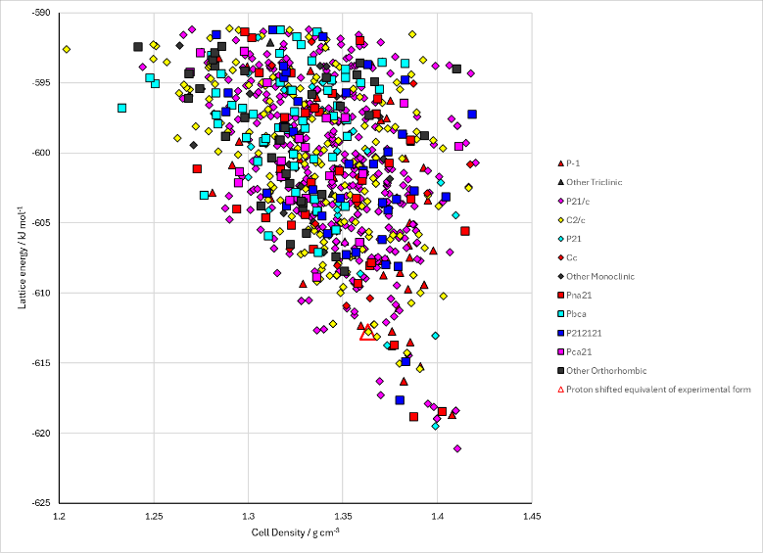
Figure 2. Crystal energy landscape of 4-cyanopyridine 4-fluorobenzoic acid and 4-cyanopyridinium 4-fluorobenzoate from previous work.

CSD structures (CSD version 6.01)

Table 1. Crystallographic information for CSD entries for 4-cyanopyridine 4-fluorobenzoic acid and 4-cyanopyridinium 4-fluorobenzoate. Different polymorphs are coloured differently.
REFCODE | space group | Z’ | a / Å | b / Å | c / Å | α / ° | β / ° | γ / ° | density / g cm⁻³ | Form
SARKII | C2/c | 1.0 | 12.959 | 7.48520 | 23.703 | 90.0 | 91.632 | 90.0 | 1.4116 | None

Table 2. Experimental information for CSD entries for 4-cyanopyridine 4-fluorobenzoic acid and 4-cyanopyridinium 4-fluorobenzoate.
REFCODE | space group | R factor | T / K | Year | Comments
SARKII | C2/c | 4.01 | 150 K | 2011 | 10.1016/j.ijpharm.2011.03.063

Make this table include whether polymorphs are solution-grown, sublimation grown, templated or otherwise. Add references.

Other notes

