Salt and cocrystal:
4-dimethylanimopyridine maleic acid
(Last updated February 2026)
Figure 1. The molecular diagram of 4-dimethylaminopyridine maleic acid and 4-dimethylaminopyridinium maleate.

CSP studies
REFCODE | UCLSMB
Formula | C7 H10 N2 - C4 H4 O4
Common Name | 4-dimethylaminopyridine - butan-1,4-dioic acid
IUPAC Systematic Name | 4-dimethylaminopyridine - butan-1,4-dioic acid
Other Names
CSD Refcodes
Search Identifier | A
Scientist | Sharmarke Mohamed
Date | 2011
Publication | Mohamed S, Tocher DA, Price SL 2011. Int J Pharm 218
Energy model | 1
Study_ID | 20
Programs | Rigid CrystalPredictor, DMACRYS (2.0.0)
Location on S Drive | \CHEMISTRY_CPOSS\SaltOrCocrystal-IntJPharm2011\dimethylaminopyridinemaleicacid\4dimethylaminopyridine-maleicacid
Potential Description | DMA(MP2 6-31(d,p)) + FIT + Theresa Beyer OH parameters
Intramolecular Description | MP2/6-31G(d,p)
REFCODE | GUKVUE
Formula | C7 H11 N2 - C4 H3 O4
Common Name | 4-dimethylaminopyridinium - butan-1-carboxylate-4-carboxylic acid
IUPAC Systematic Name | 4-dimethylaminopyridinium - butan-1-carboxylate-4-carboxylic acid
Other Names
CSD Refcodes | GUKVUE
Search Identifier | A
Scientist | Sharmarke Mohamed
Date | 2011
Publication | Mohamed S, Tocher DA, Price SL 2011. Int J Pharm 218
Energy model | 1
Study_ID | 20
Programs | Rigid CrystalPredictor, DMACRYS (2.0.0)
Location on S Drive | \CHEMISTRY_CPOSS\SaltOrCocrystal-IntJPharm2011\dimethylaminopyridinemaleicacid\4dimethylaminopyridinium-maleate
Potential Description | DMA(MP2 6-31(d,p)) + FIT + Theresa Beyer OH parameters
Intramolecular Description | MP2/6-31G(d,p)

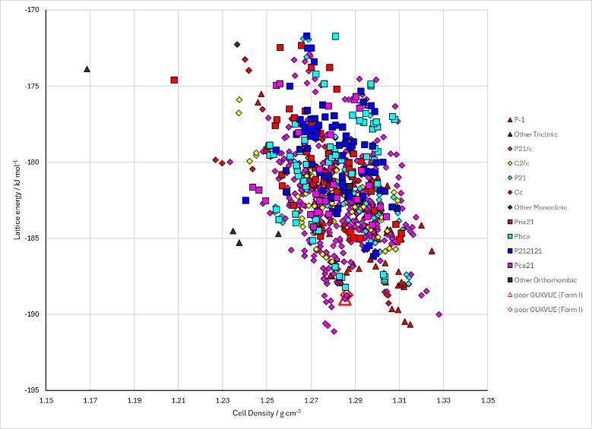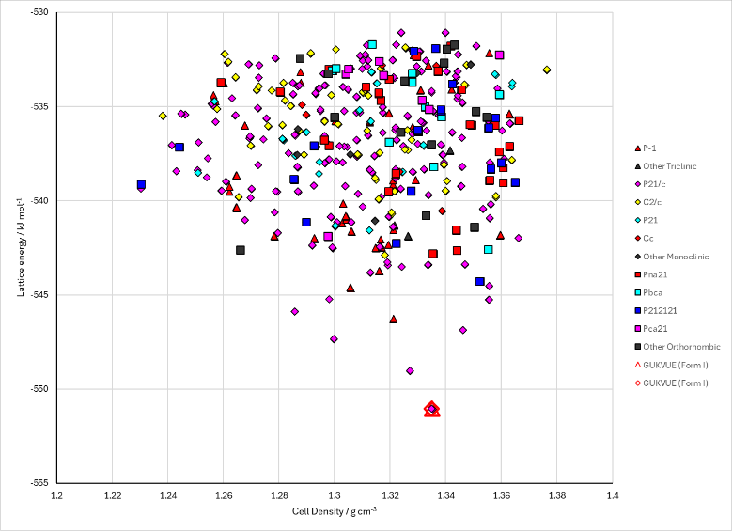
Figure 2. Crystal energy landscape of 4-dimethylaminopyridine maleic acid and 4-dimethylaminopyridinium maleate from previous work.

CSD structures (CSD version 6.01)

Table 1. Crystallographic information for CSD entries for 4-dimethylaminopyridine maleic acid and 4-dimethylaminopyridinium maleate. Different polymorphs are coloured differently.
REFCODE | space group | Z’ | a / Å | b / Å | c / Å | α / ° | β / ° | γ / ° | density / g cm⁻³ | Form
GUKVUE | P21/c | 1.0 | 13.127 | 7.599 | 12.576 | 90.0 | 114.23700 | 90.0 | 1.3833 | None

Table 2. Experimental information for CSD entries for 4-dimethylaminopyridine maleic acid and 4-dimethylaminopyridinium maleate.
REFCODE | space group | R factor | T / K | Year | Comments
GUKVUE | P21/c | 6.08 | at 150 K | 2009 | 10.1021/cg9001994

Make this table include whether polymorphs are solution-grown, sublimation grown, templated or otherwise. Add references.

Other notes

