Salt and cocrystal:
pyridine isophthalic acid
(Last updated February 2026)
Figure 1. The molecular diagram of pyridine isophthalic acid and pyridinium isophthalate.

CSP studies
REFCODE | IYUPEX
Formula | C5 H5 N1 - C8 H6 O4
Common Name | pyridine isophthalic acid cocrystal
IUPAC Systematic Name | pyridine isophthalic acid cocrystal
Other Names
CSD Refcodes | IYUPEX
Search Identifier | A
Scientist | Sharmarke Mohamed
Date | 2011
Publication | Mohamed S, Tocher DA, Price SL 2011. Int J Pharm 218
Energy model | 1
Study_ID | 20
Programs | Rigid CrystalPredictor, DMACRYS (2.0.0)
Location on S Drive | \CHEMISTRY_CPOSS\SaltOrCocrystal-IntJPharm2011\pyridineisophthalicacid\pyridine-isophthalicacid
Potential Description | DMA(MP2 6-31(d,p)) + FIT + Theresa Beyer OH parameters
Intramolecular Description | MP2/6-31G(d,p)
REFCODE | IYUPEX
Formula | C5 H5 N1 - C8 H6 O4
Common Name | pyridinium isophthalate
IUPAC Systematic Name | pyridinium isophthalate
Other Names
CSD Refcodes | IYUPEX
Search Identifier | A
Scientist | Sharmarke Mohamed
Date | 2011
Publication | Mohamed S, Tocher DA, Price SL 2011. Int J Pharm 218
Energy model | 1
Study_ID | 21
Programs | Rigid CrystalPredictor, DMACRYS (2.0.0)
Location on S Drive | \CHEMISTRY_CPOSS\SaltOrCocrystal-IntJPharm2011\pyridineisophthalicacid\pyridiniumisophthalate
Potential Description | DMA(MP2 6-31(d,p)) + FIT + Theresa Beyer OH parameters
Intramolecular Description | MP2/6-31G(d,p)

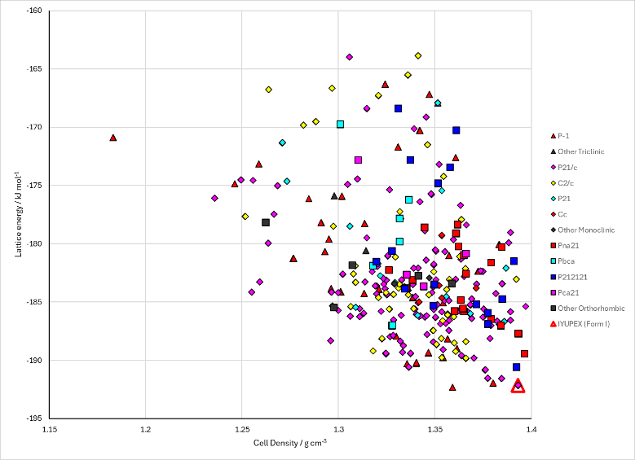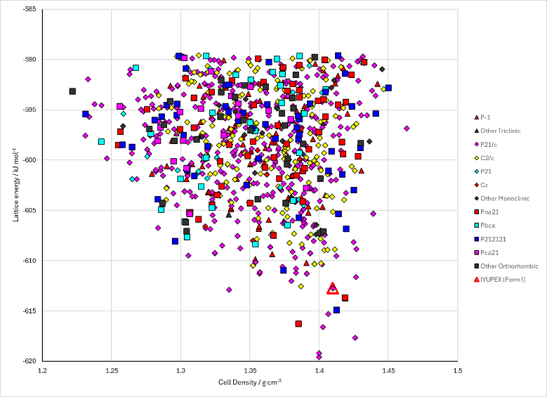
Figure 2. Crystal energy landscape of pyridine isophthalic acid and pyridinium isophthalate from previous work.

CSD structures (CSD version 6.01)

Table 1. Crystallographic information for CSD entries for pyridine isophthalic acid and pyridinium isophthalate. Different polymorphs are coloured differently.
REFCODE | space group | Z’ | a / Å | b / Å | c / Å | α / ° | β / ° | γ / ° | density / g cm⁻³ | Form
IYUPEX | P21/c | 1.0 | 3.79690 | 17.2355 | 17.2272 | 90.0 | 90.374 | 90.0 | 1.4448 | None

Table 2. Experimental information for CSD entries for pyridine isophthalic acid and pyridinium isophthalate.
REFCODE | space group | R factor | T / K | Year | Comments
IYUPEX | P21/c | 3.4 | at 150 K | 2004 | 10.1039/b404563g

Make this table include whether polymorphs are solution-grown, sublimation grown, templated or otherwise. Add references.

Other notes

