Isocytosine
(Last updated May 2026)
Figure 1. The molecular diagram of the two tautomers of Isocytosine.

CSP studies
The searches for the two tautomers had to be considered separately.
REFCODE | ICYTIN
Formula | C4 H5 N3 O1
Common Name | Isocytosine Tautomer 1
IUPAC Systematic Name | 2-Amino-1H-pyrimidin-4-one
Other Names
CSD Refcodes | ICYTIN01
Search Identifier | A
Scientist | Ashley Hulme
Date | pre-2010
Publication | No publication planned.
Energy model | 1
Study_ID | 0
Programs | MOLPAK, DMAREL (4.1.1)
Location on S Drive | \CHEMISTRY_CPOSS\0-EarlySearches\home\louise_price.eminerals\isocytosine1
Potential Description | DMA + FIT
Intramolecular Description | MP2/6-31G(d,p)
Search Identifier | B
Scientist | Ashley Hulme
Date | pre-2010
Publication | No publication planned.
Energy model | 1
Study_ID | 1
Programs | MOLPAK, DMAREL (4.1.1)
Location on S Drive | \CHEMISTRY_CPOSS\0-EarlySearches\home\louise_price.eminerals\isocytosine2
Potential Description | DMA + FIT
Intramolecular Description | MP2/6-31G(d,p)

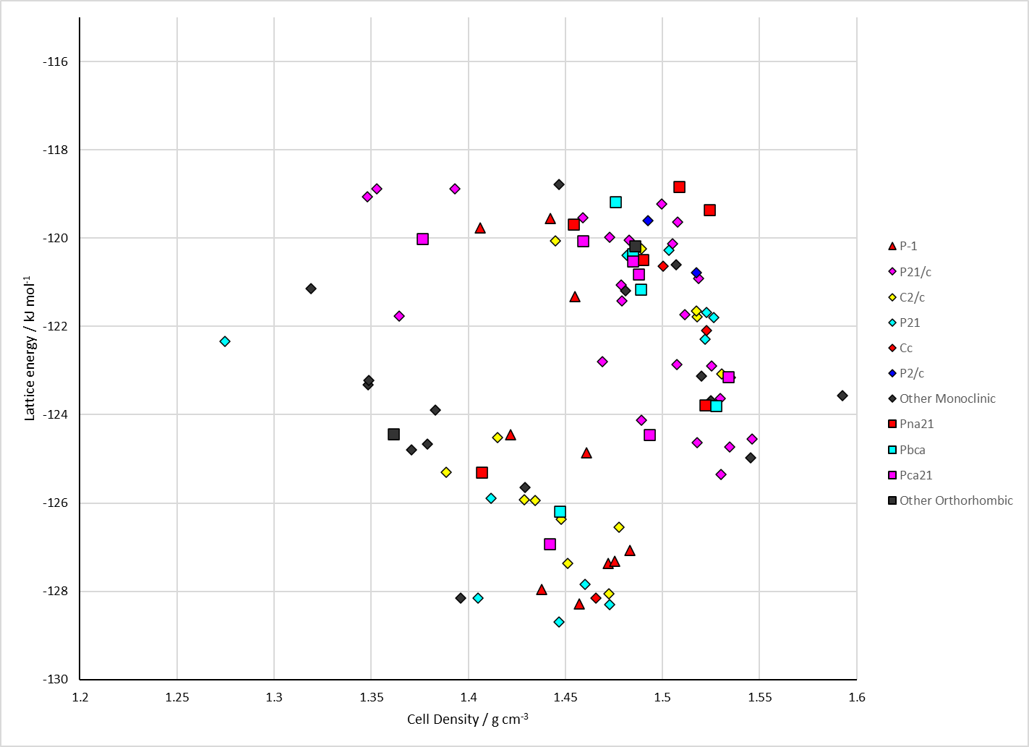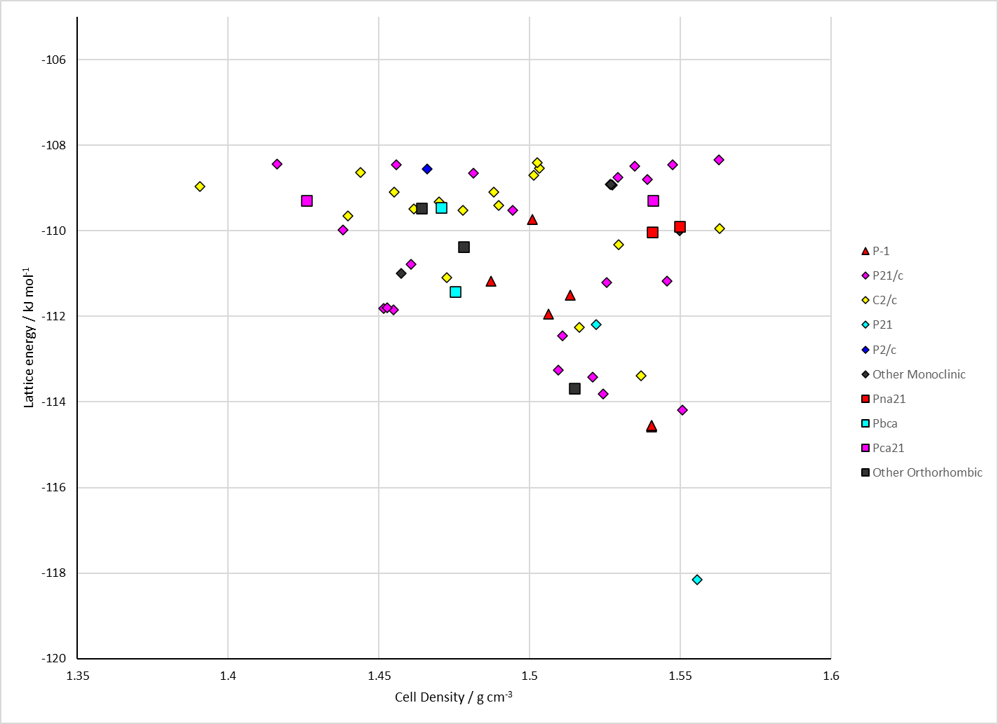
Figure 2. Crystal energy landscape of the two tautomers of Isocytosine from previous work.

CSD structures (CSD version 6.01 with Feb 2026 update)

Table 1. Crystallographic information for CSD entries for Isocytosine. Different polymorphs are coloured differently.
REFCODE | space group | Z’ | a / Å | b / Å | c / Å | α / ° | β / ° | γ / ° | density / g cm⁻³ | Form
ICYTIN | P21/n | 1.0 | 8.74500 | 11.412 | 10.441 | 90.0 | 94.78 | 90.0 | 1.4213 | None
ICYTIN01 | P21/n | 2.0 | 8.7211 | 11.4222 | 10.5027 | 90.0 | 94.605 | 90.0 | 1.4152 | None

Table 2. Experimental information for CSD entries for Isocytosine.
REFCODE | space group | R factor | T / K | Year | Comments
ICYTIN | P21/n | 6.100 | None | 1965 | 10.1107/S0365110X65004371
ICYTIN01 | P21/n | 5.36 | at 298 K | 2007 | 10.1107/S1600536807012494

Make this table include whether polymorphs are solution-grown, sublimation grown, templated or otherwise. Add references.

Other notes

