Hydantoin (Blind Test VIII)
(Last updated March 2026)
Figure 1. The molecular diagram of Hydantoin.

CSP studies
REFCODE | PAHYON
Formula | C3 H4 N2 O2
Common Name | Hydantoin
IUPAC Systematic Name | Imidazolidine-2,4-dione
Other Names | Blind Test 8
CSD Refcodes | PAHYON01
Search Identifier | A
Scientist | Tom Lewis
Date | 2005
Publication | Day GM et al, Acta Cryst. B 2005, 61 (5), 511-527
Energy model | 1
Study_ID | 0
Programs | Molpak, DMAREL (3.0)
Location on S Drive | \CHEMISTRY_CPOSS\0-EarlySearches\home\louise_price.eminerals\hydantoin
Potential Description | DMA + FIT
Intramolecular Description | Ab initio MP2

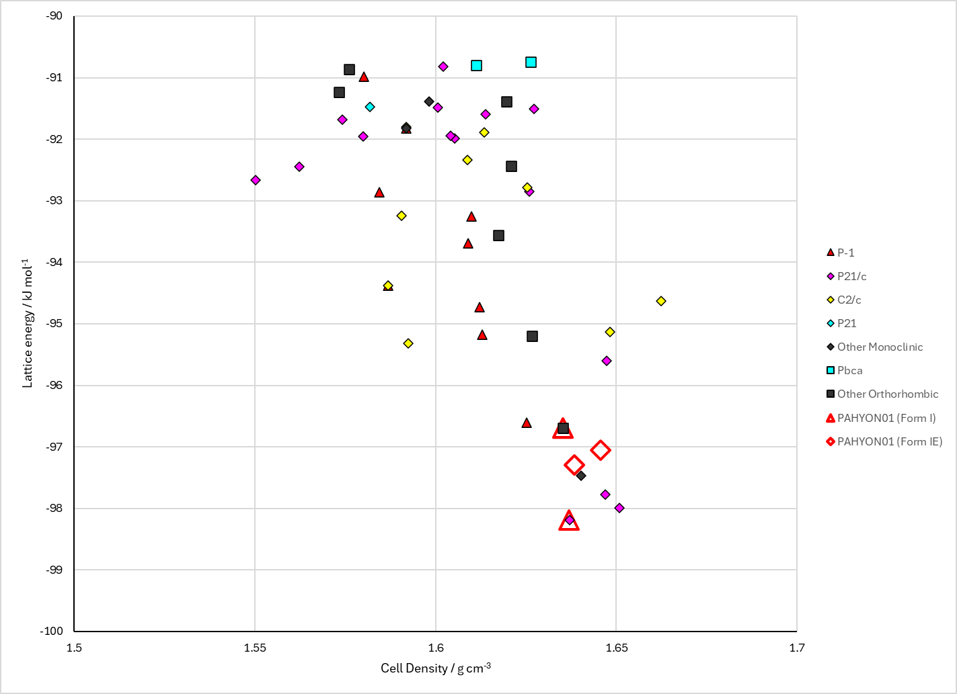
Figure 2. Crystal energy landscape of Hydantoin from previous work.

CSD structures (CSD version 6.01)

Table 1. Crystallographic information for CSD entries for Hydantoin. Different polymorphs are coloured differently.
REFCODE | space group | Z’ | a / Å | b / Å | c / Å | α / ° | β / ° | γ / ° | density / g cm⁻³ | Form
PAHYON | C2/c | 1.0 | 9.3538 | 12.1757 | 7.2286 | 90.0 | 104.593 | 90.0 | 1.6686 | None
PAHYON01 | C2/c | 1.0 | 9.3538 | 12.1757 | 7.2286 | 90.0 | 104.593 | 90.0 | 1.6686 | None
PAHYON02 | C2/c | 1.0 | 9.39900 | 12.242 | 7.375 | 90.0 | 105.205 | 90.0 | 1.6234 | None
PAHYON04 | C2/c | 1.0 | 9.3446 | 12.244 | 7.34580 | 90.0 | 105.194 | 90.0 | 1.6390 | None

Table 2. Experimental information for CSD entries for Hydantoin.
REFCODE | space group | R factor | T / K | Year | Comments
PAHYON | C2/c | 6.11 | at 190 K | 2004 | 10.1107/S0108270104017706
PAHYON01 | C2/c | 6.11 | at 190 K | 2005 | 10.1107/S0108768105016563
PAHYON02 | C2/c | 12.01 | 299.1 K | 2019 | None
PAHYON04 | C2/c | 5.46 | 293 K | 2020 | 10.1039/D0MH00688B

Make this table include whether polymorphs are solution-grown, sublimation grown, templated or otherwise. Add references.

Other notes

