Amino pyrimidine Otolic acid cocrystal (Blind Test XV)
(Last updated March 2026)
Figure 1. The molecular diagram of amino pyrimidine and otolic acid.

CSP studies
REFCODE | WICZUF
Formula | C13 H15 N3 O2
Common Name | amino-pyrimidine otolic acid cocrystal
IUPAC Systematic Name | 4-methyl-pyrimidin-2-ylamine - 2-methylbenzoic acid cocrystal
Other Names
CSD Refcodes | WICZUF
Search Identifier | A
Scientist | Panos Karamertzanis
Date | 2008
Publication | Day GM, 2009. Acta Crystallogr , Sect B 65, 107-125.
Energy model | 1
Study_ID | 0
Programs | MOLPAK, DMAREL (4.1.1)
Location on S Drive | \CHEMISTRY_CPOSS\0-EarlySearches\home\louise_price.eminerals\BlindTestXV\btxvcc_molpak
Potential Description | MP2 6-31G(d,p) DMA(1.1)+ fit.pots
Intramolecular Description | MP2 6-31G(d,p)
Search Identifier | B
Scientist | Panos Karamertzanis
Date | 2008
Publication | Day GM, 2009. Acta Crystallogr , Sect B 65, 107-125.
Energy model | 1
Study_ID | 10
Programs | Flexible CrystalPredictor (1), Dmaflex, DMAREL (4.1.1)
Location on S Drive | \CHEMISTRY_CPOSS\0-EarlySearches\home\louise_price.eminerals\BlindTestXV\btxvcc_dmaflex
Potential Description | DMAflex GDMA2.1 + FIT
Intramolecular Description | MP2/6-31G(d,p)

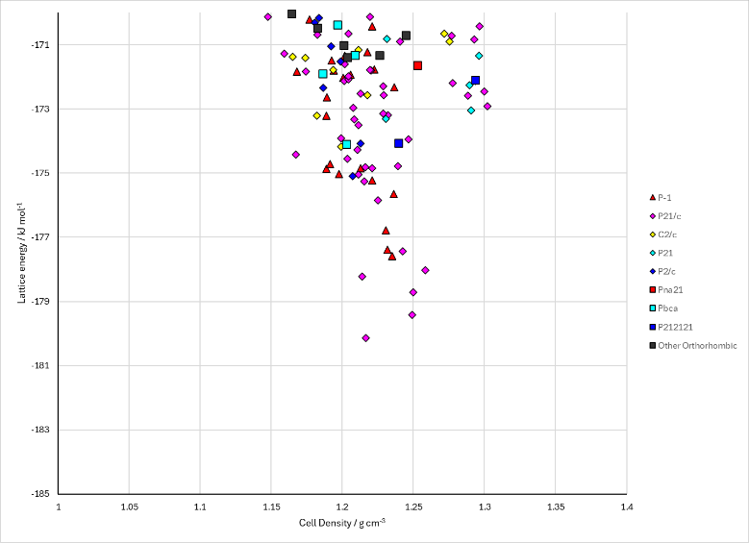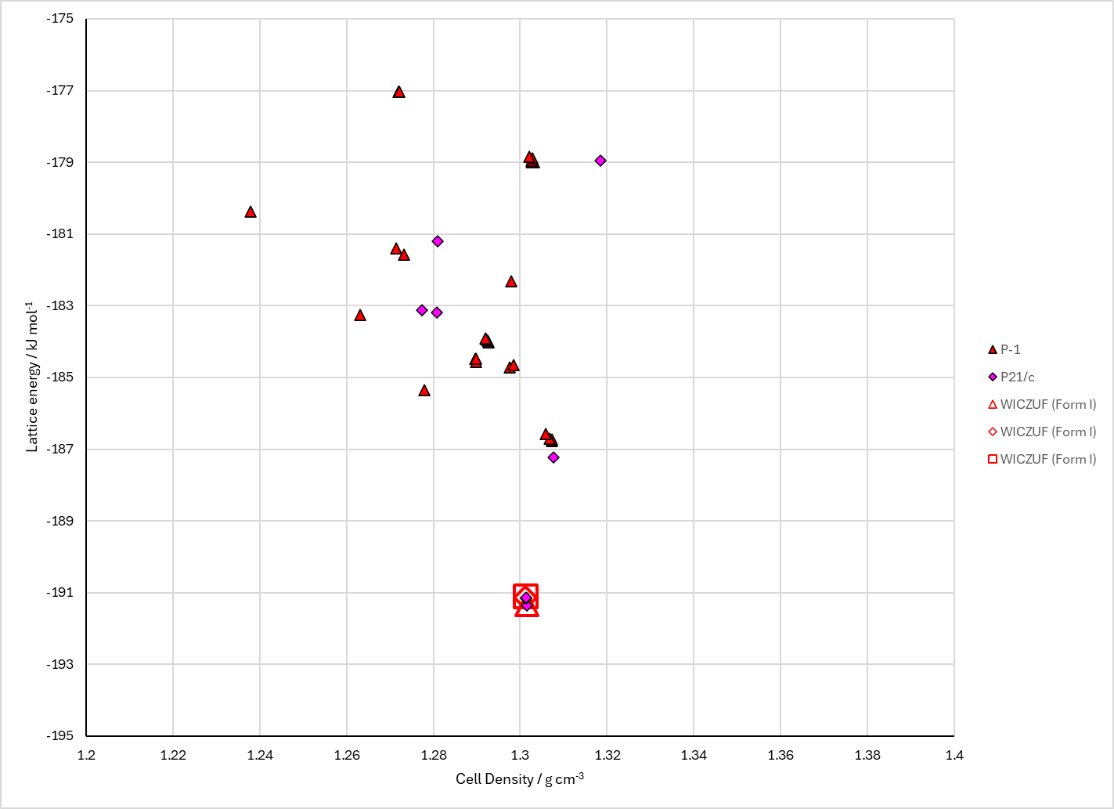
Figure 2. Crystal energy landscape of amino pyrimidine and otolic acid from previous work. Left: From MOLPAK (Energy Model A1). Right: From CrystalPredictor and DMAflex (Energy Model B1).

CSD structures (CSD version 6.01)

Table 1. Crystallographic information for CSD entries for amino pyrimidine and otolic acid. Different polymorphs are coloured differently.
REFCODE | space group | Z’ | a / Å | b / Å | c / Å | α / ° | β / ° | γ / ° | density / g cm⁻³ | Form
WICZUF | P21/n | 1.0 | 7.27950 | 13.6699 | 12.6695 | 90.0 | 96.646 | 90.0 | 1.3009 | None
WICZUF01 | P21/n | 1.0 | 7.271 | 13.5961 | 12.6804 | 90.0 | 97.069 | 90.0 | 1.3095 | None

Table 2. Experimental information for CSD entries for amino pyrimidine and otolic acid.
REFCODE | space group | R factor | T / K | Year | Comments
WICZUF | P21/n | 4.57 | 203 K | 2009 | 10.1107/S0108768109004066
WICZUF01 | P21/n | 8.69 | 100 K | 2016 | None

Make this table include whether polymorphs are solution-grown, sublimation grown, templated or otherwise. Add references.

Other notes

