Desloratadine
(Last updated December 2025)
Figure 1. The molecular diagram of desloratadine.

CSP studies
REFCODE | GEHXEX
Formula | C19 H19 N2 Cl1
Common Name | Desloratadine
IUPAC Systematic Name | 8-chloro-6,11-dihydro-11-(4-piperdinylidene)- 5H-benzo[5,6]cyclohepta[1,2-b]pyridine
Other Names
CSD Refcodes | GEHXEX01, GEHXEX04, GEHXEX02
Search Identifier | A
Scientist | Rui Guo
Date | December 2016
Publication | Srirambhatla VK, Guo R, Dawson DM, Price SL, Florence AJ, Cryst Growth Des 2020, 20(3), 1800
Energy model | 1
Study_ID | 10
Programs | CrystalPredictor (2.1.01), CrystalOptimizer (2.4), DMACRYS (2.2.0.1)
Location on S Drive | CHEMISTRY_CPOSS\Desloratadine\CrystOpt
Potential Description | CrystalOptimizer with GDMA2.2(PBE0/6-31G(d,p)) + FIT
Energy model | 2
Study_ID | 30
Programs | Study_ID=10, DMACRYS (2.2.0.1)
Location on S Drive | CHEMISTRY_CPOSS\Desloratadine\PCM
Potential Description | GDMA2.2(PCMdielectric3(PBE0/6-31G(d,p))) + FIT

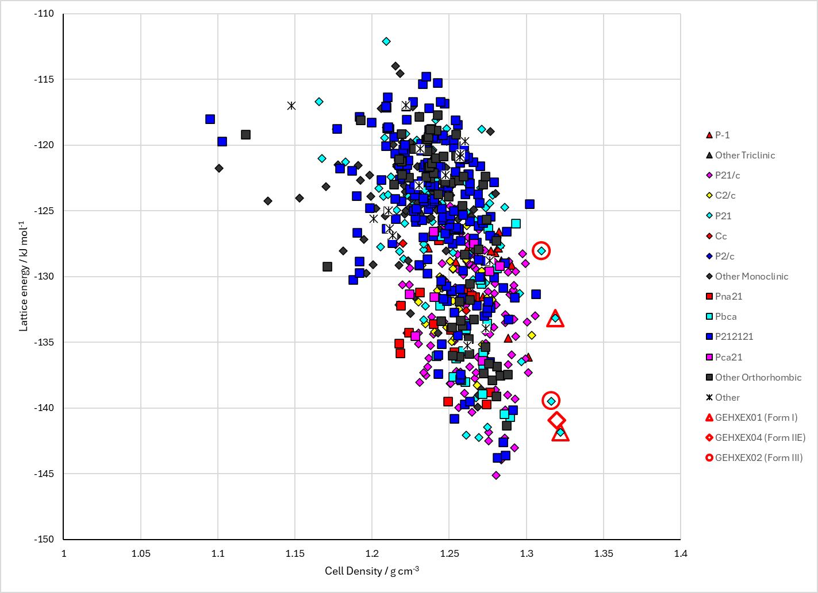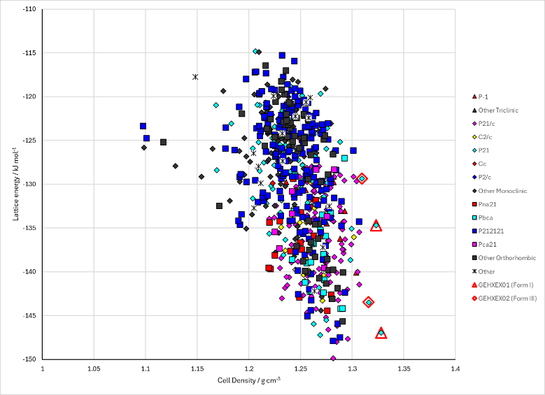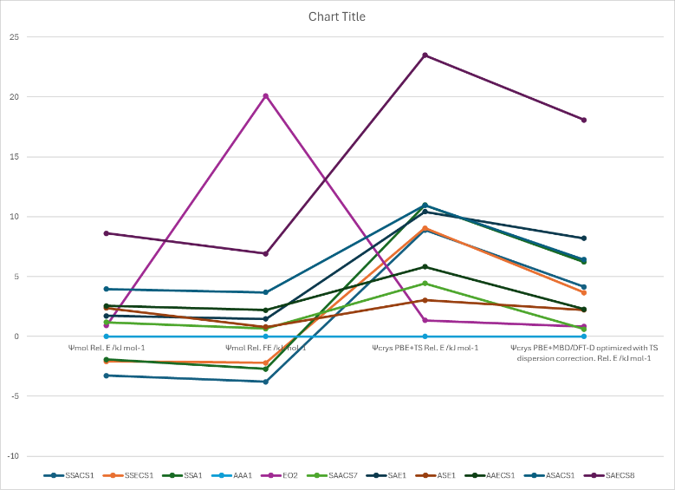
Figure 2. Top: crystal energy landscape of Desloratadine from CrystalOptimizer. Bottom left: crystal energy landscape of Desloratadine with PCM correction to rigid molecule structure of CrystalOptimizer structures. Bottom right: relative energies with different methods.

CSD structures (CSD version 5.43 with Mar, Jun, Sep and Nov 2022 updates)

Table 1. Crystallographic information for CSD entries for Desloratadine. Different polymorphs are coloured differently.
REFCODE | space group | Z’ | a / Å | b / Å | c / Å | α / ° | β / ° | γ / ° | density / g cm⁻³ | Form
GEHXEX | P21 | 1 | 6.9336 | 11.998 | 9.4691 | 90 | 107.365 | 90 | 1.373 | I
GEHXEX01 | P21 | 1 | 6.9522 | 12.006 | 9.4804 | 90 | 107.387 | 90 | 1.367 | I
GEHXEX02 | P21 | 1 | 7.7534 | 12.1384 | 9.608 | 90 | 118.78 | 90 | 1.302 | III
GEHXEX03 | P21 | 1 | 7.061 | 12.0699 | 9.559 | 90 | 108.2 | 90 | 1.334 | I
GEHXEX04 | P21 | 2 | 14.818 | 12.223 | 9.631 | 90 | 113.255 | 90 | 1.288 | II

Table 2. Experimental information for CSD entries for Desloratadine.
REFCODE | space group | R factor | T / K | Year | Comments
GEHXEX | P21 | 3.2 | 100 | 2006 | Slow evaporation from ethyl acetate¹
GEHXEX01 | P21 | 4.21 | 80 | 2020 | Slow evaporation from ethyl acetate²
GEHXEX02 | P21 | 3.99 | 360 | 2020 | Heating in DSC or VT-PXRD²
GEHXEX03 | P21 | 4.79 | 293 | 2020 | End point of a heating/cooling cycle?²
GEHXEX04 | P21 | 6.57 | 335 | 2020 | Heating in DSC or VT-PXRD²

Other notes
On heating desloratadine, either as a single crystal, as a powder, in the DSC or in VT-Raman, two phase transformations occur. All the forms are enantiotropically related, and Forms I and III differ in the orientation of the 6-membered ring with respect to the benzodiazepine group. In Form II, half the molecules take each conformation (it is not disordered).
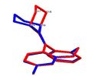

1. P. M. Bhatt and G. R. Desiraju, Acta Crystallographica Section C, 2006, 62, o362-o363.
2. V. K. Srirambhatla, R. Guo, D. M. Dawson, S. L. Price and A. J. Florence, Crystal Growth & Design, 2020, 20, 1800-1810.

