**Name/ID #**

SIAH YI LOI 15WAR08736

**Date**

26 October 2016

**Title: Control two LEDs, red LED blink for 1 cycle while green LED blink for 3 cycle using NI USB DAQ-6009 card**

**Objective:**

To learn about analogue output of the DAQ-6009 card.

To blink red LED for 1 cycle and green LED for 3 cycle through DAQmx in LabVIEW.

**Apparatus:**

National Instrument LabVIEW, computer, LEDs, resistors, breadboard, wires, power supply, NI USB DAQ-6009 card, digital multimeter.

**Introduction:**

National Instrument LabVIEW is a graphical programming language. LabVIEW software is ideal for any measurement or control system, and the heart of the NI design platform. LabVIEW is one of the very first programming language that is nonstructural and compile as the code is designed and written. LabVIEW also is the first few language that uses and runs on multi threads and real time. Integrating all the tools that engineers and scientists need to build a wide range of applications in dramatically less time, LabVIEW is a development environment for problem solving accelerated productivity, and continual innovation.

NI USB DAQ-6009 card is a very versatile data acquisition card with 8 analogue inputs at 14-bit, and sampling rates of 48 kS/s. These analogue input ports can be configures differentially or as single ended input. The NI USB DAQ-6009 is bus-powered for high mobility besides built-in signal connectivity. The NI USB DAQ-6009 is compatible with LabVIEW, LabWindows**TM**/CVI, and Measurement Studio for Visual .NET.

This practical incorporate external hardware such as electronic components and instruments, and LabVIEW software to solve textbook engineering problem. A LabVIEW program is designed to control 2 physical LEDs to blink for 1 cycle and 3 cycle with the external use of breadboard, wires, and power supply graphically. This first practical introduces the use of the instrument I/O, DAQmx VI modules.

**Procedure:**

NI USB DAQ-6009 card was configured through NI MAX program. Two analogue output channel was designed to control two real physical LEDs of different color. After that, DAQmx VI modules in LabVIEW were used to control the two LEDs blink at two different frequency. All the front panel display (normal mode) and block diagram were then screen captured for data/result section.

**Result**

Fig. 1 shows the designed Block Diagram of controlling NI USB DAQ-6009 card analogue output using LabVIEW, Fig. 2 shows the internal case structure of the design and Fig. 3 shows the designed Front Panel. In other hand, Fig. 4, Fig. 5 and Fig. 6 show the icon, Block Diagram and Front Panel of the sub VI respectively.

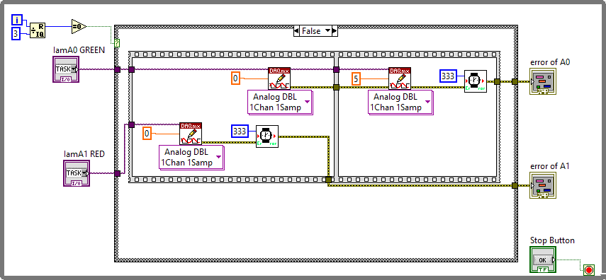

Figure 1. Block Diagram of controlling NI USB DAQ-6009 card analogue output using LabVIEW

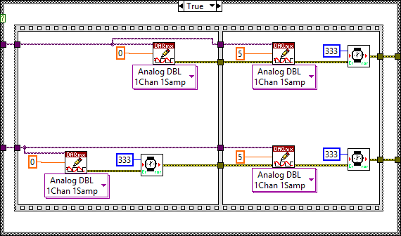

Figure 2. ‘True Case’ for the design in Fig. 1

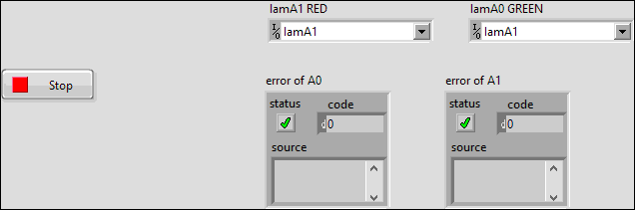

Figure 3. Front Panel of controlling NI USB DAQ-6009 card analogue output using LabVIEW



Figure 4. Icon of subVI

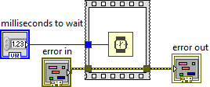

Figure 5. Block Diagram of subVI

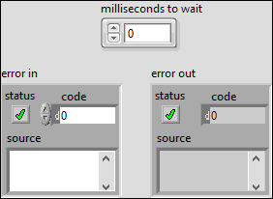

Figure 6. Front Panel of subVI

**Discussions**

Timing diagram for both LEDs is shown in Figure 7. Green LED will light for two times before the red LED light up. During the third cycle, green LED and red LED will light up at the same time. The ratio of the light up cycle need to be design correctly so that both of the LEDs can light up repeatedly as the timing diagram shown.

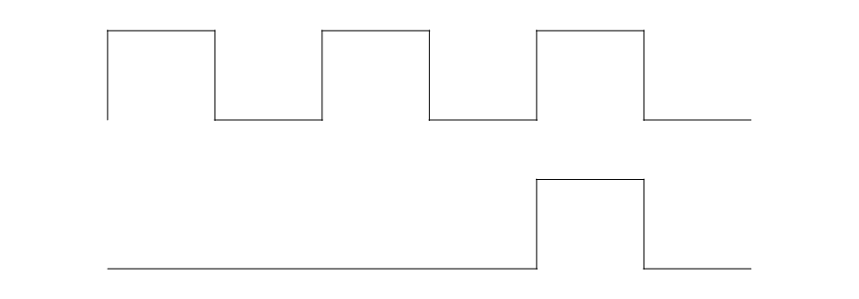

Green LED

Red LED

Figure 7. Timing Diagram of both LEDs

When building the physical circuit, the polarity of the LED can be observed through the shape of its cap. The flatten side of the LED cap is indicating cathode pin while the other side is indicating anode pin. Incorrect polarity connection can result in no light emission and open-circuit LED. This could result in burn/overheat to the LED that depending on power supply.

**Conclusions**

This paper has discussed the design of controlling controlling NI USB DAQ-6009 card analogue output by using LabVIEW. NI MAX is necessary to be used to create the two channels that is controlling the two analogue output port. The instrument I/O, DAQmx VI modules also play the important role in controlling the blinking cycle of the LEDs.Both of the LEDs can light up continuously as the expected frequency. From the result, we can see that this experiment was carried out successfully.

**References**

1. BAAP2113 Data Acquisition and Instrument Interfacing Practical Manual
2. National Instrument USB DAQ-6009/6009 User Guide and Specification. National Instrument, 2012, 371303m-01