**Name/ID #**

SIAH YI LOI 15WAR08736

**Date**

09 November 2016

**Title: Use NI USB DAQ-6009 digital output port to control a physical 7-segment display**

**Objective:**

1. To control a 7-segment display to count up and down in 10 decimal counts via NI DAQ-6009.
2. To display the number input through Human Interface Device (HID), keyboard, in LabVIEW.

**Apparatus:**

National Instrument LabVIEW, computer, 7-segments display, resistors, breadboard, wires, NI USB DAQ-6009 card, digital Multimeter.

**Introduction:**

In this practical, a common anode type of 7-segments display is used. The pin layout is shown in Figure 1. An array of Boolean control will be used to control a 7-Segments display and the data will be outputted then via the NI USB DAQ-6009 digital I/O port. The 8 I/O pins of port 0 are all configured as output.

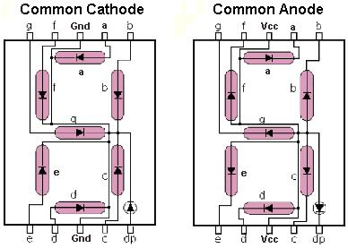

Figure 1. Pin layout of common anode type 7-Segments display

The 7-segments truth table is provided as in Table 1 below to indicate the Boolean array control in LabVIEW. A Boolean array control of the 7-segments display is programmed as a sub VI in LabVIEW. The count up and count down program is done with the help of sub VI. For the HID program, the number is displayed according to the user selected number via keyboard. The 7-segments will turn off once there is no any number detected with helping of Event structures. Again, HID program is done with the help of the Boolean array control sub VI. The design presented in this report was using DAQmx, Event structure and Input Device Control. After this, the report will discuss the Procedure, Result, Discussion and Conclusion.

Table 1. Truth Table of 7-segments display

|  |  |  |  |  |  |  |  |  |
| --- | --- | --- | --- | --- | --- | --- | --- | --- |
|  | **P0.0** | **P0.1** | **P0.2** | **P0.3** | **P0.4** | **P0.5** | **P0.6** | **P0.7** |
| **Input** | **g** | **f** | **a** | **b** | **e** | **d** | **c** | **dp** |
| **0** | 1 | 0 | 0 | 0 | 0 | 0 | 0 | 1 |
| **1** | 1 | 1 | 1 | 0 | 1 | 1 | 0 | 1 |
| **2** | 0 | 1 | 0 | 0 | 0 | 0 | 1 | 1 |
| **3** | 0 | 1 | 0 | 0 | 1 | 0 | 0 | 1 |
| **4** | 0 | 0 | 1 | 0 | 1 | 1 | 0 | 1 |
| **5** | 0 | 0 | 0 | 1 | 1 |  | 0 | 1 |
| **6** | 0 | 0 | 0 | 1 |  |  | 0 | 1 |
| **7** | 1 | 1 | 0 | 0 | 1 | 1 | 0 | 1 |
| **8** | 0 | 0 | 0 | 0 | 0 | 0 | 0 | 1 |
| **9** | 0 | 0 | 0 | 0 | 1 | 0 | 0 | 1 |
| **10** | 1 | 1 | 1 | 1 | 1 | 1 | 1 | 0 |
| **11** | 1 | 1 | 1 | 1 | 1 | 1 | 1 | 1 |

**Procedure:**

NI USB DAQ-6009 card was configured through NI MAX program. One digital output port, P0, was initialized to control the 7-segments display of different number. After that, DAQmx VI modules in LabVIEW were used to control the number displayed in two mode, count up and count down and HID device. All the front panel display (normal mode) and block diagram were then screen captured for data/result section.

**Result**

Figure 2 shows the Icon of Boolean array control sub VI, Figure 3 shows the designed Front Panel of the sub VI, Figure 4 shows the Block Diagram of the sub VI and Figure 5 shows the internal Boolean array control according to input number of the design. Furthermore, Figure 6 shows Front Panel and Figure 7 shows Block Diagram of count up and count down, Figure 8 shows the internal ‘True’ case of counting up. Figure 9 shows the Front Panel and Figure 10 shows the Block Diagram of HID program, Figure 11 shows the ‘Key up’ Event Case, no key pressed, design and Figure 12 shows the design of different number pressed.



Figure 2. Icon of Boolean array control sub VI

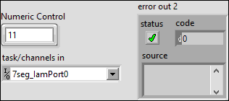

Figure 3. Front Panel of Boolean array control sub VI

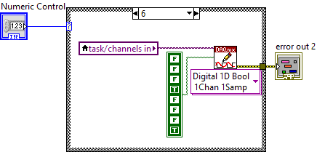

Figure 4. Block Diagram of Boolean array control sub VI

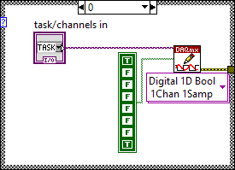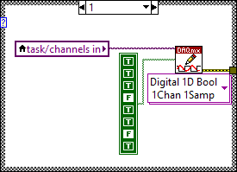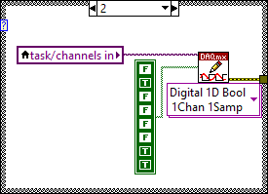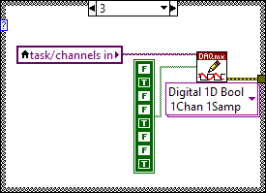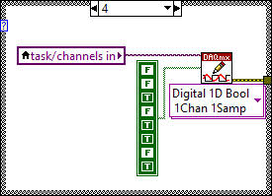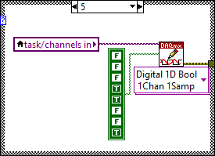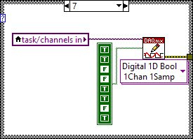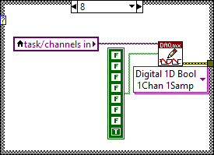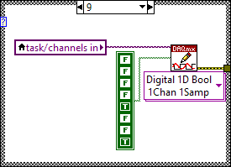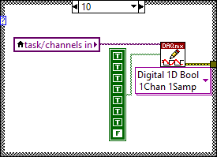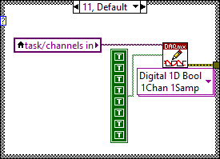

Figure 5. Boolean array control according to input number in sub VI

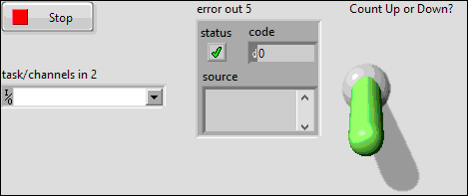

Figure 6. Front Panel of count up and count down

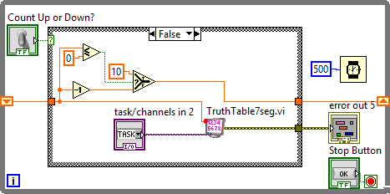

Figure 7. Block diagram of count up and count down

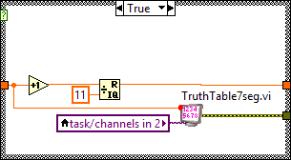

Figure 8. Internal case structure, 'True' case, of counting up

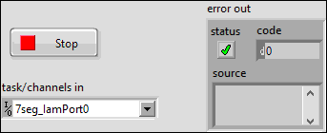

Figure 9. Front Panel of HID

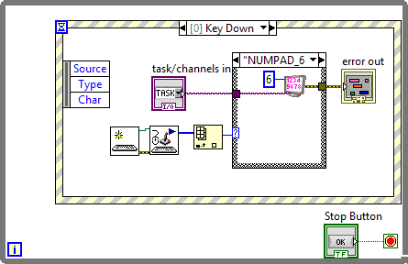

Figure 10. Block Diagram of HID

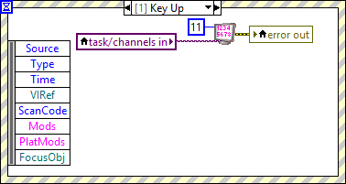

Figure 11. Case of 'Key up', no key pressed, turn off 7-segments display

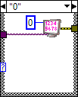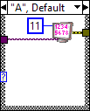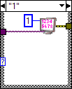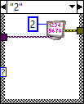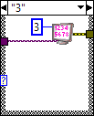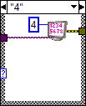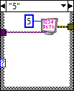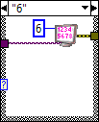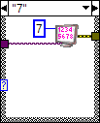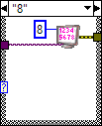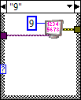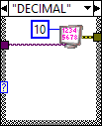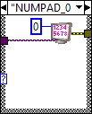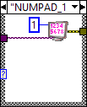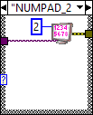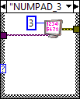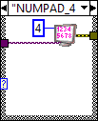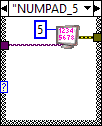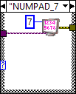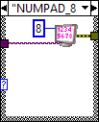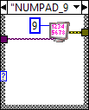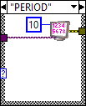

Figure 12. 7-segments display according to user input number or decimal point

**Discussions**

For common anode, a logic ‘0’ is used instead of a logic ‘1’ to turn on the LEDs. As shown in Figure 1, the diode/LED will only turn on when 5V is connected to the vcc pin, and ‘0’ is connected to the pins of LED. In addition, a resistor is needed to series with the 5V to vcc pin, the resistor is very important to protect the 7-segments LED from burn or damage. In order to make the 7-segments LED displays as the Figure 13, the logic leverl written in Table 1 must be followed.

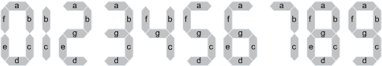****

Figure 13. Display pattern

The discussion of count up and count down design can refer to the lab report 7 of BAAP2104 Virtual Instrument. To control the 7-segments display through DAQ-6009 card, a correct digital output port must be chose instead of digital input port. For digital input port, it’s used to acquire data over the pins, means that, it was detecting input from external device. In contrast, digital output port was used to output the data over the pins, therefore it can control the external device through the pins.

**Conclusions**

This paper has discussed the design of controlling a 7-segment display to count up and down in 10 decimal counts via NI DAQ-6009 and displaying the number input through Human Interface Device (HID), keyboard, in LabVIEW. The digital output port is used instead of the digital input port to control the external device. The instrument I/O, DAQmx VI modules play the important role in controlling the output logic to the pins. The 7-segments display was working as function expected. From the result, we can see that this experiment was carried out successfully.

**References**

1. BAAP2113 Data Acquisition and Instrument Interfacing Practical Manual
2. National Instrument USB DAQ-6009/6009 User Guide and Specification. National Instrument, 2012, 371303m-01