**Name/ID #**

SIAH YI LOI 15WAR08736

**Date**

30 November 2016

**Title: Use NI USB DAQ-6009 analogue input channel to read the continuous output of a photoresistor and basic triangulation with the help of 3 photoresistors**

**Objective:**

1. To learn how to read in continuous analogue input voltage of a photoresistor sensor using the NI USB DAQ-6009 card and DAQmx.
2. To learn how to use three photoresistors to triangulate the external light source location.

**Apparatus:**

National Instrument LabVIEW, computer, photoresistors, wires, resistors, breadboard, power supply, NI USB DAQ-6009 card, digital multimeter.

**Introduction:**

In this practical, a Photoresistor, is also known as light dependent resistor (LDR), will be used. Photoresistor is very sensitive to light energy. The resistance of LDR will decrease with the increase of the light source intensity and light source wavelength. LDR is typically made of low cost cadmium sulphide (CdS) and indium antimonide (InSB) semiconductor material in zig-zag pattern for maximum efficiency. Photoresistivity of LDR may also varies with ambient temperature besides light energy.

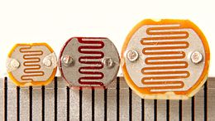

Figure 1 Typical LDR devices

Photoresistor is commonly used to control streetlights, light-dark activated switching circuits. Since, LDR is a passive sensor, constant voltage supply is need to be input into the electronics circuit from the NI USB DAQ-6009 +5V output pin.

**Procedure:**

A circuit was constructed as shown in Figure 2. NI USB DAQ-6009 card was configured through LabVIEW. Two analogue input port was configured to measure the voltage drop of both of the LDRs. After that, both of the voltage drop reading will be cascaded as a complex number and was fed into a 2D Compass Graph. All the front panel display (normal mode) and block diagram were then screen captured for data/result section.

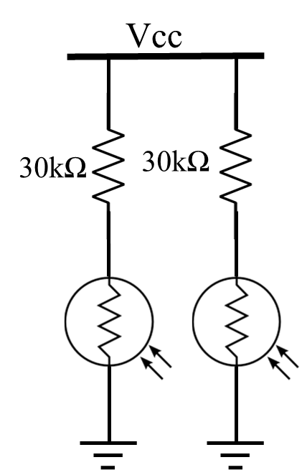

Figure 2. Circuit connection

**Result**

Figure 3 shows the sub VI icon of creating channel of DAQ card, while Figure 4 shows the block diagram and Figure 5 shows the front panel of sub VI. Figure 6 shows the block diagram of the design of read in continuous analogue input voltage and Figure 7 shows its Front Panel.

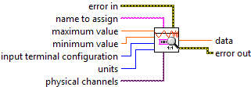

Figure 3. Sub VI icon of Creating Channel of DAQ card.

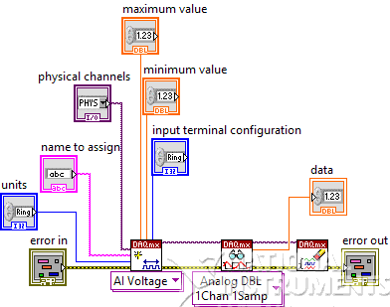

Figure 4. Block Diagram of Sub VI

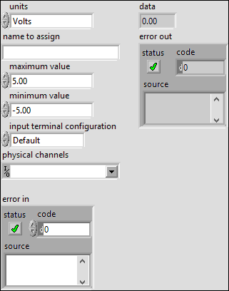

Figure 5. Front Panel of Sub VI

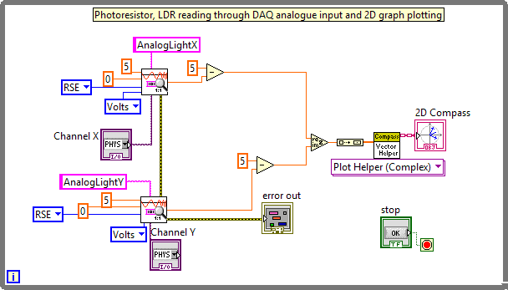

Figure 6. Block Diagram of Acquiring Voltage Drop across LDR

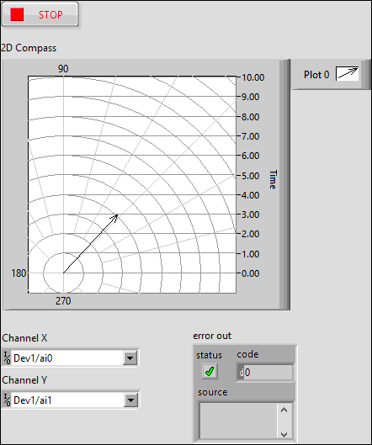

Figure 7. Front Panel of the design

**Discussions**

There are two LDRs connected in the circuit are to indicate the magnitude of the light source on X-axis and Y-axis respectively. Both of the voltage drop readings are then transformed into a complex form (x+jy) and plotted in a 2D compass graph. The magnitude of the arrow in the graph is indicating the magnitude of the light source. For example, the nearer the light source to LDR, the larger magnitude shown in the compass graph. In order to make the magnitude of arrow in compass graph proportional to the magnitude of light source, the value of maximum voltage supplied minus voltage drop accoss the LDR was taken instead of the value of voltage drop reading.

When the voltage supplied is more than 5V, then the resistor value need to be changed in order to get the right amount of current flowing through LDR.

When the LDR was placed in the dark, its resistance can increase up to about 30MΩ. It seem like open circuit and there shouldn’t be any current flow through. However, there is relatively small electric current flow through the LDR, it’s named dark current. In other words, it can be said as the reverse bias leakage current.

**Conclusions**

This paper has discussed the design of read in continuous analogue input voltage of a photoresistor sensor and plot the light source location and magnitude in a 2D compass graph in LabVIEW. The analogue input port is used instead of digital input port. In darker environment, resistance of LDR higher, voltage drop across LDR higher. The 2D Compass Graph was working as function expected. From the result, we can see that this experiment was carried out successfully.

**References**

1. BAAP2113 Data Acquisition and Instrument Interfacing Practical Manual
2. National Instrument USB DAQ-6009/6009 User Guide and Specification. National Instrument, 2012, 371303m-01