**Name/ID #**

SIAH YI LOI 15WAR08736

**Date**

14 December 2016

**Title: Use NI USB DAQ-6009 digital output channel to control a stepper motor**

**Objective:**

1. To learn how to control a stepper motor using the NI USB DAQ-6009 card and DAQmx in LabVIEW.

**Apparatus:**

National Instrument LabVIEW, computer, resistors, breadboard, power supply, NI USB DAQ-6009 card, digital multimeter, stepper motor, diode, BJT.

**Introduction:**

Stepper motors are DC motors that move in discrete steps. They have multiple coils that are organized in groups called “phases”. By energizing each phase in sequence, the motor will rotate, one step at a time. With a computer controlled stepping, a very precise positioning and/or speed can be achieved. For this reason, stepper motors are the motor of choice for many precision motion control applications. Stepper motors are good for positioning, speed control and low speed torque. However, they are have limitations such as low efficiency, limited high speed torque and no feedback. Figure 1 shows the schematic of a stepper motor.



Figure 1 Schematic of Stepper Motor

To drive the stepper motor, four digital output pin was configured as Table1. The stepper motor is powered with 5V. BJT is used to amplify the current so that the stepper motors have enough torque to rotate.

Table 1. Truth table to drive a stepper motor

|  |  |  |  |
| --- | --- | --- | --- |
| X | !X | Y | !Y |
| 1 | 0 | 0 | 0 |
| 0 | 1 | 0 | 0 |
| 0 | 0 | 1 | 0 |
| 0 | 0 | 0 | 1 |

**Procedure:**

Four of the digital output channel of DAQ card was connected to the circuit as shown in Figure 2. NI USB DAQ-6009 card was configured through LabVIEW. Four digital output port was configured to control the phases of the stepper motor. All the front panel display (normal mode) and block diagram were then screen captured for data/result section.

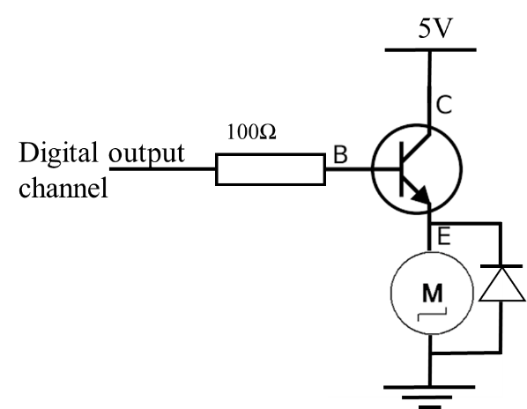

Figure 2. Circuit connection

**Result**

SubVI

Figure 3, Figure 4 and Figure 5 are showing the icon, block diagram and front panel of ‘write one channel’ subVI, respectively.



Figure 3. Icon of write 1 channel

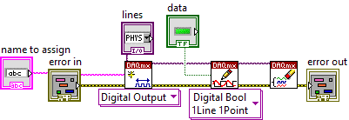

Figure 4. Block Diagram of write 1 channel

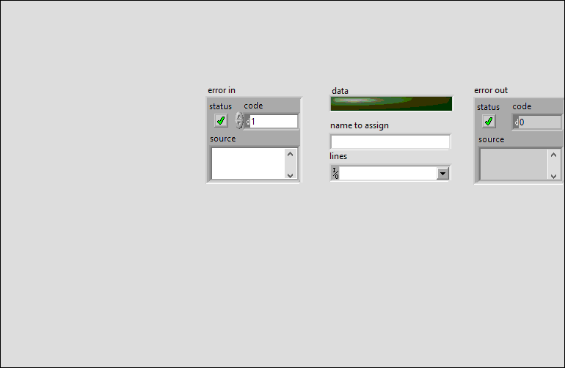

Figure 5. Front Panel of write 1 channel

Figure 6, Figure 7 and Figure 8 are showing the icon, block diagram and front panel of ‘truth table’ subVI, respectively.



Figure 6. Icon of truth table

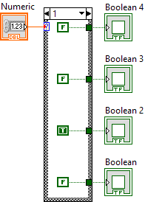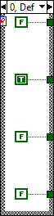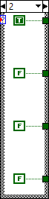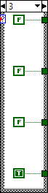

Figure 7. Block Diagram of truth table



Figure 8. Front Panel of truth table

Figure 9, Figure 10 and Figure 11 are showing the icon, block diagram and front panel of ‘controlling the phases of stepper motor’ subVI, respectively.

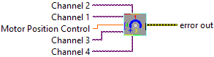

Figure 9. Icon of controlling the phases of stepper motor

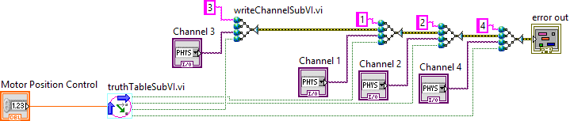

Figure 10. Block Diagram of controlling the phases of stepper motor

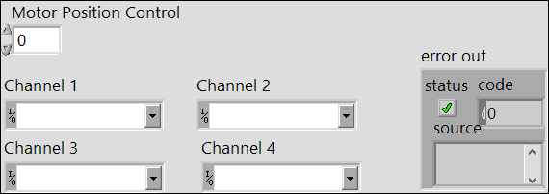

Figure 11. Front Panel of controlling the phases of stepper motor

Main

Figure 12 shows the Block Diagram of main program while Figure 13 and Figure 14 shows the internal event structure in main program. Figure 15 shows the Front Panel of main program.

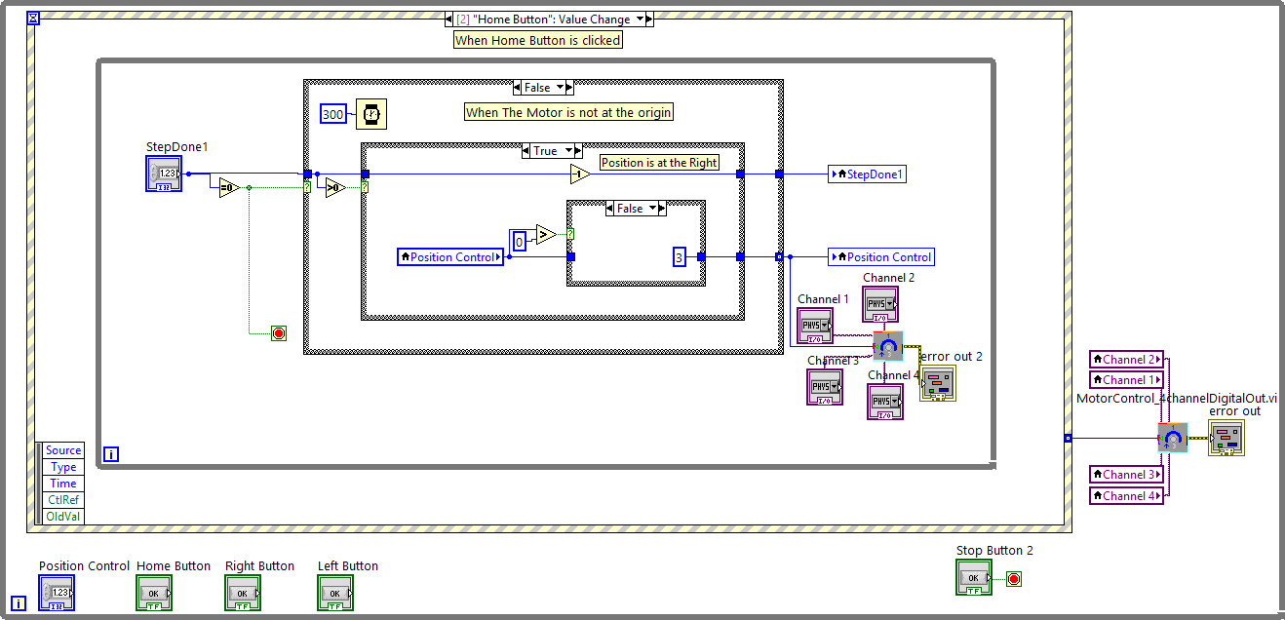

Figure 12. Block Diagram of main program

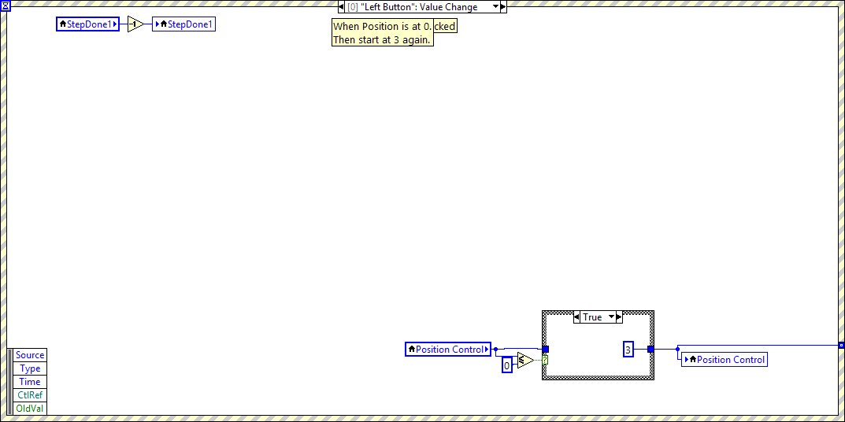

Figure 13. Internal event structure of "Left Button Value Change"

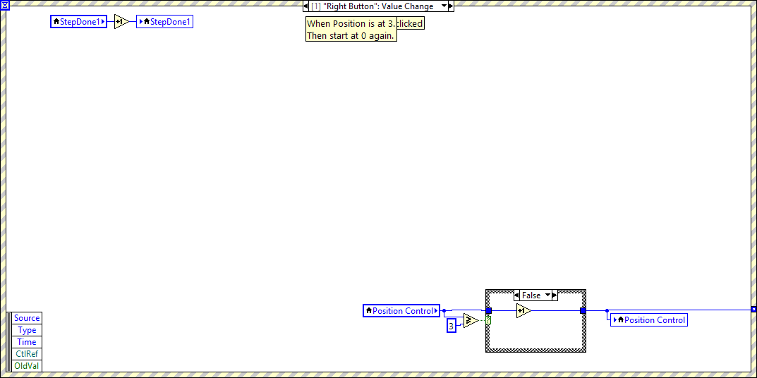

Figure 14. Internal event structure of "Right Button Value Change"

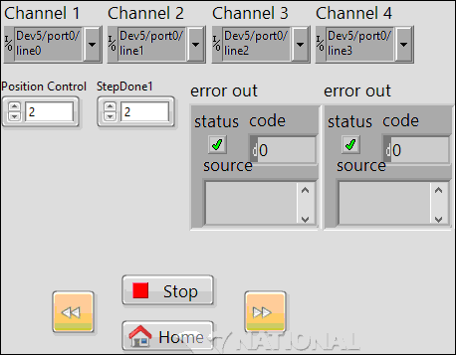

Figure 15. Front Panel of Main Program

**Discussions**

There are six terminals of this stepper motor used in this practical, since the stepper motor used is unipolar, so two of the terminals are common ground. Figure 16 shows the unipolar and bipolar stepepr moror windinds. In order to drive the stepper motor, the coils have to turn on and off in the right order. Before driving the four digital output channels, a right sequence for turning the phases of the stepper motor has to be determined first. Then, the four terminals only can be controlled through the digital output channels.

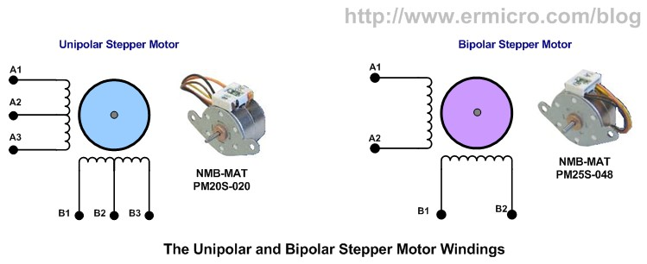

Figure 16. Unipolar Stepper Motor vs. Bipolar Stepper Motor

The purpose of using BJT here is to amplify the current so that the stepper motor can be drived. The terminals of stepper moter can be connected to the digital output channels directly without the existence of BJT, resistor and diode, and it can work too. However, the output current from DAQ card is still consider low to drive the stepper motor and the stepper motor might only rotate in a small degree. Besides BJT, the diode acrossing the stepper motor from ground to emitter terminals of BJT is also used for amplify the driving current of the stepper motor, it’s also known as Flyback diode .

**Conclusions**

This paper has discussed the design of controlling a stepper motor in LabVIEW. The right sequence to turning on and off the coils had to be determined first. Current need to be amplified with the help of BJT and Flyback diode. The stepper motor was working as expected. From the result, we can see that this experiment was carried out successfully.

**References**

1. BAAP2113 Data Acquisition and Instrument Interfacing Practical Manual
2. National Instrument USB DAQ-6009/6009 User Guide and Specification. National Instrument, 2012, 371303m-01