**Name/ID #**

SIAH YI LOI 15WAR08736

**Date**

04 January 2016

**Title: Use NI myRIO to control a servomotor with LabVIEW myRIO**

**Objective:**

1. To learn how to generate pulse width modulation, PWM square wave to control a servomotor using NI myRIO with LabVIEW myRIO.

**Apparatus:**

National Instrument LabVIEW, computer, resistors, SV003 Servo motor, wires, breadboard, power supply, NI myRIO, Rigol DS1000z oscilloscope, diode, BJT.

**Introduction:**

A servomotor is an AC rotary actuator that allow accurate angular rotational control. The velocity and acceleration of the servomotor can also be set precisely and controlled with LabVIEW using pulse width modulation, TTL PWM signal at 40 Hz. USB is used to control a NI myRIO to generate the TTL PWM signal manually using LabVIEW programming algorithm. The servomotor requires relatively sophisticated PID controller. The servomotor used in this practical has metal gear that guard against normal wear and tear. The servomotor is powered with 4.8V – 6V with a maximum torque of 13 Kg-cm. However, the angle of rotation is limited to 180 degree rotational. The servomotor is suitable for robotic arm, and biped robot application. Figure 1 shows the servo motor used in this practical.

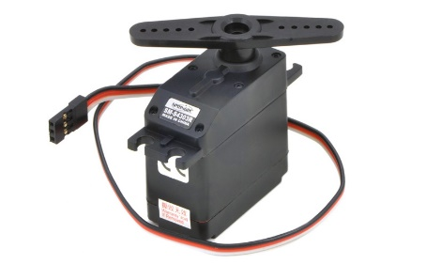

Figure 1. SV003 Servo motor used in the practical

A customizable duty cycle square wave (i.e. TTL PWM) needs to be generated and output to the servomotor via NI myRIO by using LabVIEW. The length of duration of for output a certain angle can be obtained from the Servo motor SV003 datasheet. The datasheet was shown in Table 1.

Table 1. Servo motor SV003 datasheet

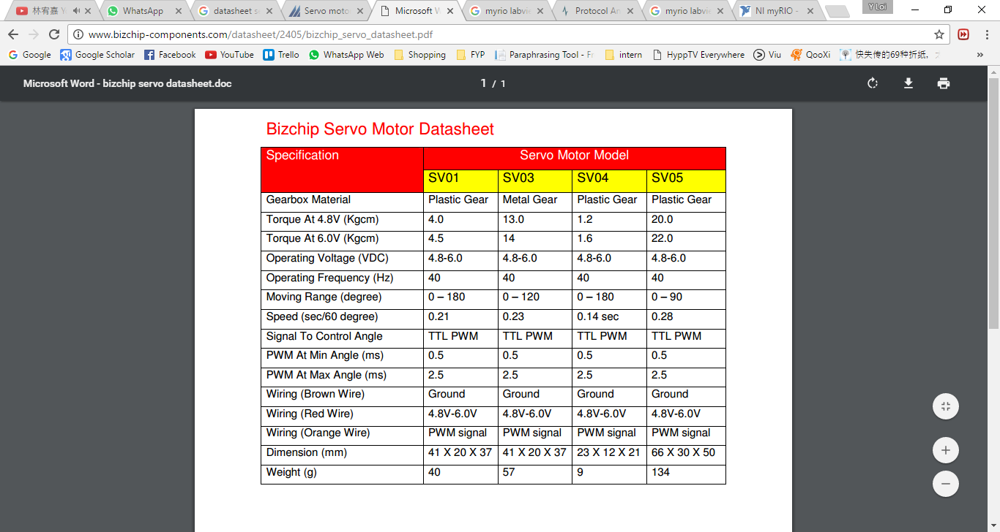

**Procedure:**

NI myRIO was connected to computer via USB. The port myRIO MSP Connector C was chosen during the myRIO interface. The pin-outs will be mapped as Figure 2. Digital Input Output 7 (DIO7) was chosen to generate the PWM and it was connected to the control pin of servo motor. The connection of the pins of servo motor has shown in Figure 3.

The USB DAQ-6009 card was configured through LabVIEW. Four digital output port was configured to control the phases of the stepper motor. All the front panel display (normal mode) and block diagram were then screen captured for data/result section.

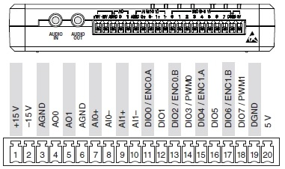

Figure 2. Port myRIO MSP Connector C

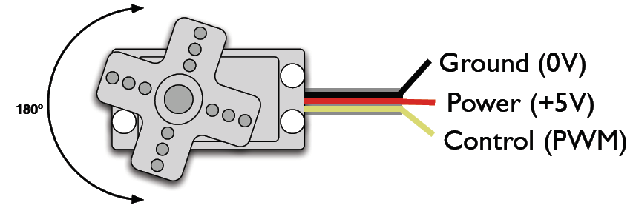

Yellow

Red

Black

Figure 3. Pins of servo motor

**Result**

Figure 4 shows the Front Panel of the design while Figure 5 shows the Block Diagram of the design.

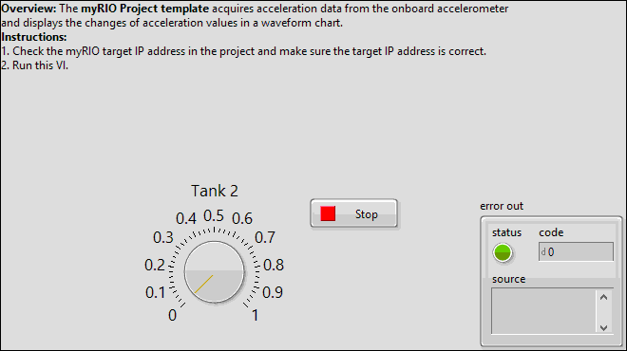

PWM Duty Cycle

Figure 4. Front Panel of controlling myRIO

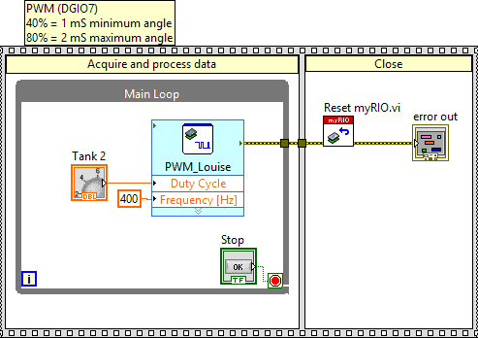

PWM Duty Cycle

Figure 5. Block Diagram of controlling myRIO

**Discussion**

The operating frequency obtained from the datasheet shown in the Table 1 is 40 Hz for the SV003 servo motor. However, when the frequency of the output PWM signal was set to 400 Hz, the servo motor still work. From here, we can know that, the servo motor is not operating depends on the frequency but the duration of the signal. As shown in Table 1, a 0.5 ms duration signal can give a minimum angle while a 2.5 ms duration signal can give a maximum angle for the wings of the servo motor. The value of the duration can obtain easily by calculation even a different frequency was set.

**Conclusions**

This paper has discussed the design of controlling a servo motor via NI myRIO in LabVIEW. Servo motor is not operating in only one certain frequency. The length of the signal duration is important to drive a servo motor. An accurate duration need to be calculated for a PWM signal to control a servo motor. The stepper motor was working as expected by giving a correct PWM duration. From the result, we can see that this experiment was carried out successfully.

**References**

1. BAAP2113 Data Acquisition and Instrument Interfacing Practical Manual