Name: Siah Yi Loi

ID: 15WAR08736

**Objective**

To study ‘Case Structure’ by building simple mathematic arithmetic.

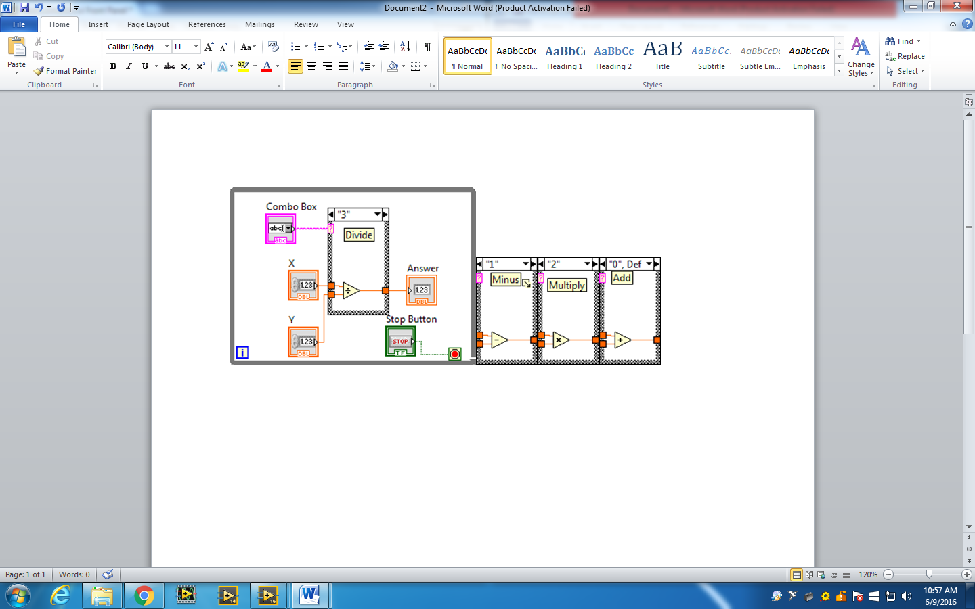

Figure 1 Block diagram of design

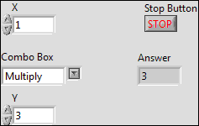

Figure 2 Front Panel of the design