**Name/ID #**

SIAH YI LOI 15WAR08736

**Date**

15 June 2016

**Title**

To learn how to use Flat and Stacked Sequence structure and delay to control two virtual LED to blink at 1.0 Hz and 2.0 Hz.

**Objective**

1. To explore Labview by building ‘while loop’ and ‘for loop’.

2. To control a virtual LED blinking 1Hz by using ‘while loop’ and ‘for loop’.

3. To display the number of interaction of ‘while loop’ and ‘for loop’.

**Introduction**

This experiment was carried out to explore Labview (Laboratory Virtual Instrument Engineering Workbench), which is a software use graphical programming of icons and wires instead of writing codes in the traditional way. The experiment was done with design of ‘while loop’ and ‘for loop’ to control a virtual LED blinking 1Hz.

**Experimental Setup**

**Procedure**

Labview software was turned on. The icon that was wanted had been added in block diagram or front panel. The icons was then been wired. The steps were repeated until ‘while loop’ had been done. The steps from start were repeated for ‘for loop’.

**Result**

For loop

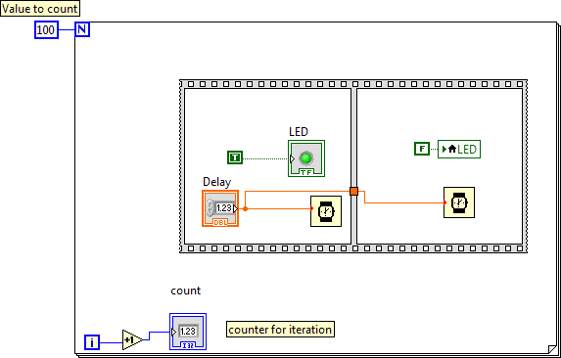

Figure 1 Block Diagram for 'for loop'

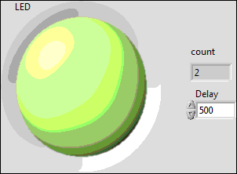

Figure 2 Front panel for 'for loop'

While loop

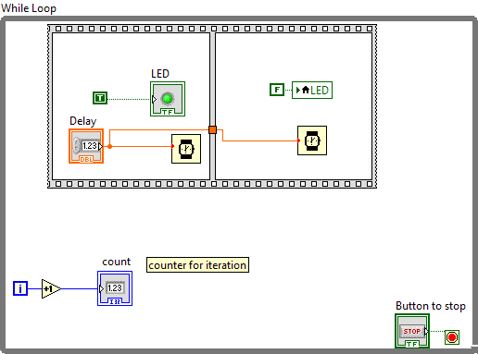

Figure 3 Block diagram for 'while loop'

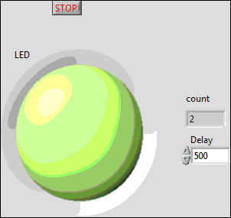

Figure 4 Front panel for 'while loop'

**Discussions**

To display an accurate number of interaction of ‘for loop’, a ‘+1’ icon need to be wired from the ‘i’ to the counter. So that, ‘100’ can be showed exactly when ‘for loop’ had running through 100 time and stopped. A ‘stop button’ or ‘condition button’ need to be given to indicate stop for ‘while loop’, otherwise it will be running the program without stop. Left side or right side of an icon be wired must do carefully to indicate a correct input or output accordingly.

**Conclusions**

The ‘while loop’ and ‘for loop’ was designed successfully by using Labview. A ‘+1’ icon was connected between the counter for interaction and ‘i’ to indicate an accurate number of interaction while a ‘stop button’ need to be provided in ‘while loop’ to indicate a stop. From the result, we can see that this experiment was carried out successfully.

**References**

1. Travis, J. and Kring, J., 2006. *LabVIEW for Everyone: Graphical Programming Made Easy and Fun (National Instruments Virtual Instrumentation Series)*. Prentice Hall PTR.

