**Name/ID #**

SIAH YI LOI 15WAR08736

**Date**

15 June 2016

**Title**

To blink 2 LEDs at 1.0 Hz and 2.0 Hz.

**Objective**

1. To learn how to use Flat Sequence structure and delay to control two virtual LED to blink at 1.0 Hz and 2.0 Hz.

2. To understand the concept of frequency.

**Introduction**

This report presents an experiment by writing a program in LabVIEW that was controlling two LEDs to blink simultaneous at different frequency, 1.0 Hz and 2.0 Hz. Blink a single LED is straight forward and simple. Learning to control two LEDs to blink simultaneous at different frequency is a step forward. The delay need to be calculated by using formula T = 1/f. This experiment was done by using Flat Sequence coupled with a time delay to program the LEDs to blink accurately at prescribed frequencies.

**Procedure**

LabVIEW software was turned on. While Structure, Flat Sequence, Stacked Sequence and LEDs were added to block diagram and front panel. The delay timer was set to the calculated value, 250ms and then added to the block diagram. Two virtual LED that blink at 1.0 Hz and 2.0 Hz was programmed with the help of the delay timer.

**Result**

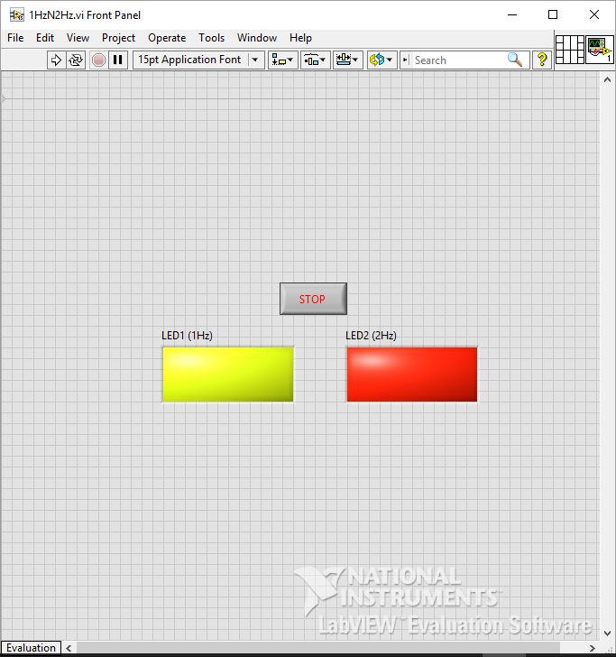

Figure First display in Front Panel

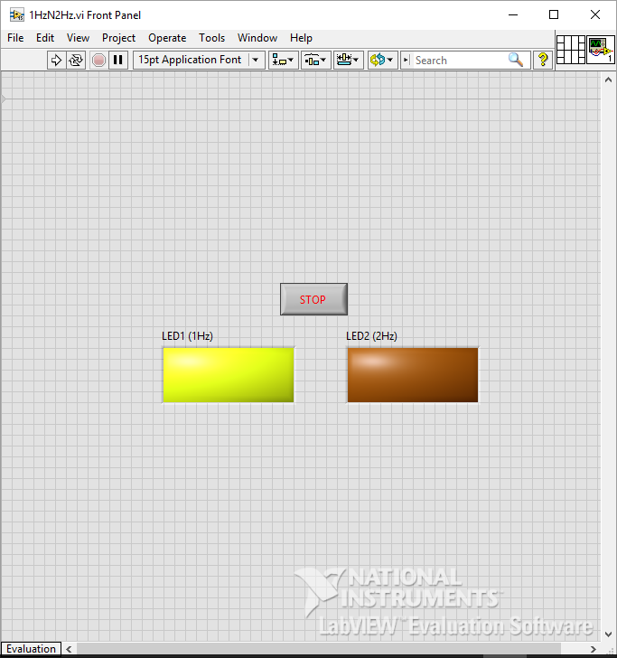

Figure Second display in Front Panel

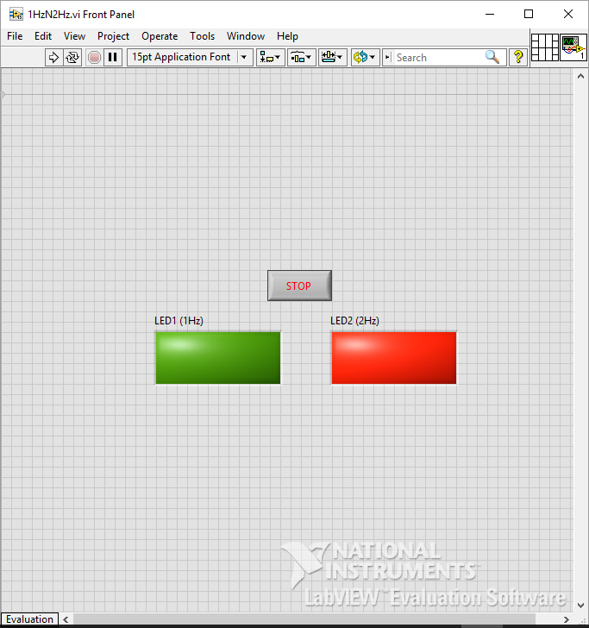

Figure Third Display in Front Panel



Figure Forth Display in Front Panel

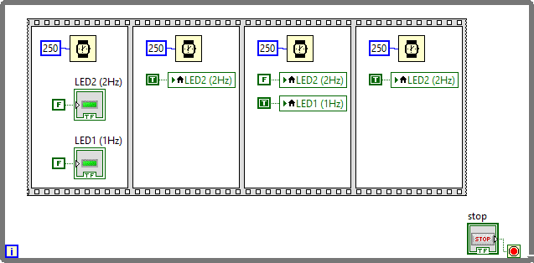

Figure Block Diagram

**Discussions**

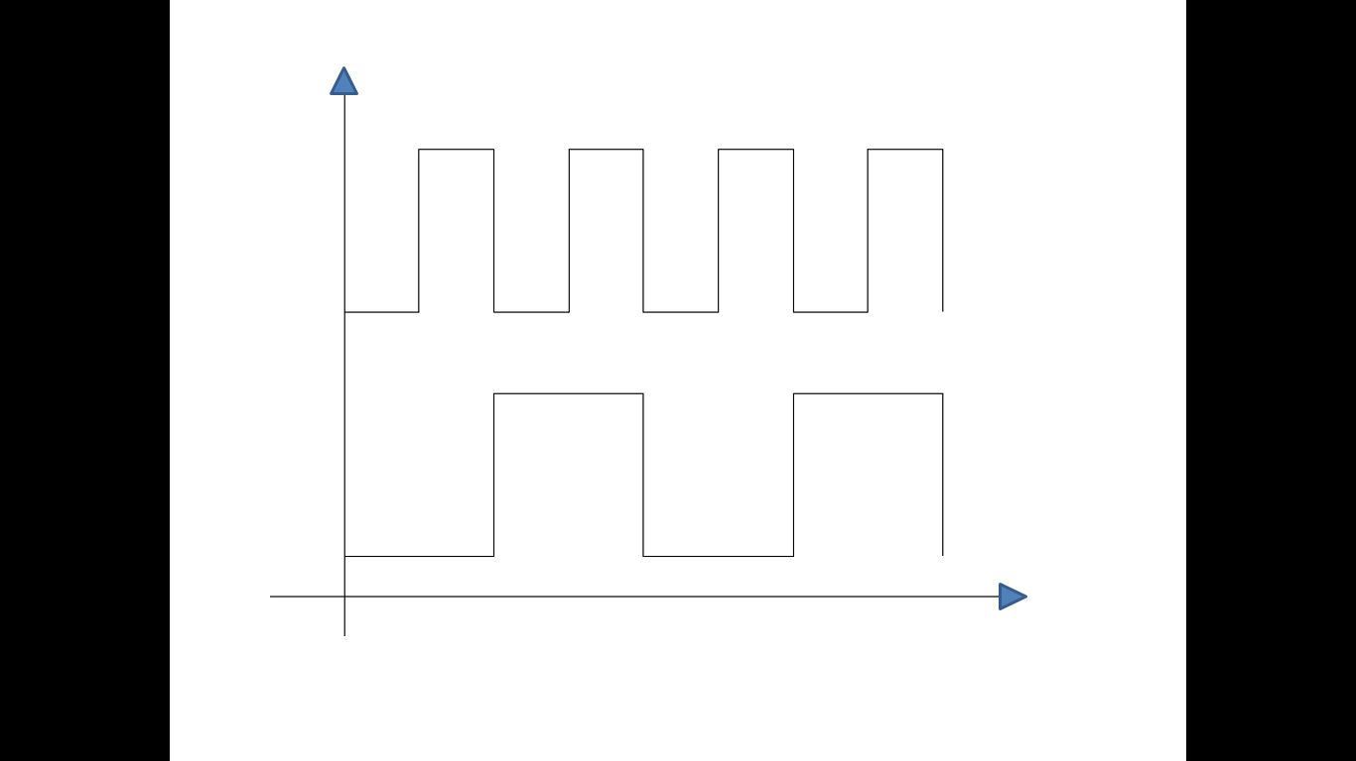

LED 2

LED 1

time

Figure Graph of Signal of LEDs versus Time

To put a suitable delay to blink both LEDs, need to be calculated by formula F= 1/T. For this case here, there are two different frequencies need to be taken care. We should calculate the ratio of the delay for the both frequency too. For example, 1 Hz means ‘on’ for 500ms and ‘off’ for 500ms while 2 Hz means ‘on’ for 250ms and ‘off’ for 250ms. So that, 1Hz and 2Hz can share a 250ms timer delay here.

**Conclusions**

The 2 LEDs blink at 1.0Hz and 2.0Hz was designed successfully by using Flat Sequence structure and delay. There is total four frame and a 250ms timer delay used in this program. From the result, we can see that this experiment was carried out successfully.

**References**

1. Bishop, R.H., 2007. *LabVIEW 8 student edition*. Pearson Prentice Hall.