# Team 37 – Project Initiation Document

# Project Goals/Scope

The main goal of this project is to provide a cross-platform mobile app that will allow the user to send for help when they are in danger, this will hopefully provide the help that people may need when they are in danger and may even prevent deaths. The app will have to send a help message to the user’s contacts that they have added during the configuration of the app, the app will also record the voice of the user, so it can be included in the help message. The help message must also give the contacts the exact location of the user, this means the app will need know the location of the user’s phone. Once the app is installed onto the user’s mobile device the app will operate in the background while the mobile device is running, this will help make emergency call happen, immediately when the user needs help and cut out unnecessary loading. On initial setup the user will have to create an account by supplying their email and then login to the app, on first time setup the user will have to provide at least 3 to 5 contacts and supply their mobile, landline numbers and/or Facebook information so the app can send the help messages or call them in case of an incident. The signup and login for the app must be easy for the user to follow and not very time consuming, this will ensure that users will use the app because if this initial step is difficult/frustrating for the user they will most likely not use this app and look for an alternative. The app will need a beautiful and professional looking design so that the user is not put off from using this app. The app should ideally have voice recognition to help stop false alarms and allow the user to quickly send for. Ideally the app will be able to hear if there is an emergency without the user needing to tell the app as it will be able to pick up on the tone of the persons voice that is either being attacked or the person attacking, this feature should be considered if there is time and for the time being the app should be able to pick up on a list of threatening words or for a user’s buzzword. The app must be as hidden as possible, therefore it mustn’t be easy to see on the user’s phone and the app shouldn’t have to be opened to send the help message. The app will record what is happening when it has been triggered, this will be included in the help message, and the user’s location on their phone will also be sent. It is recommended to use React Native for the development of the app however; other frameworks, libraries and API’s can be used. There are several deliverables for this project, these include:

## Working Prototype

A working prototype of the app will need to be constructed to help demonstrate the capabilities of such an app. Having a working prototype will help demonstrate that this type of app can be done and will be a benchmark for future development.

## Documentation

Documentation throughout the project will need to be supplied to help with the development of the application and help show the progress of the project. Having well-made documentation will also make future development of the app easier as future developers will have a reference when working on this app.

## Description of Remaining Development

The client will need this so they understand what will need to be finished or continued to be developed on when they work on this application in the future.

## Code in an Accessible Repository

Code should be in an accessible repository to help the team and the client easily get new and old updates of the application. This will also make development easier and more efficient and allows the team to have solid version control.

The main resources that the team has access to are a dedicated server with admin access from the university. The team will also get constant access from the client and the client will work as part of the team.

# Background Research

## Existing Applications

There are many similar apps that keep the user safe in a similar manner as the app we are developing. Apps such as StaySafe and WatchOver Me, allow the user to set a countdown and if after this countdown the user doesn’t respond to say they are safe it alerts the contacts that they have entered, the main problem with these apps that false alarms can easily be flagged if the user simply forgets to respond to the application after the countdown is finished. Other apps like bSafe and React Mobile work similarly to the application that will be developed as they allow the user to send an SOS message to their contacts and this SOS message will contain the location of the user’s mobile phone. We could differ a lot from these apps by implementing good voice recognition as the apps above are quite basic and prone to false alarms, also if the application can easily pickup an emergency it could make it a very favourable app for the general market.

## React Native Framework

React Native uses Javascript and the React libraries to allow the user to create native mobile apps quickly and efficiently. As React Native, uses the React libraries it gives the developer access to lots of UI features that are great for creating UI for mobile phones. React Native also allows the developer to change the code while it is running and reload it from the same state, this could be helpful when trying to create the UI for the app as it will allow our group to efficiently try out different designs.

## Voice Recognition

Voice recognition works by analysing what was said and converting it into text form, we could go about implementing voice recognition by using an API, and the main API that will most likely be used is googles speech recognition API. With using this, we would be using their already established voice recognition technology, will help us tackle some difficulties such as difficult to understand accents, and could allow future developers to implement other languages in the system.

# Approach

We will be using an Agile framework to complete the project, in the form of a Scrum management approach. With this approach, we will split the team into different roles, focusing on different sections of the project and complete iterations of work - also called sprints. We will begin the project by identifying and prioritising the project tasks. Most of our sprints will be one week, the team will meet weekly to discuss the development of the project and to decide who will complete which of the tasks in the upcoming sprint. These meetings will also be used to present completed work and review our progress. During the week, the Project Manager will be monitoring the progress made by each member so that processes can be adapted if problems occur.

We have considered other approaches, however, feel this is the most beneficial for the project due to its proven benefits including improved communication between the team and client, quick identification of problems and increased efficiency.

The project phases we intend to follow reflect the ‘Waterfall’ development; beginning with initial research. We will research similar concept applications to identify possible user requirements, common layouts, structures, content, and designs. We will also use this research to identify what users aren’t being provided with the current applications available.

Using this research, along with our client brief we will then construct basic designs including wireframes to identify possible structures, hierarchy, and relationships between features. Designs that are more detailed will then be constructing which will incorporate colour schemes and navigation features.

Once the client has approved our designs, we will begin the implementation stage of our project. The application will be developed for the Android platform initially, using Java and JavaScript programming languages. We will use GitHub extensively throughout the project, keeping all modified code in a central repository. This will allow each team member to access, modify and upload changes to files related to the project. All other members will be notified of changes made – keeping the whole team up to date on project progress.

Once we have completed the development stage of the project, we will begin testing the mobile application to ensure it reaches a high standard for functionality, usability, and consistency. Any issues that are identified during the testing process will be resolved before deployment, provided there is time available.

The appropriate documentation will be completed throughout the project, primarily throughout the code to ensure that any developer accessing it following the project’s completion will be able to read and understand what we have written during development. We will also provide other documentation including a test plan, test cases and a user and technical guide.

# Project Organisation

Client

The Project Team

Project Manager

Developer Developer Developer Admin

Designer

The project organisation is broken into four roles: The Project Manager, the Designer, Admin and The Developers. Each role has a different objective. Although some roles are doubled, the different team members will have a different objective.

The Project Manager – the go between the client and the team. Keeping the team within the deadlines set.

The Designer – keeping the design simple for the users to easily navigate

Admin – saving all the details of the clients

Developers – ensuring that what is agreed is by the client is met.

# Business Case

The app only has one main benefit, which is to keep members of the public feeling safe and secure with the Protection App. With the app constantly, listening and alerting the user’s contacts when they are in danger, the public can have a sense of security.

# Constraints

The primary constraint on this project will be scheduling. Each member of the team will have other module commitments, which could have an impact on the amount of time spent on the application development. A possible result of this constraint is that some application feature requirements may not be implemented, voice activation for instance, or the app being developed on iOS.

Additionally, there are specific application requirements provided in the overview that we have not previously done/used in other projects, such as using the React Native Framework or voice activation. Consequently, we will have to spend time learning how to successfully implement these in the project.

We will have no budget throughout this project, which could become a constraint, as there may be certain features that cannot be implemented without purchasing specific software. We are planning to use the resources provided by the University to design and develop the application and therefore, we are limited to what these resources provide.

# Stakeholders

Stakeholders are people who are invested in the project and who will be affected by the project at any point along the way. There are some stakeholders that can be identified that could affect or be affected by our project. An obvious stakeholder would be the client, as they will set out the main requirements and objectives of the project. The client will already have an idea of what they will want so good communication is vital in order to deliver a product that satisfies the client. It is also important to find out if the client has any other stakeholders that we might not be aware of from the start. In the kick-off meeting, we established that our client was a student and had no other organisations that could have an impact on our project. This can have both positive and negative sides to it, the positive being that there are no other groups that can influence the decisions of our project and the negative being that there will be less resources available to us in terms of technical support any other information. Another stakeholder in our project would be the users as knowing what kind of audience we would be tailoring our app for will greatly influence the overall design and layout of the project. After meeting with the client they determined that there would be no specific target audience, as they want the app to be general purpose and for all types of user. This also has advantages and disadvantages to it. The disadvantage being that having a target audience would mean the app could be specifically designed to fit the needs of that group of users, having no target audience means it is harder to design an app that will suit the needs of everybody. However, an advantage of this would be that we are not limited in the scope of our design. A stakeholder that will have to be taken into consideration is the University. The University has a completely different set of requirements that need to be delivered from our project when compared to that of the client. The University gives our project a mark based on just the documentation produced rather than the outcome and quality of the app, or if the app itself even satisfies the needs of our client. The client however is only interested in the product that we will make and will not have too much concern for our documentation that needs to be submitted to the University.

# Risks

## Communication

The lack of or misunderstandings may hinder the project in such a way that there may be pats of the project may go unfinished or may even be done in the wrong way, which may lead to the project running over time. Group Members not knowing what is going on, such as in meetings or in other platforms of communication. There may also be the issue of not keeping the client up to date. Which means that here may not be much feedback on the development of the project.

## A group member may take leave from the group.

Leaves the group short on a resource, as their activities may need to be completed by other group members, putting more strain on the to get things done. This may also relate to communication, especially when it comes to coding. If the group member does not put comments within their own code, which explain what they are doing, then the other members take on the extra work, they may not be sure what the group member was trying to do.

## Lost Data

This may be caused by various reasons, such as corrupted data or forgetting to save. The easiest way to solve this is to make sure all documents and work is back up, as this may lead to major delays within the project.

## Group members disagreeing

If group members disagree this may lead to arguments, which may hinder the project if they cannot come to a compromise, especially if they are working closely together.

## Difficulty in Starting

This may be for various reasons such as not knowing where to start, or not having the correct resources at the beginning of the project.

## Lack of contributions from members

This may hinder the project, as they are not putting in the same effort as other members, leading to more work being put onto other members.

## Lacking in certain skills

This may mean certain parts of the project may take longer to complete, as group members will have to spend time learning and developing the skills needed. This may lead to some activities taking longer to be completed.

## Documentation

Lack of documentation, means that the project may be hindered from going forward, if it passed to other members, then they may not know what the app is able to do, or if the final product is given to the client then they may not know what has been done to complete the project.

## Group meetings for the sake of group meetings

This may mean that the group meets up without having any objective and not accomplishing anything. These types of meetings may be more meaningful if done through other platforms of communication.

## Not being able to get in contact with the client

This may mean the project won’t get any feedback before the end of the project, leading the project possibly being done differently to what the client wanted.

# Project Controls

Tasks have been allocated to individual members of the team and smaller groups within the team. A group chat has been set up on Facebook for communication purposes and another group has also been set on GitHub for sharing work and other documents. Meetings are being scheduled as and when required given the various communication tools already in place.

# Reporting Frameworks

During the kick-off meeting with our client we discussed ways in which they would like to be updated on the progress of the project, whether that be via progress reports and more formal documentation or a more informal approach. The client stated that they would prefer an informal approach and would rather be updated on our progress by means of a social media group. By creating a group containing our team and the client in it on social media has many positives such as being able to clarify anything with our client as the problems arise and the fact that the client can ask us any questions that they might have without having to set up a formal meeting. In terms of creating a report schedule, we as a group will produce a report every three weeks detailing all the progress that has happened over this time as well as a list of tasks and problems that we will encounter between the next reports. Although the client does not require this information, I think is beneficial to our project that we keep a track of everything that we have done, as this will make it easier at the end when it comes to writing up our Project Report and Presentation.

# Schedule

In order to schedule this project, we have produced a Gantt chart, which breaks down our tasks and shows the timeline we intend to complete them. We have included snippets of the chart created below but a copy will also be sent to the client so he can reference it at any stage.

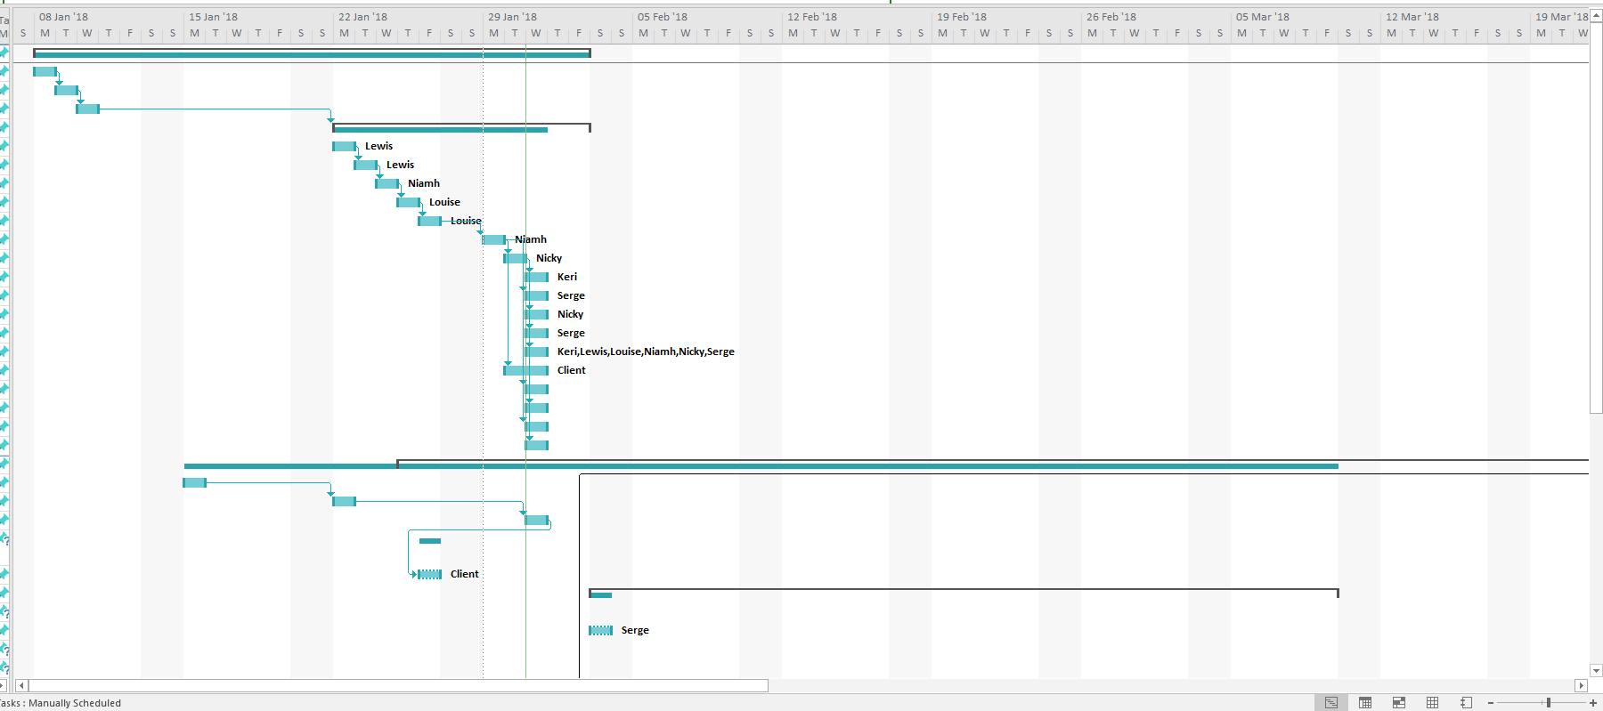

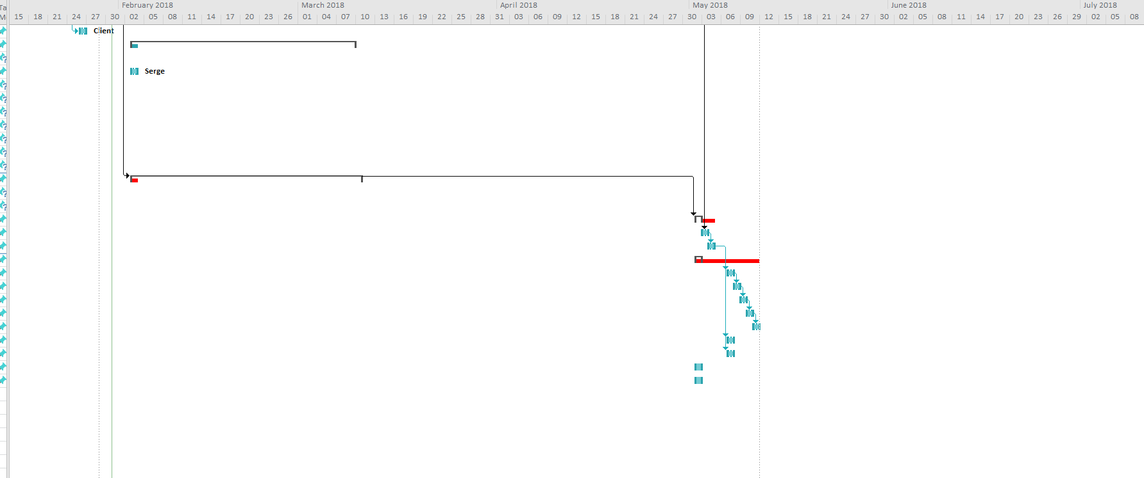

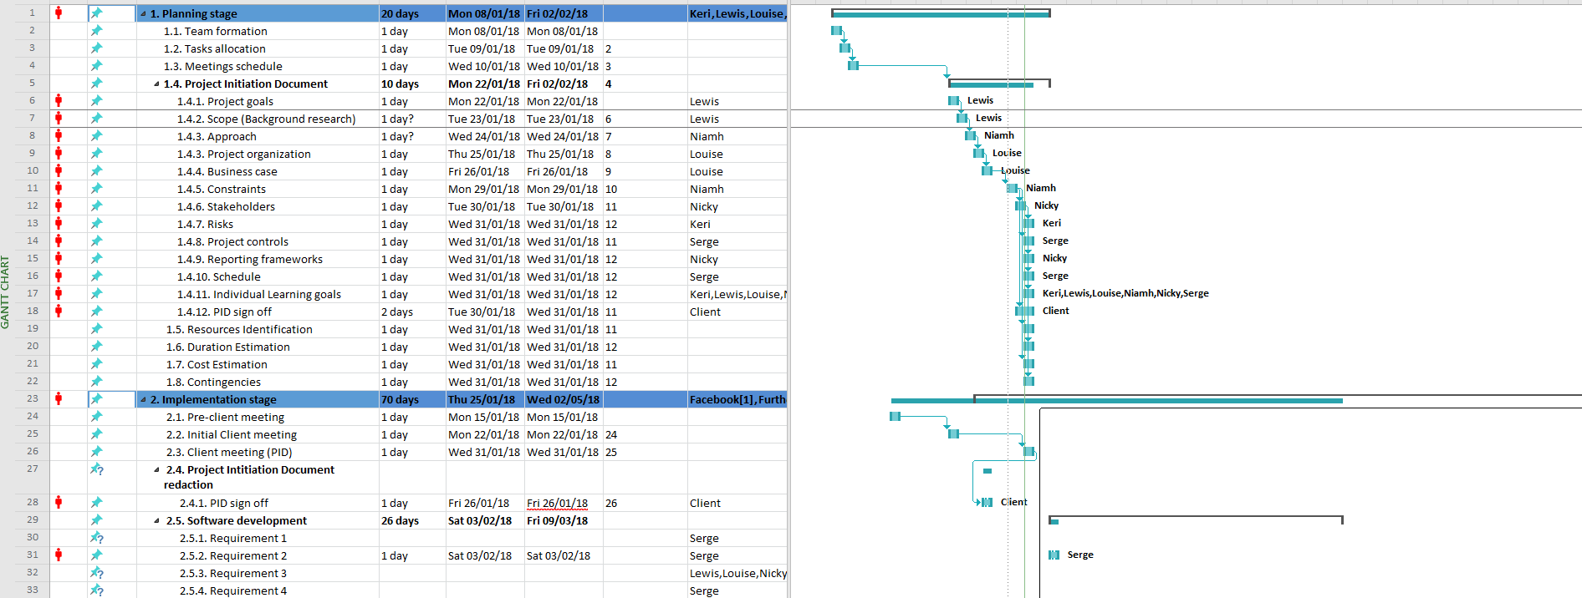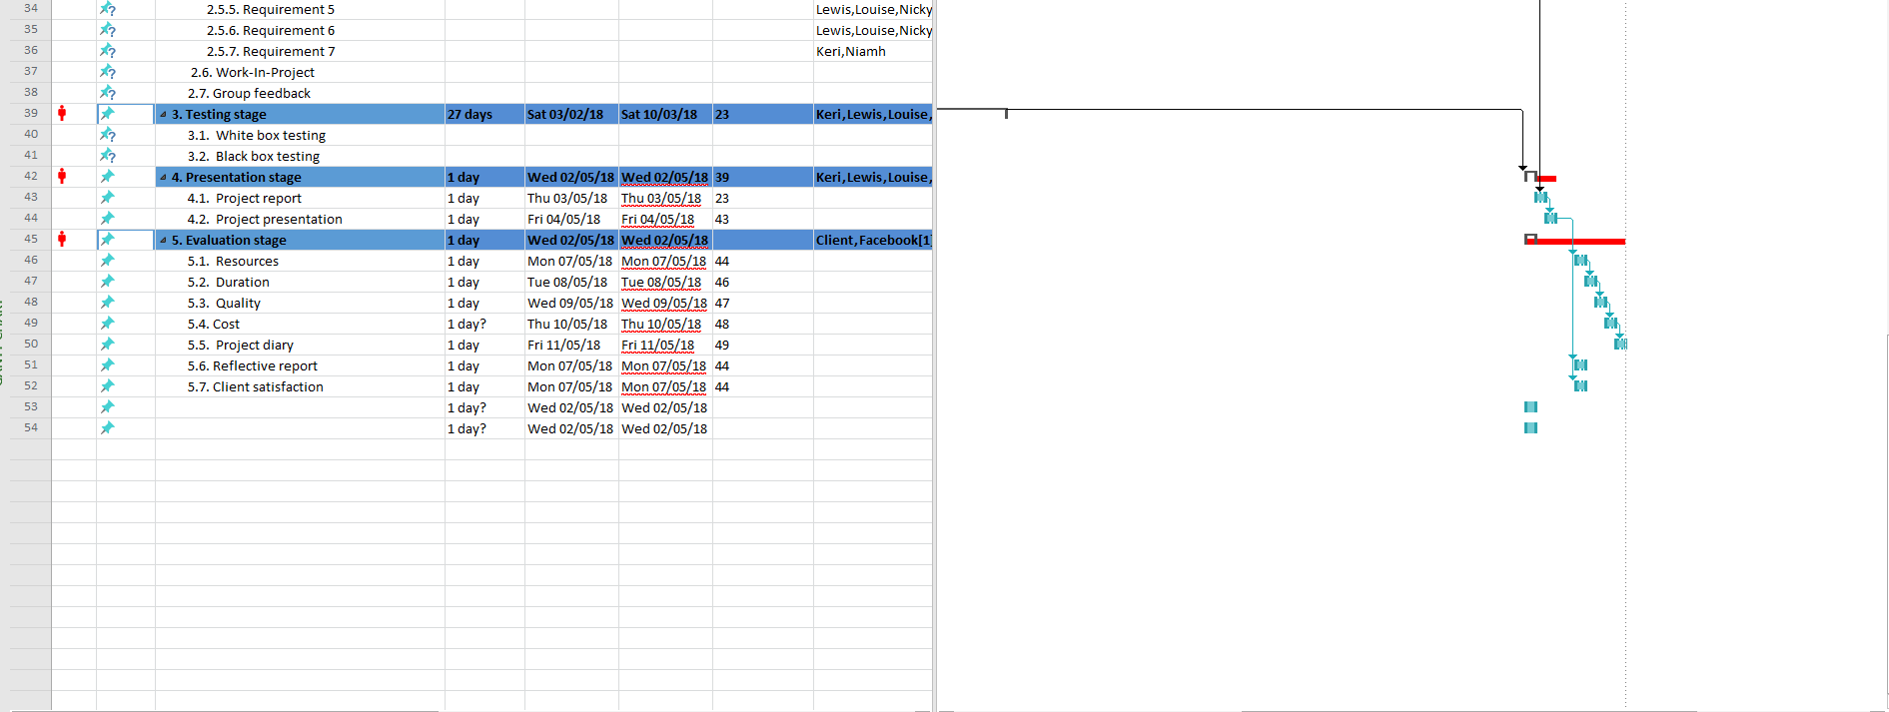

Client Signature ……………………………………… Project Manager Signature ……………………………….

31/01/2018