# Plotten Strecke

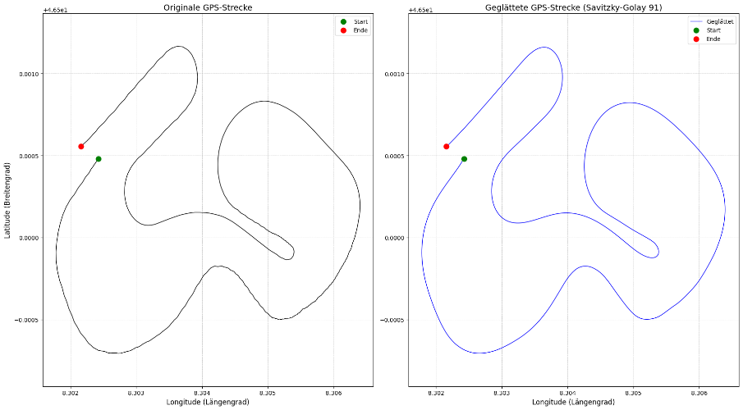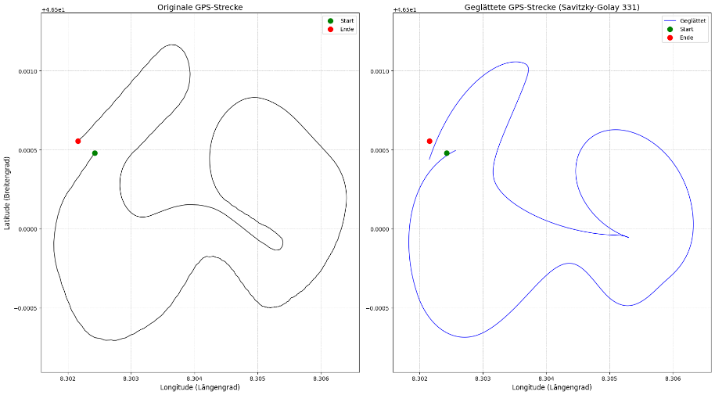

# Gesmoothte Strecke jeder Position den Winkel bestimmen

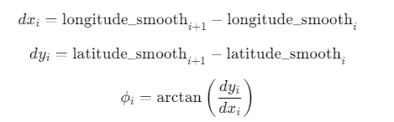

# Orginalstrecke mit Winkel begradigen (euklidische Distanz)

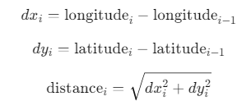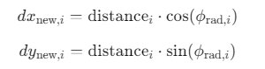

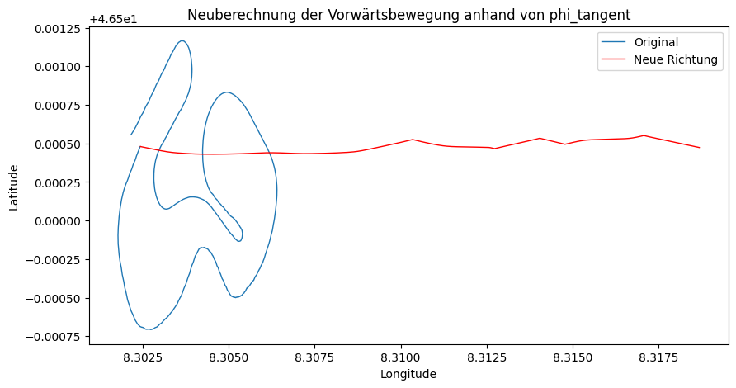

# Savitzky_Golay (Neu)

|  |  |
| --- | --- |
| **Benachbarte Werte 21** | **Polynom: 3** |
| **C:\Users\Louis.Feuillet\AppData\Local\Microsoft\Windows\INetCache\Content.MSO\C2371E05.tmp** | **C:\Users\Louis.Feuillet\AppData\Local\Microsoft\Windows\INetCache\Content.MSO\42FF6DA0.tmp** |
| **C:\Users\Louis.Feuillet\AppData\Local\Microsoft\Windows\INetCache\Content.MSO\B2E4D0D7.tmp** | |
| **Benachbarte Werte 71** | **Polynom: 3** |
| **C:\Users\Louis.Feuillet\AppData\Local\Microsoft\Windows\INetCache\Content.MSO\ACF6B5DA.tmp** | **C:\Users\Louis.Feuillet\AppData\Local\Microsoft\Windows\INetCache\Content.MSO\472E1E99.tmp** |
| **C:\Users\Louis.Feuillet\AppData\Local\Microsoft\Windows\INetCache\Content.MSO\A2FC8BC4.tmp** | |
| **Benachbarte Werte 121** | **Polynom: 3** |
| **C:\Users\Louis.Feuillet\AppData\Local\Microsoft\Windows\INetCache\Content.MSO\A8A8C3CB.tmp** | **C:\Users\Louis.Feuillet\AppData\Local\Microsoft\Windows\INetCache\Content.MSO\F479B11.tmp** |
|  | |
| **Benachbarte Werte 151** | **Polynom: 3** |
| **C:\Users\Louis.Feuillet\AppData\Local\Microsoft\Windows\INetCache\Content.MSO\BBD8E683.tmp** | **C:\Users\Louis.Feuillet\AppData\Local\Microsoft\Windows\INetCache\Content.MSO\2DEC0AF6.tmp** |
| **C:\Users\Louis.Feuillet\AppData\Local\Microsoft\Windows\INetCache\Content.MSO\5447BFE5.tmp** | |
| **Benachbarte Werte 221** | **Polynom: 3** |
| **C:\Users\Louis.Feuillet\AppData\Local\Microsoft\Windows\INetCache\Content.MSO\35E06500.tmp** | **C:\Users\Louis.Feuillet\AppData\Local\Microsoft\Windows\INetCache\Content.MSO\3DE8BB7.tmp** |
| **C:\Users\Louis.Feuillet\AppData\Local\Microsoft\Windows\INetCache\Content.MSO\F97D3A3A.tmp** | |