Surrogate

|  |  |  |
| --- | --- | --- |
|  | 70 Punkte | 700 Punkte |
| Daten erzeugen | C:\Users\Louis.Feuillet\AppData\Local\Microsoft\Windows\INetCache\Content.MSO\B9AFD372.tmp | C:\Users\Louis.Feuillet\AppData\Local\Microsoft\Windows\INetCache\Content.MSO\DED2533A.tmp |
| Schwerpunkts Linie mit Savitzky-Golay  Drehwinkel besimmen | C:\Users\Louis.Feuillet\AppData\Local\Microsoft\Windows\INetCache\Content.MSO\4418F450.tmpSG 11/3 | C:\Users\Louis.Feuillet\AppData\Local\Microsoft\Windows\INetCache\Content.MSO\4418F450.tmpSG91/3 |
|  | C:\Users\Louis.Feuillet\AppData\Local\Microsoft\Windows\INetCache\Content.MSO\F03A1E60.tmp | C:\Users\Louis.Feuillet\AppData\Local\Microsoft\Windows\INetCache\Content.MSO\A286702.tmp |
| Schwerpunkts Beschleunigung | C:\Users\Louis.Feuillet\AppData\Local\Microsoft\Windows\INetCache\Content.MSO\F3A38084.tmp | C:\Users\Louis.Feuillet\AppData\Local\Microsoft\Windows\INetCache\Content.MSO\597293D3.tmp |
|  | C:\Users\Louis.Feuillet\AppData\Local\Microsoft\Windows\INetCache\Content.MSO\8504D059.tmp | C:\Users\Louis.Feuillet\AppData\Local\Microsoft\Windows\INetCache\Content.MSO\B191B410.tmp |

Nadine_2

|  |  |
| --- | --- |
|  | C:\Users\Louis.Feuillet\AppData\Local\Microsoft\Windows\INetCache\Content.MSO\56CE6D85.tmp |
| Schwerpunkts Linie mit Savitzky-Golay  Drehwinkel besimmen | C:\Users\Louis.Feuillet\AppData\Local\Microsoft\Windows\INetCache\Content.MSO\D45C0EF.tmpSG91/3 |
| Schwerpunkts Beschleunigung | C:\Users\Louis.Feuillet\AppData\Local\Microsoft\Windows\INetCache\Content.MSO\81C3A7D5.tmp |
|  | C:\Users\Louis.Feuillet\AppData\Local\Microsoft\Windows\INetCache\Content.MSO\D3ABB320.tmp |
|  | C:\Users\Louis.Feuillet\AppData\Local\Microsoft\Windows\INetCache\Content.MSO\F3604457.tmp |

Zyklen

Damit elevation Zyklen eingebaut werden können: 

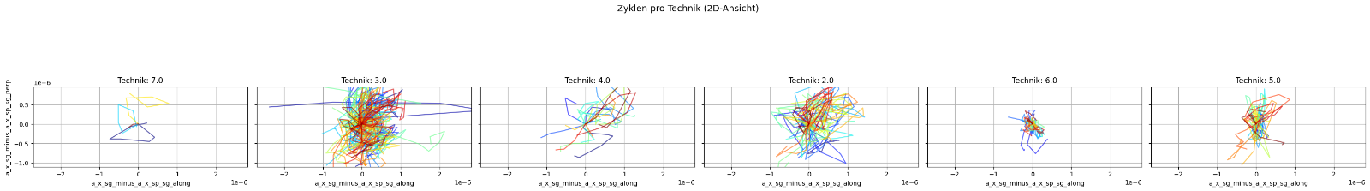

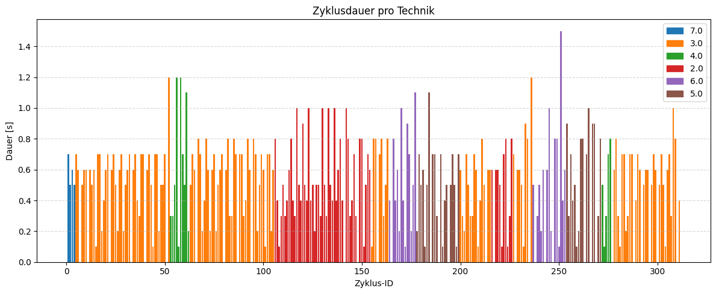

detect_and_plot_cycles_by_technic_time

detect_and_2d_plot_cycles_by_technic_time

signal_projection

subtract_column_pairs

Phi_tangents

rotate_acceleration_by_phi_column

compute_and_plot_derivatives

subtract_column_pairs

Nur_Savitzky_golay

Savitzky_golay

Process_preprocess(df_lof_2,

                   x_col = "x",

                   y_col = "y",

                   t_col = "t",

                   sp_window = 11,

                   acc_window = 5

                   )