<http://www.sdss.org/>

Sky server

<http://portal.sciserver.org/login-portal>

<https://apps.sciserver.org/dashboard/>

Started with sky server tutorial

<http://skyserver.sdss.org/dr14/en/proj/basic/basichome.aspx>

Howto’s for sky server e.g. how to start jupyter

<http://www.sciserver.org/wp-content/uploads/2018/07/SciServer-How-Tos.pdf>

<https://www.google.com/sky/>

Stellarium

<http://simbad.u-strasbg.fr/simbad/>

<http://cdsweb.u-strasbg.fr/cgi-bin/Sesame>

<https://astroquery.readthedocs.io/en/latest/#available-services>

What astronomy is

[what is astronomy](http://skyserver.sdss.org/dr14/en/astro/astrohome.aspx)

<https://skyview.gsfc.nasa.gov/current/cgi/query.pl>

<https://skyview.gsfc.nasa.gov/current/docs/batchpage.html>

Query skyview using python

<https://astroquery.readthedocs.io/en/latest/skyview/skyview.html>

VSO

<https://sdac.virtualsolar.org/cgi/search>

<https://vso.nascom.nasa.gov/API/VSO_API.html>

e.g.

1. theres one on SDSS hunting for rogue asteroids (need ImageJ)

2. plot a herzsprung russel diagram - for different star clusters

3. look for galaxy clusters ... where are they how big are they how are they distributed

4. supernova distributions

### COMPLICATED ASTRONOMY

TYPES OF STARS

Names of chemical elements

Decimals

Wavelength

The spectrum

Ultra-violet

infra-red(cant see it)

<http://skyserver.sdss.org/dr14/en/proj/kids/kidshome.aspx>

Childrens asronomy

Constellations

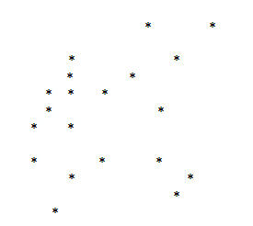

I think its a constellation of a wolf

Before

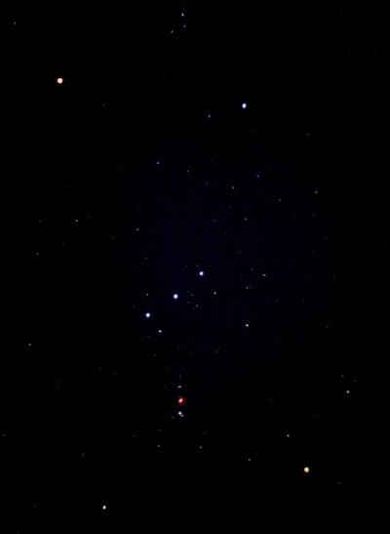

http://skyserver.sdss.org/dr14/en/proj/kids/constellation/orion.aspx

AFTER

