Quality Management and Experimental
Software Engineering
2015/2016

Report from survey research:
Video watching habits Survey

Authors:
Louis Hancquart 124735
Marceli Tokarski 104082

Poznan, 18.01.2016

Introduction
This report presents design and summarizes results of the survey research Video watching habits Survey. The survey research was a part of the project realized in the frame of Quality Management and Experimental Software Engineering classes at Poznan University of Technology.

Objectives

The objectives is to get information about habits of people watching videos in order to help to production of a video platform software. This software will be distributed based on torrent technology and may face some technical problems that may delay the watching. Moreover the software will compete with the other video platform. That’s why we wanted to focus on habits to know how to fit the best the expectations.
We translated the survey in French to get more answers. We expected to reach around 35 or more people to be able to have some consistent data to rely on.

Bivariates habits analyzed:

unknown video VS Torrent video :
See whether the users would accept to wait if it is torrent related technology ( as some waiting time can appear on launch of video for example).

unknown video VS interesting video:
Know about what kind of video the platform should provide ( random or selected ).

smartphone give up time VS computer give_up time :
As we thought that depending on the device you are watching, you can tolerate more or less the latency of the video.

Design
We designed our study as successive independent sample. We decided to administer the survey to the participants in the following way :
The questions were asked the same way to different people from random samples of a population. The Answer shouldn’t differ with the time for a same person.

Instrument

We put our survey on google Forms. By using this device we could start the survey session, look at the results and download them in excel.

We asked participants following questions:

Question 1: What device(s) are you using the most?

Justification: We asked such question to know which is the most popular device which people use to watch videos. That piece of information is crucial to conduct this experiment properly.

Answers:
- TV
- Computer ( ordinateur )
- cable
- satellite
- smartphone

Response scale – Nominal.

Question 2: When are you usually watching videos? ( most of the time )

Answers:
- Early Morning - le matin très tôt
- Morning - le matin
- Afternoon - l'après-midi
- Evening - le soir
- Night - tard le soir

Justification: To check the time in which people mostly watch videos. It can affect the disponibility of videos and so the technical choices of the platform. As it is distributed it could be good to that everyone watch videos in the same hours so that we can focus on broadcast rather than atomic requests.

Response scale – Ordinal.
Question 3: What kind of videos are you usually watching?

Answers:
- Animation
- Arts & Design
- Cameras & Techniques
- Comedy
- Documentary
- Experimental
- Fashion ( Mode )
- Food - Cuisine
- Instructionals ( Pédagogique )
- Music
- Narrative
- Personal
- Reporting & Journalism
- Sports
- Talks ( Débat )
- Travel ( Voyage )
- Adult

Justification: To check what types of videos are the most requested, in order to guide the offer to provide to customers.

Response scale – Nominal.

Question 4: On the internet, what platform are you using ?

Possible answers:
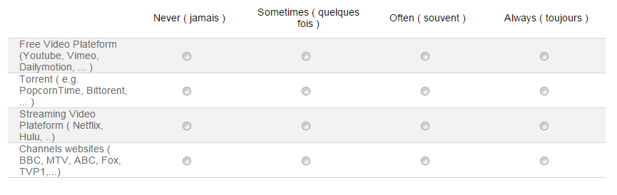

Justification: To check what are the most popular sources which people use to watch videos.

Response scale – Ordinal.
Question 5: How long can you wait for a video to be loaded before giving up?

Possible answers:

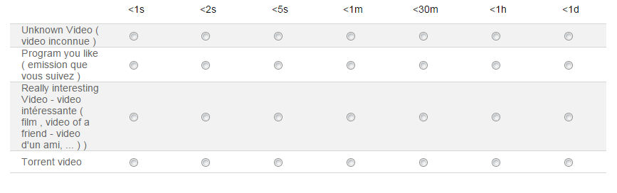

Justification: This question simply ask about people’s determination for watching movies - how long they can wait for video to be loaded. Regardless to the ressources disponibles, the platform should compete with giants like Youtube.
This question can help us to specialize the offer if it is not possible to deliver all the videos efficiently.

Response scale – Ratio.

Question 6: Are you annoyed by advertisements?

Possible answers:
- YES
- NO

Justification:
As the product won’t certainly be sold for a price, it is interesting to see how much percentage of the population is not bothered by the advertisement.

Response scale – Nominal.

Question 7: How much time do you spend on watching videos per day?

Possible answers:
- <30m
- <1h
- <2h
- <3h
- <4h
- >4h

Justification: This question can help to do architectural choices . For example: RAM management: favor broadcasting in case of a lot of people watching the same kind of videos at the same time, or unicast video supply if the not so much people watch together.

Response scale – Ratio.

Question 8: In comparison to last year, would you say that you watch videos more or less often?

Possible answers:
- More ( + )
- Less ( - )

Justification:
To check if the person is more and more interested in watching videos or not. We can evaluate the tendency of the market ( growing or not ).

Response scale – Nominal.

Evaluation
Instrument was evaluated by pilot study about watching videos by adults.

Executing the study
The survey was destined for people who are adults . We managed to question 35 people, mostly by sharing the survey in Facebook groups as well as sharing the link to the survey with colleagues who study Computing Science at Poznan University of Technology. We sent also some mails to people that doesn’t use facebook. However, the population of our study is generally young.

Analysis

Univariate

Question 1: What device(s) are you using the most?

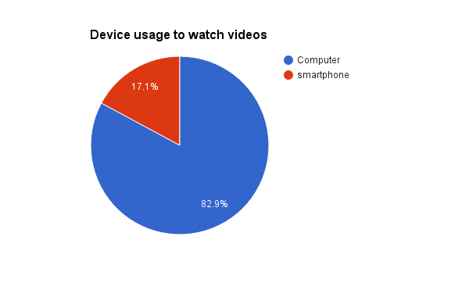

First question regards device usage of participants of the survey. At this very moment we can presume that the big majority of people are using computers to watch videos (82,9%). Only 17,1% watch videos in usage of smartphones. We can see that the TV, cable and satellite wasn’t even mentioned once in the answers. We can see it as a sign of regression of the use of these devices or a limitation in the population studied.
In this context, it looks unnecessary to put efforts to port the platform for mobile application.

Question 2: When are you usually watching videos? ( most of the time )

Response scale – Ordinal.

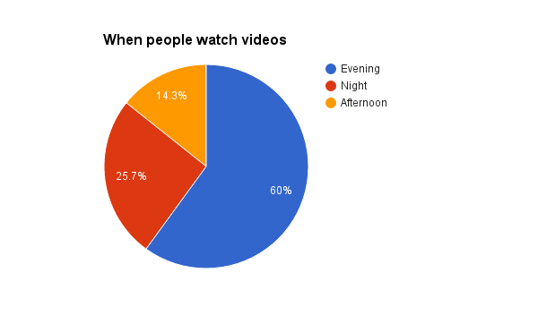

As it is shown in chart, the time when people watch video is mostly the Evening with 60%. After that, is the night with 25.71%. this value is decreasing to 14.28% at afternoon. So we can see that more than 85% of people are watching videos on the evening and the night. We can expect that a big part of the videos will be watched around during the same time. Considering this, it is worth to focus on broadcast than unicast.

Question 3: What kind of videos are you usually watching?

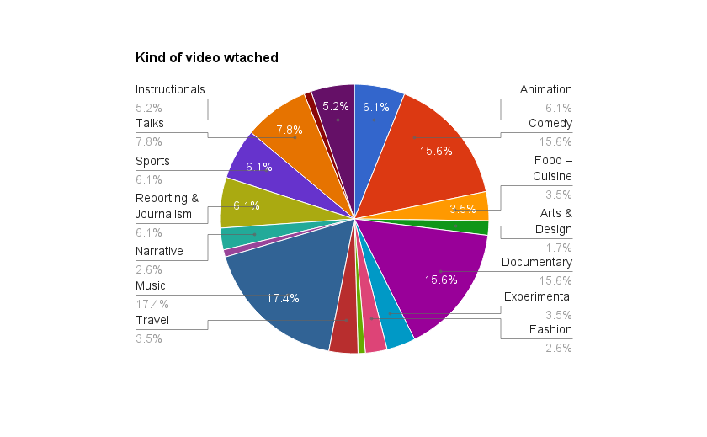

The third question, in which people were asked about the type of videos that they are usually watching, showing us that the most popular are Music videos.
Almost 18% (17,39%) answered this way, which is clearly visible on the plot provided above. On the second place we have Comedy and Documentary films with almost 16% (15,65%) answers.
We can also see that over the 35 people that answered, we have 115 choices. So, statistically, people focus on 3 kind of video : Music, Comedy and Documentary.

Question 4: On the internet, what platform are you using ?

Response scale – Ordinal.

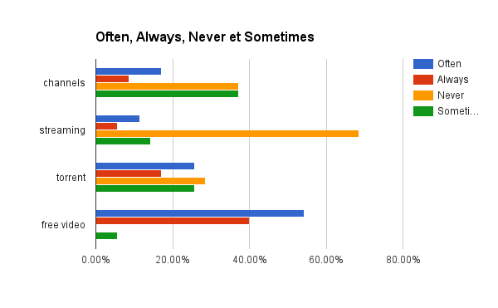
Data :

 | Often | Always | Never | Sometimes
channels | 17,14% | 8,57% | 37,14% | 37,14%
streaming | 11,42% | 5,71% | 68,57% | 14,28%
torrent | 25,71% | 17,14% | 28,57% | 25,71%
free video | 54,29% | 40,00% | 0,00% | 5,71%

Channels:

Most of the people asked never ( 37.14%) used channels or only sometimes ( 37.14%) . It is clearly not the prefered platform to supply videos.

Streaming:

IN this survay, 68.57% of subject never use streaming platform and the just 5.71% of them use it always.11.42% of them often use it.so according to this survay it can be said video streaming was not popular between the subjects.

Torrent:
As it clear in chart, 28.57% of subjects never use torrent and just 17.14% of them always use it. 25.71% use it sometimes and 25.71% use it often. It is quite uniform repartition of usage.

Free video platform:

94.29 % of people use About the Free video platform often or always, and nobody never use it. It is obviously the most of the subjects want to use free video platform than the other type of platforms.

Conclusion:

People obviously prefer the free and popular video platform like Youtube but the most popular platform just after it is the torrent platform. So the video platform should be web oriented and free.

Question 5: How long can you wait for a video to be loaded before giving up?

Response scale – Ratio.

First the answers have been changed to set them in the same measure unit. Then we could extract the data.

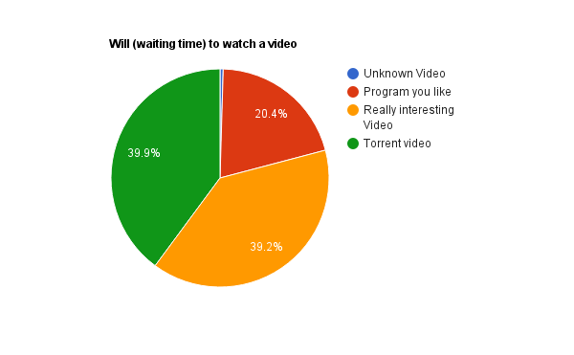

About this question, we can see that people usually accept to wait for a torrent video with almost 40% of people agreeing to wait for torrent or a really interesting video.
we can notice that nobody is willing to wait for an unknown video proposed by the platform (as it was mentioned in the description ). Moreover half of the people is able to wait a video coming from known source ( like youtube channel or a program they like).

Question 6: Are you annoyed by advertisements?

Response scale – Nominal.

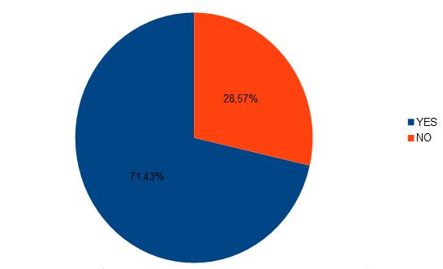

The next question and the provided answers show us how the situation with advertisements looks like. 71,43% of all the interviewers are annoyed by advertisements, but to our surprise, 10 people, which stands for almost 29% (28,57%) do not mind about advertisements.

Question 7: How much time do you spend on watching videos per day?

Response scale – Ratio.

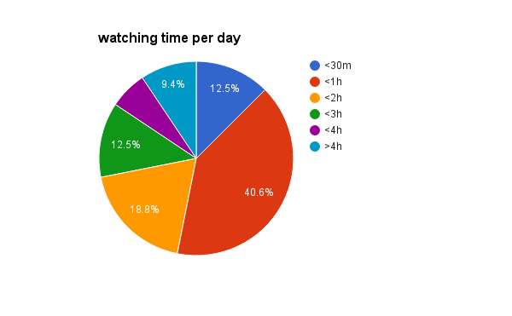On this chart, we can see that most of people ( more than 70%) are watching between half an hour and 2 hours of video a day. That represent a big potential.

Is there a correlation between tolerance about advertisement and the time watched per day? ( Q6/Q7 )

- Are you annoyed by advertisements?
- How much time do you spend on watching videos per day?

Data summary

Annoyed.by.advertisements. time.per.day
NO :10 0,5 : 4
YES:25 1 :13
2 : 7
3 : 5
4 : 3
5 : 3

mean

mean(donnees$time.per.day)
[1] 2.028571

We know that people watching around 2 hours of video per day

standard deviation

sd(donnees$time.per.day)
[1] 1.392959
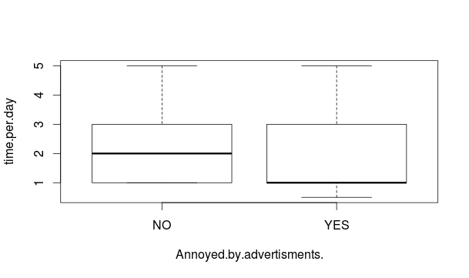Here, we can observe that people are annoyed by advertisement are watching less videos.

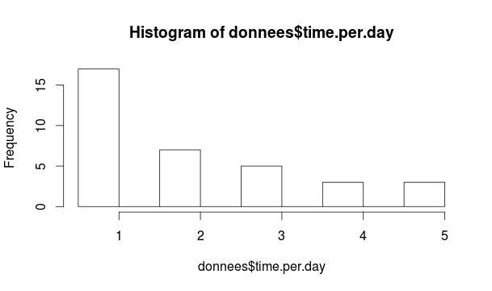

Question 8: In comparison to last year, would you say that you watch videos more or less often?

Response scale – Nominal.

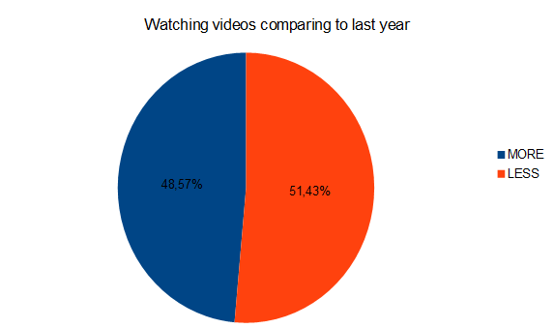

In the last question regarding feelings of the people about watching videos in comparison to last year, the answers were pretty surprising. It is difficult to see a tendency. More than half (51,43%) claim they watch less videos than last year, but 48,57% watch more, so we are near from 50% of each.
Unfortunately we cannot exploit this question as we thought: the result doesn’t show any particular tendency, only a stagnancy from last year to now.

Bivariate

Q5 : How long before giving up?

unknown video VS Torrent video

H0: there is no difference between the time to give up on a unknown video and a torrent video.
H1: there is no difference between the time to give up on a unknown video and a torrent video.

> with(data = give_up, t.test(give_up$unknown,give_up$torrent))

Welch Two Sample t-test

data: give_up$unknown and give_up$torrent
t = -2.5316, df = 34.013, p-value = 0.01614
alternative hypothesis: true difference in means is not equal to 0
95 percent confidence interval:
-11717.908 -1282.121
sample estimates:
mean of x mean of y
63.65714 6563.67143

p-value equals 0.01614, so the null hypothesis is rejected. We can see that there is a difference between the 2 variables. Therefore the mean of the time to give up for the torrent video (6563.67143) is much more greater than for an unknown video (63.65714 ).

unknown video VS interesting video

H0: there is no difference between the time to give up on a unknown video and a interesting video.
H1: there is no difference between the time to give up on a unknown video and an interesting video.

> t.test(give_up$unknown,give_up$interesting, var.equal = T)

Two Sample t-test

data: give_up$unknown and give_up$interesting
t = -2.2197, df = 68, p-value = 0.02978
alternative hypothesis: true difference in means is not equal to 0
95 percent confidence interval:
-9860.8062 -524.5653
sample estimates:
mean of x mean of y
63.65714 5256.34286

The p-value is 0.02978, so the null hypothesis is rejected. We can say that there is a difference between the will of watching a recommended video from a random video.

Q1/Q5 : Is there a difference between the time people can wait to watch a video, whether there are watching on smartphone or on computer?

smartphone give up time VS computer give_up time

H0: there is no difference between the time to give up on a video watched from a computer and from a smartphone.
H1: there is a difference between the time to give up on a video watched from a computer and from a smartphone.

>shapiro.test(as.matrix(data.frame(smartphone=as.double(gv_means[,1]),

computer=as.double(gv_means[,2]))))

Shapiro-Wilk normality test

data: as.matrix(data.frame(smartphone = as.double(gv_means[, 1]), computer = as.double(gv_means[, 2])))
W = 0.62164, p-value = 0.0001635

As p-value = 0.0001635, the data are normally distributed , so we can conduct the wilcoxon test.

Wilcoxon rank sum test with continuity correction

data: gv_means$smartphone.gv_means and gv_means$comp.gv_means
W = 66, p-value = 0.4257
alternative hypothesis: true location shift is not equal to 0

The p-value = 0.4257 is bigger than the level of significance so the null hypothesis is NOT rejected. We can assume that there is not any big difference between people watching videos from computer or from smartphones regarding the time to give up while loading.

Threats to validity

The number of people answering should be just enough to not be disturbed by the standard error.
However, we can see the limits of the study as the survey filled mainly by people using facebook communication. Even though there were also a mail communication campaign, we can assume that the population is quite young and doesn’t watch the TV anymore ( e.g. 1st question).

Conclusions

In order to sum up the survey, we would like to come back to each point and show what we concluded about it.

Question 1: What device(s) are you using the most?

Regarding the devices used, we can see that the choice of a video platform is accurate as the TV, cable and satellite are not used. The computer is the most used device. So, we can focus on a desktop application and let mobile development for the future.

Question 2: When are you usually watching videos? ( most of the time )

We can expect that a big part of the videos will be watched around during the same time. Considering this, it is worth to focus on broadcast than unicast.
As it would be a decentralized application, we can use the memory of each user to perform request of other users on the harddrive (to fetch torrent files - unicast ) or to focus on the currently watched video( broadcast ).
More than 85% are watching videos on the same period of the day (Evening, Night) , so we think it would be worth to focus on broadcast as most of requested videos would be the most watched as well and during the same time.

Question 3: What kind of videos are you usually watching?

The question showed that people are mostly focused on 3 kind of video : Music, Comedy and Documentary. So we should specialize our offer on Documentaries.

Question 4: On the internet, what platform are you using ?

People obviously prefer the free and popular video platform like Youtube but the most popular platform just after it is the torrent platform. So the video platform can appear as an alternative available solution. Moreover, we can adapt front-end to not disturb users habits and couple a desktop application and a web front-end.

Question 5: How long can you wait for a video to be loaded before giving up?

In general, people can wait but it should have a reason : it can be the technology used ( torrent ), but mostly the content (recommended video ). So, in the platform we should favour the quality videos, with a “like” system for example.

unknown video VS Torrent video :
People agree to wait for torrent as they know it have sometimes some delay.

unknown video VS interesting video:
As we thought, people can wait much longer for a recommended video than a random one.

smartphone give up time VS computer give_up time :
Surprisingly, the device used doesn’t affect so much the behaviour about the waiting time.

Question 6: Are you annoyed by advertisements?

Most of the people do not like advertisement but almost 30% do not care about it. So, if we have to introduce it to finance the project, we certainly would do it in the last moment when the project is enough popular.

Question 7: How much time do you spend on watching videos per day?

We have mean of 2 hours of watching per people a day. That confirm previous questions that said that a broadcast method would be efficient. It appears that there is a correlation between the time watched per day and tolerance of the ads. Ads may annoy people and make them watch less videos.

Question 8: In comparison to last year, would you say that you watch videos more or less often?

It appears that watching time stay constant from last year to this one.

To put it in a nutshell, this survey was really interesting and useful. Combining results of questions we could see how to orient the video platform and what to avoid.
At the technical level, the survey enforced the torrent technological choice, as people accept the delay that it can induce. The choice of a desktop application is also relevant compared to a website or a mobile application because the computer is by far the device used. Furthermore, we can apply a broadcast strategy in the video transfer process, because it appear that the users are watching 2 hours per day on the same period of the day.
At the offer level, the users mostly agree on the delay when they are waiting for an interesting video. We should have a ranking system in the application to provide quality videos for the user.
The use of ads to finance the platform should be limited at least at the beginning. It annoy the user and decrease the watching time.

